# **Part 1 : AWS Overview Notes**

## **AWS Overview Notes**

## **What Is Cloud Computing?**

Cloud computing is the on-demand delivery of compute power, database storage, applications, and other IT resources through a cloud services platform via the internet with pay-as-you-go pricing.

### **Six Advantages and Benefits of Cloud Computing**

* Trade capital expenses for variable expense
* Benefit from massive economies of scale
* Stop guessing capacity
* Increase speed and agility
* Stop spending money on running and maintaining data centers
* Go global in minutes

Additional information is available at<https://aws.amazon.com/what-is-cloud-computing/>.

### **Deployment Models**

There is a range of deployment models, from all on-premises to fully deployed in the cloud. Many users begin with a new project in the cloud, and they might integrate some on-premises applications with these new projects in a hybrid architecture. They might decide to keep some legacy systems on-premises. Over time, they might migrate more and more of their infrastructure to the cloud, and they might eventually reach an all-in-the-cloud deployment.

Details can be found at<https://aws.amazon.com/types-of-cloud-computing/>.

## **Products and Services**

AWS offers a broad set of global cloud-based products, including compute, storage, databases, analytics, networking, mobile, developer tools, management tools, Internet of Things (IoT), security, and enterprise applications.

Details can be found at<https://aws.amazon.com/products/>.

## **AWS Partner Network (APN)**

APN Partners are focused on your success, and they help customers take full advantage of all the business benefits that AWS has to offer.

More details about accessing the AWS Partner Network--or becoming an AWS Partner--can be found at:<https://aws.amazon.com/partners/>.

## **AWS Marketplace**

The AWS Marketplace is a digital catalog with thousands of software listings from independent software vendors, where you can find, test, buy, and deploy software to run on AWS.

These offerings can range from simple web server applications to security, networking business intelligence, databases, DevOps, and media. Many of these applications offer pay-as-you-go or Bring Your Own License (BYOL) models.

Details on the AWS Marketplace can be found at<https://aws.amazon.com/marketplace>.

## **AWS Infrastructure Notes**

The AWS Cloud infrastructure is built around Regions and Availability Zones. AWS Regions provide multiple, physically separated, and isolated Availability Zones that are connected with low latency, high throughput, and highly redundant networking.

As of the time of publication, the AWS Cloud spans 55 Availability Zones within 18 geographic Regions and 1 Local Region around the world. There are announced plans for 15 more Availability Zones and five more Regions in Bahrain, Hong Kong SAR, Sweden, and South Africa; and a second AWS GovCloud Region in the US.

There is a *Local Region* in Osaka, Japan (**Osaka-Local**). An AWS Local Region is a single data center that is designed to complement an existing AWS Region. It is available to select AWS customers who request access. Customers who want to use the Asia Pacific (Osaka) Local Region should speak with their sales representative. Like all AWS Regions, AWS Local Regions are completely isolated from other AWS Regions.

[Click here](https://aws.amazon.com/about-aws/global-infrastructure/) for the most current information.

Each AWS Region has multiple, isolated locations that are known as Availability Zones. Amazon Relational Database Service (Amazon RDS) provides you with the ability to place resources (such as instances) and data in multiple locations. Resources aren't replicated across AWS Regions unless you do so specifically.

Detailed information about Availability Zones can be found [here](https://docs.aws.amazon.com/AmazonRDS/latest/UserGuide/Concepts.RegionsAndAvailabilityZones.html).

## **Compute Services Notes**

Building and running your application starts with compute, whether you are building enterprise, cloud-native, or mobile applications; or running massive clusters to sequence the human genome.

AWS offers a comprehensive portfolio of compute services that allow you to develop, deploy, run, and scale your applications and workloads in the world’s most powerful, secure, and innovative compute cloud.

Details about the full range of AWS compute services can be found [here](https://aws.amazon.com/products/compute/).

Later in this module, you will learn about both Amazon Elastic Compute Cloud (Amazon EC2) and Amazon Lightsail. See those sections for more details.

Both serverless computing and container services are beyond the scope of this class. We will cover these topics in subsequent courses, but the following descriptions provide an introduction to some of the key services for serverless computing and containers.

## **AWS Lambda**

AWS Lambda lets you run code without provisioning or managing servers. You pay only for the compute time you consume--there is no charge when your code isn't running. Additional information about Lambda can be found at<https://aws.amazon.com/lambda>

## **AWS Container Services**

Amazon Elastic Container Service (Amazon ECS) is a highly scalable, high-performance container orchestration service that supports Docker containers. It allows you to run and scale containerized applications on AWS. You can find more details at<https://aws.amazon.com/ecs/>

Amazon Elastic Container Service for Kubernetes (Amazon EKS) makes it straightforward to deploy, manage, and scale containerized applications that use Kubernetes on AWS. Details can be found at<https://aws.amazon.com/eks/>

AWS Fargate is a compute engine for Amazon ECS and Amazon EKS that allows you to run containers without having to manage servers or clusters. You can find more information at:<https://aws.amazon.com/fargate/>

Note that before you use any of these services, you should check whether they are eligible for the AWS Free Tier: [https://aws.amazon.com/free](https://aws.amazon.com/free/)

## 

## 

## 

## 

## 

## 

## 

## 

## 

## 

## 

## 

## 

## 

## **Amazon EC2 Notes**

Amazon Elastic Compute Cloud (Amazon EC2) is a web service that provides secure and resizable compute capacity in the cloud. It's designed to make web-scale cloud computing easier for developers.

Amazon EC2 presents a true virtual computing environment, and it allows you to use web service interfaces to launch instances with a variety of operating systems, load them with your custom application environment, manage your network’s access permissions, and run your image by using as many or few systems as you want.

Details on the features and cost of Amazon EC2 are available at<https://aws.amazon.com/ec2/>

### **Amazon EC2 instance types**

*Required Reading -- Quiz and exam questions might refer to information from the link about instance types below.

Amazon EC2 provides a wide selection of instance types that are optimized to fit different use cases. Instance types comprise varying combinations of CPU, memory, storage, and networking capacity. They give you the flexibility to choose the appropriate mix of resources for your applications. Each instance type includes one or more instance sizes, which allows you to scale your resources to the requirements of your target workload. Current details about available instance types are available at<https://aws.amazon.com/ec2/instance-types/>

## **Networking on AWS Notes**

## **CIDR Notation**

An important concept that's used in networking on AWS is CIDR, or *Classless Inter-Domain Routing*. CIDR network addresses are allocated in a virtual private cloud (VPC) and in a subnet by using CIDR notation. A /16 block provides 65,536 IPv4 addresses. A /24 block provides 256 addresses. [See this article](https://en.wikipedia.org/wiki/Classless_Inter-Domain_Routing) for more information about CIDR.

## **Amazon Virtual Private Cloud**

Amazon Virtual Private Cloud (Amazon VPC) lets you provision a logically isolated section of the AWS Cloud where you can launch AWS resources in a virtual network that you define. You have complete control over your virtual networking environment, including the selection of your own IP address range, the creation of subnets, and the configuration of route tables and network gateways. You can use both IPv4 and IPv6 in your VPC for secure and easy access to resources and applications. You could create up to five non-default VPCs per AWS account per Region. (See below for information about default VPCs.)

Details on Amazon VPC can be found here:<https://aws.amazon.com/vpc>

## **Subnets**

A VPC spans all the Availability Zones in the Region. After creating a VPC, you can add one or more subnets in each Availability Zone. When you create a subnet, you specify the CIDR block for the subnet, which is a subset of the VPC CIDR block. Each subnet must reside entirely within one Availability Zone, and it can't span Availability Zones.

This is an important fundamental topic, and we strongly recommend that you review the information at:<https://docs.aws.amazon.com/vpc/latest/userguide/VPC_Subnets.html>

Security in a VPC is provided by using Security Groups and Network Access Control Groups. We will talk about AWS Security in a later module.

## 

## **Default VPC**

In each Region, AWS will provision a default VPC. This VPC has a /16 IPv4 CIDR address block of 172.31.0.0/16. This provides 65,536 private IPv4 addresses. In addition, there will be a /20 subnet that is created for each Availability Zone in the Region, which provides 4,096 addresses per subnet, with a few addresses reserved for AWS usage. The route table that is associated with the default VPC will have a public route, which in turn is associated with a provisioned internet gateway.

You can modify or delete the default VPC if you want to do so.

The most current details on the default VPC can be found here:<https://docs.aws.amazon.com/vpc/latest/userguide/default-vpc.html>

## 

## 

## 

## 

## 

## 

## 

## 

## 

## **Amazon EBS Notes**

Amazon Elastic Block Store (Amazon EBS) provides persistent block storage volumes for use with Amazon EC2 instances in the AWS Cloud. Each Amazon EBS volume is automatically replicated inside an Availability Zone to protect you from component failure, which offers high availability and durability. Amazon EBS volumes offer the consistent and low-latency performance that you need to run your workloads.

Amazon EBS provides a range of options that allow you to optimize storage performance and cost for your workload. These options are divided into two major categories: SSD-backed storage for transactional workloads, such as databases and boot volumes (performance depends primarily on IOPS), and hard disk drive (HDD)-backed storage for throughput-intensive workloads, such as MapReduce and log processing (performance depends primarily on MB/s).

The Elastic Volume feature of Amazon EBS allows you to dynamically increase capacity, tune performance, and change the type of live volumes with no downtime or performance impact. This allows you to easily right-size your deployment and adapt to performance changes.

Pricing for Amazon EBS is based on the amount (volume) and type of Amazon EBS volume that you provision. For pricing information, see:<https://aws.amazon.com/ebs/pricing/>. Confirm that you are looking at cost in the correct Region.

Full details on Amazon EBS are available here:<https://aws.amazon.com/ebs>

## 

## 

## 

## 

## 

## **Amazon S3 Notes**

Amazon Simple Storage Service (Amazon S3) stores data as objects within resources that are called *buckets*. You can store as many objects as you want within a bucket, and you can write, read, and delete objects in your bucket. Objects can be up to 5 TB in size.

You can control access to both the bucket and the objects (who can create, delete, and retrieve objects in the bucket for example), and view access logs for the bucket and its objects. You can also choose the AWS Region where a bucket is stored to optimize for latency, minimize costs, or address regulatory requirements.

With Amazon S3, you pay only for what you use. There is no minimum fee. Estimate your monthly bill by using the [AWS Simple Monthly Calculator](https://calculator.s3.amazonaws.com/index.html). We charge less where our costs are less, and prices are based on the location of your Amazon S3 bucket.

Full details on Amazon S3 can be found here:<https://aws.amazon.com/s3>.

## 

## 

## 

## 

## 

## 

## 

## 

## 

## **Amazon EFS Notes**

Amazon Elastic File System (Amazon EFS) provides simple, scalable, elastic file storage for use with AWS Cloud services and on-premises resources. It is straightforward to use, and it offers a simple interface that allows you to create and configure file systems quickly and easily.

Amazon EFS is designed to provide massively parallel shared access to thousands of Amazon EC2 instances. This enables your applications to achieve high levels of aggregate throughput and IOPS that scale as a file system grows, with consistent low latencies.

When an Amazon EFS file system is mounted on Amazon EC2 instances, it provides a standard file system interface and file system access semantics, which allows you to seamlessly integrate Amazon EFS with your existing applications and tools. Multiple Amazon EC2 instances can access an Amazon EFS file system at the same time, thus allowing Amazon EFS to provide a common data source for workloads and applications that run on more than one Amazon EC2 instance.

Current details on Amazon EFS can be found at:<https://aws.amazon.com/efs/>

## 

## 

## 

## 

## 

## 

## 

## **Amazon RDS Notes**

Amazon Relational Database Service (Amazon RDS) makes it straightforward to set up, operate, and scale a relational database in the cloud. It provides cost-efficient and resizable capacity while automating time-consuming administration tasks such as provisioning hardware, setting up the database, patching, and making backups.

Amazon RDS currently supports six database engines:

* Amazon Aurora:<https://aws.amazon.com/rds/aurora/>
* PostgreSQL:<https://aws.amazon.com/rds/postgresql/>
* MySQL:<https://aws.amazon.com/rds/mysql/>
* MariaDB:<https://aws.amazon.com/rds/mariadb/>
* Oracle:<https://aws.amazon.com/rds/oracle/>
* Microsoft SQL Server:<https://aws.amazon.com/rds/sqlserver/>

You can use the AWS Database Migration Service (AWS DMS) (<https://aws.amazon.com/dms>) to quickly and securely migrate your databases to AWS.

Amazon RDS is eligible for the AWS Free Tier. More details on pricing for Amazon RDS are available here:<https://aws.amazon.com/rds/pricing/>

## 

## 

## 

## 

## 

## 

## **Amazon DynamoDB Notes**

[Amazon DynamoDB](https://aws.amazon.com/dynamodb) is a fast and flexible NoSQL database service for applications that need consistent, single-digit millisecond latency at any scale. Its a fully managed cloud database, and it supports both document and key-value store models. Its flexible data model, reliable performance, and automatic scaling of throughput capacity make it a great fit for mobile, web, gaming, advertising technology (ad tech), Internet of Things (IoT), and many other applications. [Pricing for DynamoDB](https://aws.amazon.com/dynamodb/pricing/) includes a non-expiring AWS Free Tier allotment.

## 

## 

## 

## 

## 

## 

## 

## 

## 

## 

## **Monitoring and Amazon CloudWatch Notes**

## **Amazon CloudWatch**

[Amazon CloudWatch](https://aws.amazon.com/cloudwatch/) is a monitoring service for AWS Cloud resources and the applications that you run on AWS. You can use Amazon CloudWatch to collect and track metrics, collect and monitor log files, set alarms, and automatically react to changes in your AWS resources.

## **Amazon CloudWatch Events**

[Amazon CloudWatch Events](https://docs.aws.amazon.com/AmazonCloudWatch/latest/events/WhatIsCloudWatchEvents.html) delivers a near real-time stream of system events that describe changes in AWS resources. Using simple rules that you can quickly set up, you can match events and route them to one or more target functions or streams. CloudWatch Events becomes aware of operational changes as they occur.

## **Amazon CloudWatch Logs Metrics**

You can use [Amazon CloudWatch Logs](https://docs.aws.amazon.com/AmazonCloudWatch/latest/logs/WhatIsCloudWatchLogs.html) to monitor, store, and access your log files from Amazon EC2 instances, AWS CloudTrail, Amazon Route 53, and other sources. You can then retrieve the associated log data from CloudWatch Logs.

You can collect [metrics](https://docs.aws.amazon.com/AmazonCloudWatch/latest/monitoring/CW_Support_For_AWS.html) from servers by installing the CloudWatch agent on the server. You can install the agent on both Amazon EC2 instances and on-premises servers, and on servers that run either Linux or Windows Server.

## **Security in AWS Notes**

## **Amazon Shared Responsibility Model**

Security and compliance are shared responsibilities between us and the customer. This shared model can help relieve a customer’s operational burden because we operate, manage, and control the components from the host operating system and virtualization layer down to the physical security of the facilities where the service operates. The customer is responsible for--and manages--the guest operating system (including updates and security patches) and other associated application software, in addition to the configuration of the AWS-provided security group firewall. Customers should carefully consider the services that they choose because their responsibilities will vary depending on the services that they use, the integration of those services into their IT environment, and applicable laws and regulations. The nature of this shared responsibility also provides the flexibility and customer control that permits the deployment. This differentiation of responsibility is commonly referred to as Security *of* the Cloud versus Security *in* the Cloud.

## **AWS responsibility**

*Security of the Cloud:* We are responsible for protecting the infrastructure that runs all of the services that are offered in the AWS Cloud. This infrastructure is composed of the hardware, software, networking, and facilities that run AWS Cloud services.

## **Customer responsibility**

*Security in the Cloud:* Customer responsibility will be determined by the AWS Cloud services that a customer selects. This determines the amount of configuration work the customer must perform as part of their security responsibilities.

For more details about the Shared Responsibility Model, see:<https://aws.amazon.com/compliance/shared-responsibility-model/>

## 

## **Cost Management on AWS Notes**

AWS uses a *pay-as-you-go* pricing model. This allows you to easily adapt to changing business needs without over-committing budgets, and it improves your responsiveness to changes. General pricing information can be found at:<https://aws.amazon.com/pricing/>.

As mentioned in the segment on Regions, AWS pricing varies by Region. When you explore costs, make sure that you select the appropriate Region.

Pricing for each service can be found on the AWS website under the specific service listing. For example, Amazon EC2 pricing can be found at:<https://aws.amazon.com/ec2/pricing/>. The price for Amazon S3 can be found at:<https://aws.amazon.com/s3/pricing/>.

## **AWS Pricing Calculator**

AWS has announced a new pricing tool, the [AWS Pricing Calculator](https://calculator.aws/#/). This new tool, which is currently in beta, can be used to calculate Amazon EC2 and Amazon EBS pricing. For further information about this tool, see [this blog post](https://aws.amazon.com/blogs/aws/check-it-out-new-aws-pricing-calculator-for-ec2-and-ebs/). For other services, you can use the [AWS Simple Monthly Calculator.](https://calculator.s3.amazonaws.com/index.html)

## **AWS Cost Explorer**

[AWS Cost Explorer](https://aws.amazon.com/aws-cost-management/aws-cost-explorer/) lets you visualize, understand, and manage your AWS costs and usage over time. You can create custom reports (including charts and tabular data) that analyze cost and usage data, both at a high level (e.g., total costs and usage across all accounts) and for highly specific requests (e.g., m2.2xlarge costs within account Y that are tagged **project: secretProject**).

## **AWS Trusted Advisor**

[AWS Trusted Advisor](https://aws.amazon.com/premiumsupport/trustedadvisor/) is an online resource to help you reduce costs, increase performance, and improve security by optimizing your AWS environment. Trusted Advisor provides real-time guidance to help you provision your resources by following our best practices.

# **Part 2 : AWS Fundamentals: Addressing Security Risk**

## **Shared Responsibility**

## **Shared Responsibility**

Security and Compliance is a shared responsibility between AWS and the customer. This shared model can help relieve customer’s operational burden as AWS operates, manages and controls the components from the host operating system and virtualization layer down to the physical security of the facilities in which the service operates. The customer assumes responsibility and management of the guest operating system (including updates and security patches), other associated application software as well as the configuration of the AWS provided security group firewall. Customers should carefully consider the services they choose as their responsibilities vary depending on the services used, the integration of those services into their IT environment, and applicable laws and regulations. The nature of this shared responsibility also provides the flexibility and customer control that permits the deployment.

AWS responsibility “Security of the Cloud” - AWS is responsible for protecting the infrastructure that runs all of the services offered in the AWS Cloud. This infrastructure is composed of the hardware, software, networking, and facilities that run AWS Cloud services.

Customer responsibility “Security in the Cloud” – Customer responsibility will be determined by the AWS Cloud services that a customer selects. This determines the amount of configuration work the customer must perform as part of their security responsibilities. For example, a service such as Amazon Elastic Compute Cloud (Amazon EC2) is categorized as Infrastructure as a Service (IaaS) and, as such, requires the customer to perform all of the necessary security configuration and management tasks. Customers that deploy an Amazon EC2 instance are responsible for management of the guest operating system (including updates and security patches), any application software or utilities installed by the customer on the instances, and the configuration of the AWS-provided firewall (called a security group) on each instance. For abstracted services, such as Amazon S3 and Amazon DynamoDB, AWS operates the infrastructure layer, the operating system, and platforms, and customers access the endpoints to store and retrieve data. Customers are responsible for managing their data (including encryption options), classifying their assets, and using IAM tools to apply the appropriate permissions.

See this page on the AWS website for more details:<https://aws.amazon.com/compliance/shared-responsibility-model/>

## 

## **Compliance**

## **Compliance**

We include services in the scope of our compliance efforts based on the expected use case, feedback and demand. If a service is not currently listed as in scope of the most recent assessment, it does not mean that you cannot use the service. It is part of the [shared responsibility](https://aws.amazon.com/compliance/shared-responsibility-model/) for your organization to determine the nature of the data. Based on the nature of what you are building on AWS, you should determine if the service will process or store customer data and how it will or will not impact the compliance of your customer data environment.

Detailed information about AWS Compliance programs can be found here: https://aws.amazon.com/compliance/

Take a virtual tour and see how AWS secures it’s data centers:<https://aws.amazon.com/compliance/data-center/>

## 

## 

## 

## 

## 

## **Create Account**

## **Create Account**

AWS Identity and Access Management (IAM) enables you to manage access to AWS services and resources securely. Using IAM, you can create and manage AWS users and groups, and use permissions to allow and deny their access to AWS resources.

If you were using superuser or root user, then you can do anything in your account. (even deleting resources also) . For that fact, the best practice is to create individual user accounts for each user and provide them to relevant access. ( Ex: if they need admin access ? if they only need read access to say DynamoDB)

You can create more users via the IAM console by choosing a username , password whether you want to access via the console or programmatically. And you can add policies that stipulate the actual resources they have access to. Here we add an additional layer of protection for privileged users. That's called MFA( Multi-Factor Authentication) - It adds another verification check when you try to log in.

{

“Version” ; “2012-10-07”,

“Statement” : [

{

“Effect” : “allow”,

“Action” : “ * ”,

“Resource” : “ * “

}

]

}

IAM is a feature of your AWS account offered at no additional charge. You will be charged only for use of other AWS services by your users. To get started using IAM, or if you have already registered with AWS, go to the AWS Management Console and get started with these IAM Best Practices.

## **Multiple Accounts**

## **Multiple Accounts**

The Tutorial Hong mentioned in the video can be found at:<https://docs.aws.amazon.com/IAM/latest/UserGuide/tutorial_cross-account-with-roles.html>

### **AWS Organizations**

AWS Organizations helps you centrally govern your environment as you grow and scale your workloads on AWS. Whether you are a growing startup or a large enterprise, Organizations helps you to centrally manage billing; control access, compliance, and security; and share resources across your AWS accounts. More information on AWS Organizations can be found at:<https://aws.amazon.com/organizations/>

## 

## 

## 

## 

## 

## 

## 

## **Identity and Access Management**

## **Identity and Access Management**

There are three use cases ( UK’s ) for authentication and authorization.

There are AWS services related to the use case: AGT5

1. AWS Organization
2. AWS Identity and Access Management
3. AWS Single Sign- on
4. Amazon cloud directory

## **Amazon Cognito**

## Amazon Cognito itself provides an identity store called cognito user pools: this would store all users so that registration, authentication and even password resets are handled by the user pool.

Cognito identity pool : provides temporarily AWS credentials.

## **AWS Single Sign-On(SSO)**

## Users would log in once and then be able to access two different applications without having to log into each one individually.

## **IAM policies**

## Managed Policy

## stain alone policy that is created and administered by AWS.

1. Customer Managed Policy

Stain alone policy that you create and administrator in your account.

1. Inline Policy

Policy that is embedded in principle by an entity such as a user, a group or a role.

Recommended use managed policy instead of inline policy.

## **Detective Controls**

## Terms that describe a continuous improvement in monitoring of events & processing of blocks that allows for auditioning, automated analysis and alarming.

## 

## 

## 

## 

## 

## 

## 

## 

## 

## **Network Isolation**

## **Network Isolation**

### **Amazon VPC**

Amazon Virtual Private Cloud (Amazon VPC) lets you provision a logically isolated section of the AWS Cloud where you can launch AWS resources in a virtual network that you define. You have complete control over your virtual networking environment, including selection of your own IP address range, creation of subnets, and configuration of route tables and network gateways. You can use both IPv4 and IPv6 in your VPC for secure and easy access to resources and applications. More information is available at:<https://aws.amazon.com/vpc/>

### **Route Tables**

A route table contains a set of rules, called routes, that are used to determine where network traffic is directed.

Each subnet in your VPC must be associated with a route table; the table controls the routing for the subnet. A subnet can only be associated with one route table at a time, but you can associate multiple subnets with the same route table.

### **AWS Direct Connect**

AWS Direct Connect is a cloud service solution that makes it easy to establish a dedicated network connection from your premises to AWS. Using AWS Direct Connect, you can establish private connectivity between AWS and your datacenter, office, or colocation environment, which in many cases can reduce your network costs, increase bandwidth throughput, and provide a more consistent network experience than Internet-based connections.

AWS Direct Connect lets you establish a dedicated network connection between your network and one of the AWS Direct Connect locations. Using industry standard 802.1q VLANs, this dedicated connection can be partitioned into multiple virtual interfaces. This allows you to use the same connection to access public resources such as objects stored in Amazon S3 using public IP address space, and private resources such as Amazon EC2 instances running within an Amazon Virtual Private Cloud (VPC) using private IP space, while maintaining network separation between the public and private environments. Virtual interfaces can be reconfigured at any time to meet your changing needs. More information including pricing for AWS Direct Connect is available at:<https://aws.amazon.com/directconnect/> .

## **Auditing**

## **Auditing**

### **AWS CloudTrail**

***AWS CloudTrail is a service that enables governance, compliance, operational auditing, and risk auditing of your AWS account.***

( Enable you to see who is doing what in your AWS infrastructure. Can track user usage of the console API calls, AWS SDKs, Command Line tools and other AWS services them selves)

With CloudTrail, you can log, continuously monitor, and retain account activity related to actions across your AWS infrastructure. CloudTrail provides event history of your AWS account activity, including actions taken through the AWS Management Console, AWS SDKs, command line tools, and other AWS services. This event history simplifies security analysis, resource change tracking, and troubleshooting. More information about AWS CloudTrail can be found at:<https://aws.amazon.com/cloudtrail/> .

### 

### **AWS Config**

***AWS Config is a service that enables you to assess, audit, and evaluate the configurations of your AWS resources***.

Config continuously monitors and records your AWS resource configurations and allows you to automate the evaluation of recorded configurations against desired configurations. With Config, you can review changes in configurations and relationships between AWS resources, dive into detailed resource configuration histories, and determine your overall compliance against the configurations specified in your internal guidelines. This enables you to simplify compliance auditing, security analysis, change management, and operational troubleshooting. More information about AWS Config can be found at:<https://aws.amazon.com/config/>

### 

### **Amazon Inspector**

***Amazon Inspector is an automated security assessment service that helps improve the security and compliance of applications deployed on AWS.***

Amazon Inspector automatically assesses applications for exposure, vulnerabilities, and deviations from best practices. After performing an assessment, Amazon Inspector produces a detailed list of security findings prioritized by level of severity. These findings can be reviewed directly or as part of detailed assessment reports which are available via the Amazon Inspector console or API.

Amazon Inspector security assessments help you check for unintended network accessibility of your Amazon EC2 instances and for vulnerabilities on those EC2 instances. Amazon Inspector assessments are offered to you as pre-defined rules packages mapped to common security best practices and vulnerability definitions. Examples of built-in rules include checking for access to your EC2 instances from the internet, remote root login being enabled, or vulnerable software versions installed. These rules are regularly updated by AWS security researchers. More information on Amazon Inspector can be found at:<https://aws.amazon.com/inspector/>

### **AWS Trusted Advisor**

***AWS Trusted Advisor is an online tool that provides you real time guidance to help you provision your resources following AWS best practices.***

Then produce report under the five categories:

Cost optimization

Performance

Security

Fault Tolerance

Service Limit

Whether establishing new workflows, developing applications, or as part of ongoing improvement, take advantage of the recommendations provided by Trusted Advisor on a regular basis to help keep your solutions provisioned optimally. More information about AWS Trusted Advisor can be found at:<https://aws.amazon.com/premiumsupport/technology/trusted-advisor/>

## 

## **Monitoring**

## **Monitoring**

### **Amazon GuardDuty**

***Amazon GuardDuty is a threat detection service that continuously monitors for malicious activity and unauthorized behavior to protect your AWS accounts and workloads.***

With the cloud, the collection and aggregation of account and network activities is simplified, but it can be time consuming for security teams to continuously analyze event log data for potential threats. With GuardDuty, you now have an intelligent and cost-effective option for continuous threat detection in the AWS Cloud. The service uses machine learning, anomaly detection, and integrated threat intelligence to identify and prioritize potential threats. GuardDuty analyzes tens of billions of events across multiple AWS data sources, such as AWS CloudTrail, Amazon VPC Flow Logs, and DNS logs. With a few clicks in the AWS Management Console, GuardDuty can be enabled with no software or hardware to deploy or maintain. By integrating with AWS CloudWatch Events, GuardDuty alerts are actionable, easy to aggregate across multiple accounts, and straightforward to push into existing event management and workflow systems. More information about Amazon GuardDuty can be found at:<https://aws.amazon.com/guardduty/>

### **AWS Security Hub**

AWS Security Hub gives you a comprehensive view of your high-priority security alerts and compliance status across AWS accounts.

With ***Security Hub, you have a single place that aggregates, organizes, and prioritizes your security alerts, or findings, from multiple AWS services, such as Amazon GuardDuty, Amazon Inspector, and Amazon Macie, as well as from AWS Partner solutions.***

Your findings are visually summarized on integrated dashboards with actionable graphs and tables. You can also continuously monitor your environment using automated compliance checks based on the AWS best practices and industry standards your organization follows. More information about AWS Security Hub can be found at:<https://aws.amazon.com/security-hub/>

## **Data Types**

## **Data Types**

Rudy touched on many different data types and storage solutions.

| **Data Types** | **AWS Service** |
| --- | --- |
| Object | Amazon S3  Amazon S3 Glacier |
| Database | Amazon RDS  Amazon DynamoDB  Amazon Timestream  Amazon Quantum Ledger Database (QLDB) Amazon Neptune |
| Amazon EC2 Data | EBS (Amazon Elastic Block Store)  EFS ( Amazon Elastic File System) |
| Data warehouse | Amazon Redshift  Amazon Athena |
| Data Lake | Amazon Lake Formation |

### **Amazon Simple Storage Service (Amazon S3)**

***Amazon Simple Storage Service (Amazon S3) is an object storage service that offers industry-leading scalability, data availability, security, and performance.***

This means customers of all sizes and industries can use it to store and protect any amount of data for a range of use cases, such as websites, mobile applications, backup and restore, archive, enterprise applications, IoT devices, and big data analytics. Amazon S3 provides easy-to-use management features so you can organize your data and configure finely-tuned access controls to meet your specific business, organizational, and compliance requirements. More information on Amazon S3 is available at:<https://aws.amazon.com/s3/>

### 

### 

### **Amazon S3 Glacier**

Amazon S3 Glacier is a secure, durable, and extremely low-cost cloud storage service for data archiving and long-term backup. It is designed to deliver 99.999999999% durability, and provides comprehensive security and compliance capabilities that can help meet even the most stringent regulatory requirements. More information on Amazon S3 Glacier can be found at:<https://aws.amazon.com/glacier/>

### 

### **Amazon Relational Database Service (Amazon RDS)**

***Amazon Relational Database Service (Amazon RDS) makes it easy to set up, operate, and scale a relational database in the cloud.***

It provides cost-efficient and resizable capacity while automating time-consuming administration tasks such as hardware provisioning, database setup, patching and backups. It frees you to focus on your applications so you can give them the fast performance, high availability, security and compatibility they need.

Amazon RDS is available on several database instance types - optimized for memory, performance or I/O - and provides you with six familiar database engines to choose from, including Amazon Aurora, PostgreSQL, MySQL, MariaDB, Oracle Database, and SQL Server. You can use the AWS Database Migration Service to easily migrate or replicate your existing databases to Amazon RDS. More information on Amazon RDS can be found at:<https://aws.amazon.com/rds/>

### **Amazon DynamoDB**

***Amazon DynamoDB is a key-value and document database that delivers single-digit millisecond performance at any scale***.

It's a fully managed, multiregion, multimaster database with built-in security, backup and restore, and in-memory caching for internet-scale applications. DynamoDB can handle more than 10 trillion requests per day and can support peaks of more than 20 million requests per second. More information on Amazon DynamoDB can be found at:<https://aws.amazon.com/dynamodb/>

### **Amazon Timestream**

***Amazon Timestream is a fast, scalable, fully managed time series database service for IoT and operational applications that makes it easy to store and analyze trillions of events per day at 1/10th the cost of relational databases.***

Details on Amazon Timestream can be found at:<https://aws.amazon.com/timestream/>

### 

### **Amazon Quantum Ledger Database (QLDB)**

***Amazon QLDB is a fully managed ledger database that provides a transparent, immutable, and cryptographically verifiable transaction log ‎owned by a central trusted authority***.

Amazon QLDB tracks each and every application data change and maintains a complete and verifiable history of changes over time.

Amazon QLDB is a new class of database that eliminates the need to engage in the complex development effort of building your own ledger-like applications. With QLDB, your data’s change history is immutable – it cannot be altered or deleted – and using cryptography, you can easily verify that there have been no unintended modifications to your application’s data. Details about Amazon QLDB can be found at:<https://aws.amazon.com/qldb/>

### 

### **Amazon Elastic Block Store**

***Amazon Elastic Block Store (EBS) is an easy to use, high performance block storage service designed for use with Amazon Elastic Compute Cloud (EC2) for both throughput and transaction intensive workloads at any scale.***

A broad range of workloads, such as relational and non-relational databases, enterprise applications, containerized applications, big data analytics engines, file systems, and media workflows are widely deployed on Amazon EBS. More information on Amazon EBS is available at:<https://aws.amazon.com/ebs/>

### 

### **Amazon Elastic File System**

***Amazon Elastic File System (Amazon EFS) provides a simple, scalable, elastic file system for Linux-based workloads for use with AWS Cloud services and on-premises resources.***

Main difference : EFS vs EBS

With EFS, we can connect multiple EC2 instances. But in EBS, can use only a single EC2 instance.

Amazon EFS is well suited to support a broad spectrum of use cases from highly parallelized, scale-out workloads that require the highest possible throughput to single-threaded, latency-sensitive workloads. Use cases such as lift-and-shift enterprise applications, big data analytics, web serving and content management, application development and testing, media and entertainment workflows, database backups, and container storage. More information about Amazon EFS can be found at:<https://aws.amazon.com/efs/>

### 

### **Amazon Redshift**

Amazon Redshift extends data warehouse queries to your data lake, with no loading required. You can run analytic queries against petabytes of data stored locally in Redshift, and directly against exabytes of data stored in Amazon S3. It is simple to set up, automates most of your administrative tasks, and delivers fast performance at any scale. Information about Amazon Redshift is available at:<https://aws.amazon.com/redshift/>

### 

### **Amazon Athena**

Amazon Athena is an interactive query service that makes it easy to analyze data in Amazon S3 using standard SQL. Athena is serverless, so there is no infrastructure to manage, and you pay only for the queries that you run.

Athena is easy to use. Simply point to your data in Amazon S3, define the schema, and start querying using standard SQL. Most results are delivered within seconds. With Athena, there’s no need for complex ETL jobs to prepare your data for analysis. This makes it easy for anyone with SQL skills to quickly analyze large-scale datasets. Details about Amazon Athena can be found at:<https://aws.amazon.com/athena/>

## **Data Transfer**

### **AWS Snowball**

***Snowball is a petabyte-scale data transport solution that uses devices designed to be secure to transfer large amounts of data into and out of the AWS Cloud.***

Snowball devices use tamper-resistant enclosures, 256-bit encryption, and an industry-standard Trusted Platform Module (TPM) designed to ensure both security and full chain-of-custody for your data. More information about AWS Snowball can be found at:<https://aws.amazon.com/snowball/>

### 

### **AWS Snowmobile**

***AWS Snowmobile is an Exabyte-scale data transfer service used to move extremely large amounts of data to AWS***.

You can transfer up to 100PB per Snowmobile, a 45-foot long ruggedized shipping container, pulled by a semi-trailer truck. Snowmobile makes it easy to move massive volumes of data to the cloud, including video libraries, image repositories, or even a complete data center migration. Transferring data with Snowmobile is more secure, fast and cost effective. Information about how to get started with AWS Snowmobile can be found at:<https://aws.amazon.com/snowmobile/>

## **Database Encryption**

## **Encryption at rest and in transit**

**Amazon RDS allows you to encrypt your databases using keys you manage through AWS Key Management Service (KMS).** On a database instance running with Amazon RDS encryption, data stored at rest in the underlying storage is encrypted, as are its ***automated backups, read replicas, and snapshots.***

Amazon RDS supports Transparent Data Encryption in SQL Server and Oracle. Transparent Data Encryption in Oracle is integrated with AWS CloudHSM, which allows you to securely generate, store, and manage your cryptographic keys in single-tenant Hardware Security Module (HSM) appliances within the AWS cloud.

Amazon RDS supports the use of SSL to secure data in transit.

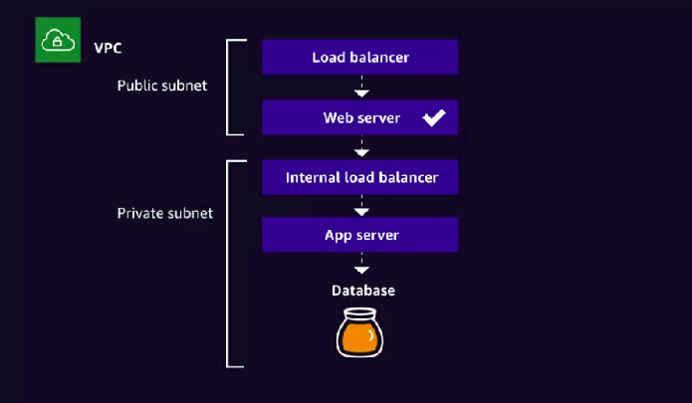

## *Can you encrypt just a subset of items in a DynamoDB table?*

## No

*When you enable encryption for RDS DB instances, what would not be encrypted?*

JBDC connection

## **Network isolation**

**AWS recommends that you run your database instances in Amazon VPC, which allows you to isolate your database in your own virtual network and connect to your on-premises IT infrastructure using industry-standard encrypted IPsec VPNs**. You can configure firewall settings and control network access to your database instances.

## **Resource-level permissions**

Amazon RDS is integrated with AWS Identity and Access Management (IAM) and provides you the ability to control the actions that your AWS IAM users and groups can take on specific Amazon RDS resources, from database instances through snapshots, parameter groups, and option groups. You can also tag your Amazon RDS resources and control the actions that your IAM users and groups can take on groups of resources that have the same tag and associated value. For example, you can configure your IAM rules to ensure developers are able to modify "Development" database instances, but only Database Administrators can make changes to "Production" database

Information on Amazon RDS Security can be found at​: https://aws.amazon.com/rds/features/#security

## **Amazon S3 Default Encryption for S3 Buckets**

**Amazon S3 default encryption provides a way to set the default encryption behavior for an S3 bucket.** You can set default encryption on a bucket so that all objects are encrypted when they are stored in the bucket. The objects are encrypted using server-side encryption with either Amazon S3-managed keys (SSE-S3) or AWS KMS-managed keys (SSE-KMS).

When you use server-side encryption, Amazon S3 encrypts an object before saving it to disk in its data centers and decrypts it when you download the objects.

More details on using Encryption with Amazon S3 can be found at:<https://docs.aws.amazon.com/AmazonS3/latest/dev/bucket-encryption.html>

Amazon S3 is cloud storage for the internet. And, think of a bucket as a literal bucket, where you can add, remove, or update objects. To upload your data, whether they be photos, videos, documents, you first create a bucket in one of the AWS Regions, and then, you can upload objects to it. But, we're talking about securing those objects, and the first thing you can do is set up bucket policies. **A bucket policy is a resource-based AWS Identity and Access Management policy, which means that you designate access permissions for the bucket and the objects in it.** So if you want a user to be able to read from a bucket, then you provision the relevant policy. Going even more fine-grained, you can dictate permissions for individual objects.

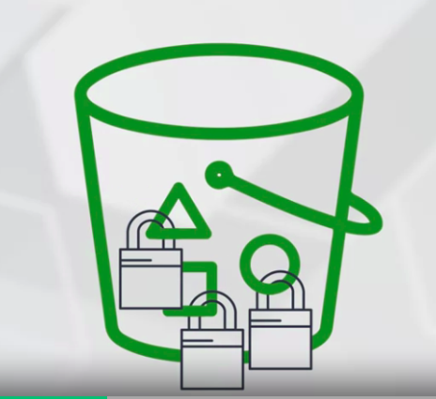

**But as a best practice for managing a whole bucket, we recommend enabling default encryption on the bucket itself.** This means that all objects in that bucket will be encrypted, and that encryption can be centrally managed at the bucket level. Objects will be encrypted using server-side encryption with either Amazon S3 managed keys, that's SSE-S3, or AWS KMS, or Key Management Service managed keys, SSE-KMS.

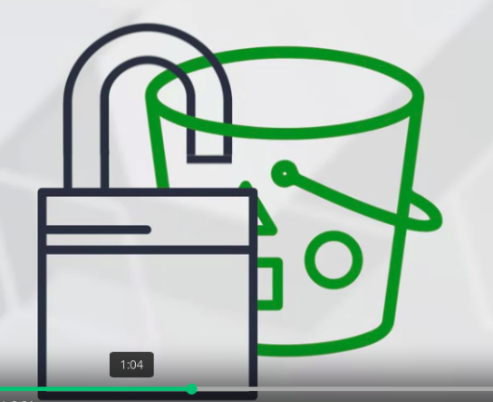

Securing Amazon S3:

* Allow access only to authorized parties.
* Disable public access unless needed.
* Consider encryption.

### **Amazon Macie**

**Amazon Macie is a security service that uses machine learning to automatically discover, classify, and protect sensitive data in AWS.**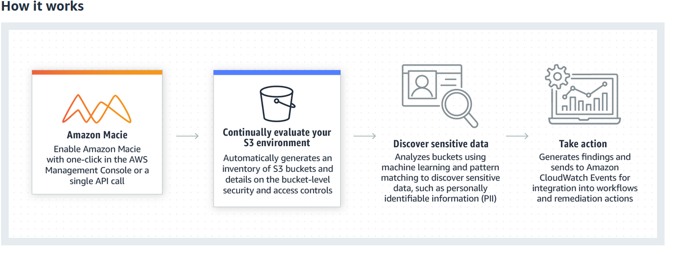

Amazon Macie recognizes sensitive data such as personally identifiable information (PII) or intellectual property, and provides you with dashboards and alerts that give visibility into how this data is being accessed or moved. ***The fully managed service continuously monitors data access activity for anomalies, and generates detailed alerts when it detects risk of unauthorized access or inadvertent data leaks. Currently, Amazon Macie is available to protect data stored in Amazon S3.***

More information about Amazon Macie is available at:<https://aws.amazon.com/macie/>

## **EBS Encryption**

EBS provides persistent block storage volume for use with Amazon EC2 instances in the AWS cloud. Amazon EBS is designed for application workloads that benefit from improving performance, the cost, and capacity.

Typical use case include:

* big data analytics engine like Hadoop
* relational and NoSQL database like Microsoft SQL server, or MongoDB.
* stream and log processing applications such as Kafka and Splunk.
* data warehousing applications like Vartika and Teradata.

**Amazon EBS encryption** offers seamless encryption of EBS data volumes, boot volumes and snapshots, **eliminating the need to build and manage a secure key management infrastructure.**

EBS encryption enables data at rest security by encrypting your data volumes, boot volumes and snapshots using Amazon-managed keys or keys you create and manage using the AWS Key Management Service (KMS). In addition, the encryption occurs on the servers that host EC2 instances, providing encryption of data as it moves between EC2 instances and EBS data and boot volumes. For more information, see Amazon EBS encryption in the Amazon EC2 User Guide.

Access to Amazon EBS volumes is integrated with AWS Identity and Access Management (IAM). IAM enables access control to your Amazon EBS volumes. For more information, see AWS Identity and Access Management. For more information about Amazon EBS encryption, see: <https://aws.amazon.com/ebs/features/>

*How do you encrypt an existing un-encrypted EBS volume?*

Take a snapshot for the EBS volume, and create a new encrypted EBS volume for this snapshot using "Create Volume" or "Copy Snapshot" API action.

## **Protecting Compute Resources**

## **Securing Amazon EC2 Instances**

Your responsible for :

Control the operating system(OS)

configure and operate any identity management system that provides access to the EC2 instance.

AWS responsible for :

protecting the hypervisor and

EC2 instance isolation.

To secure your EC2 instances, there are several best practices that we recommend.

The process for securing EC2 instances involves principles that are applicable to any OS, whether running in a virtual machine or on premises:

* **Least Access:**

**(Restrict server access at the network and the OS layer)**

Use security groups as the primary mechanism for controlling network access to EC2 network interfaces.

Use network ACLs as a secondary control for denying a specific subnet of traffic.

all providing high-level subnet guardrails.

On the instance itself, install only the required OS components and applications.

leverage(use) host-based protection software.

It is also recommended that the SSH key be used to log in to the EC2 instances that need to be secured.

* **Least Privilege:**

**Control the API access coming from EC2 instances.**

Define the minimum set of privileges each server needs in order to perform its function. ( providing interactive access to EC2 instances should follow the least privileges model)

When your applications run on EC2 instances need to access our AWS services, should use IAM roles to grant permissions for the instance to make API calls.( Using IAM roles eliminates the need to distribute and rotate long-term credentials on EC2 instances.)

* **Configuration Management:**

Create a baseline server configuration and track each server as a configuration item. Assess each server against the current recorded baseline to identify and flag any deviations. Ensure each server is configured to generate and securely store appropriate log and audit data.

* **Change Management:**

Create processes to control changes to server configuration baselines.

* **Audit Logs:**

Audit access and all changes to EC2 instances to verify server integrity to ensure only authorized changes are made.

(This will include enabling AWS CloudTrail, to capture API calls, which will enable AWS Config to audit and track changes made to your EC2 resources. )

For more information on securing EC2 instances please see:<https://aws.amazon.com/answers/security/aws-securing-ec2-instances/>

If you choose to run your application in Docker containers, there are several container management and orchestration services available.

Docker services:

* Amazon Elastic Container Service ( ECS )
* Amazon Elastic Kubernetes Service ( EKS )
* AWS Fargate
* AWS Elastic Beanstalk

When you using ECS and EKS:

maintain control over the container environment, the operating system, and the underlying EC2 instance.

Fargates:

Will not have access to the underlying compute resource. However,you have control over the container environment.

ECS, EKS, and Fargate let you use IAM roles to control requests from the application running on containers to other AWS services.

For example, you store a secret in an S3 bucket. To retrieve the secret, your containerized application run on ECS needs permission to read the secret in S3. Thus, you create an IAM role and attach it to the container so that it can read the secret.

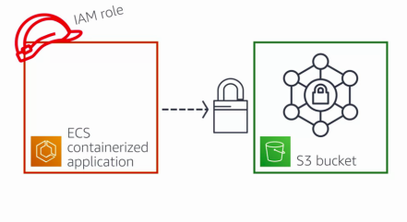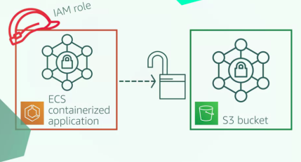

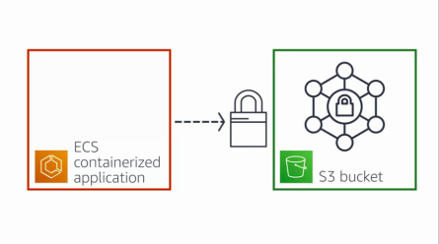

Another compute service that we should talk about is AWS Lambda.

**AWS Lambda automatically runs your code without requiring you to provision or manage servers.**

You just write the code and upload it to Lambda.

AWS manages:

underlying infrastructure and foundation services

operating system

application platform for Lambda.

You are responsible for:

security of your code

storage and accessibility of sensitive data

IAM to the Lambda service and within your function

This white paper provides an overview of security when using Lambda:<https://d1.awsstatic.com/whitepapers/Overview-AWS-Lambda-Security.pdf>

### **Amazon Elastic Container Service (Amazon ECS)**

Amazon ECS allows you to specify an IAM role for each ECS task. This allows the Amazon ECS container instances to have a minimal role, respecting the ‘least privilege’ access policy and allowing you to manage the instance role and the task role separately. You can also use Amazon CloudWatch Logs to gain visibility into the IAM role to which a task is assigned. More details on Amazon ECS can be found at:<https://aws.amazon.com/ecs/features/>

## 

## **Securing Endpoints**

### **Elastic Load Balancing (ELB)**

Elastic Load Balancing works with Amazon Virtual Private Cloud (VPC) to provide robust security features, including integrated certificate management, user-authentication, and SSL/TLS decryption. Together, they give you the flexibility to centrally manage TLS settings and offload CPU intensive workloads from your applications.

As part of securing your workloads, you need to protect your application endpoints. These endpoints are more than likely the ones that end users go through to interact with your application, and therefore, it's critical to protect them. If we look at the traditional server-based infrastructure model, with, say, an EC2 fleet. And as a reminder, EC2 is the computational building block at AWS, where you can choose specs, such as memory, disk space, and OS, and then spin up an EC2 instance itself. You can start with one,

and then you can scale out horizontally, even vertically, to have a whole fleet of servers. When you deploy fleets, you're going to spread the traffic across them like honey,

In that you want sticky sessions. And, a way to achieve this is with an AWS service called Elastic Load Balancing.

Elastic Load Balancing automatically distributes incoming application traffic across multiple targets, such as Amazon EC2 instances, containers, IP addresses, and Lambda functions. It can handle the varying load of your application traffic in a single Availability Zone or across multiple Availability Zones. Elastic Load Balancing offers three types of load balancers that all feature the high availability, automatic scaling, and robust security necessary to make your applications fault tolerant.

Type of load balances:

* Application Load Balancer ( ALB ) - operates on the individual request level, or Layer 7
* Network Load Balancer ( NLB ) - operates on the connection level, or Layer 4.
* Classic Load Balancer

For more information on ELB, see<https://aws.amazon.com/elasticloadbalancing/>

Additional information about TLS termination for Network Load balancers is available in this AWS Blog posting:<https://aws.amazon.com/blogs/aws/new-tls-termination-for-network-load-balancers/>

### **Amazon API Gateway**

Amazon API Gateway is a fully managed service that makes it easy for developers to create, publish, maintain, monitor, and secure APIs at any scale. With a few clicks in the AWS Management Console, you can create REST and WebSocket APIs that act as a “front door” for applications to access data, business logic, or functionality from your backend services, such as workloads running on Amazon Elastic Compute Cloud (Amazon EC2), code running on AWS Lambda, any web application, or real-time communication applications.

Information about Amazon API Gateway can be found at: <https://aws.amazon.com/api-gateway/>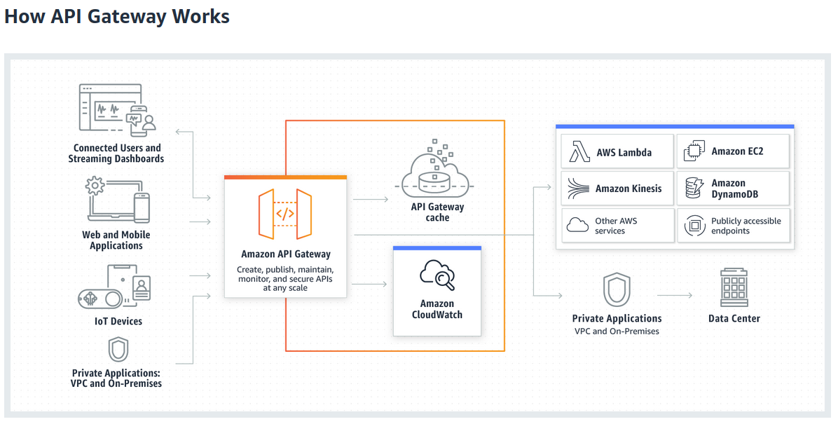

### **AWS Shield**

AWS Shield is a managed Distributed Denial of Service (DDoS) protection service that safeguards applications running on AWS. AWS Shield provides always-on detection and automatic inline mitigations that minimize application downtime and latency, so there is no need to engage AWS Support to benefit from DDoS protection. There are two tiers of AWS Shield - Standard and Advanced.

Details on AWS Shield are available at: <https://aws.amazon.com/shield/>

### **AWS WAF**

AWS WAF is a web application firewall that helps protect your web applications from common web exploits that could affect application availability, compromise security, or consume excessive resources. AWS WAF gives you control over which traffic to allow or block to your web applications by defining customizable web security rules. You can use AWS WAF to create custom rules that block common attack patterns, such as SQL injection or cross-site scripting, and rules that are designed for your specific application. New rules can be deployed within minutes, letting you respond quickly to changing traffic patterns. Also, AWS WAF includes a full-featured API that you can use to automate the creation, deployment, and maintenance of web security rules.

Details on AWS WAF are available at: <https://aws.amazon.com/waf/>

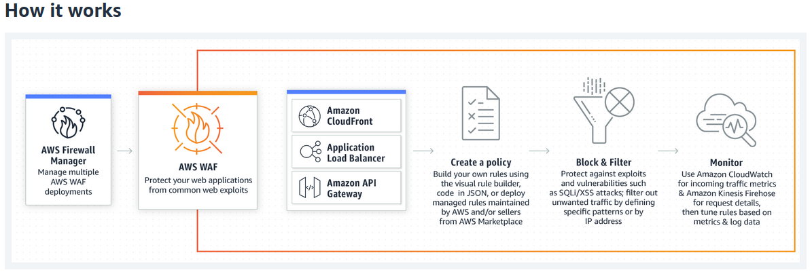

## **Secrets Manager**

AWS Secrets Manager helps you protect secrets needed to access your applications, services, and IT resources. The service enables you to easily rotate, manage, and retrieve database credentials, API keys, and other secrets throughout their lifecycle. Users and applications retrieve secrets with a call to Secrets Manager APIs, eliminating the need to hardcode sensitive information in plain text. Secrets Manager offers secret rotation with built-in integration for Amazon RDS, Amazon Redshift, and Amazon DocumentDB. Also, the service is extensible to other types of secrets, including API keys and OAuth tokens. In addition, Secrets Manager enables you to control access to secrets using fine-grained permissions and audit secret rotation centrally for resources in the AWS Cloud, third-party services, and on-premises.

More details on AWS Secrets Manager is available at: <https://aws.amazon.com/secrets-manager/>

The way that Secrets Manager works is:

1. An admin creates or retrieves the secret.
2. the admin then stores the credentials in Secrets Manager and limits access to only the necessary users.

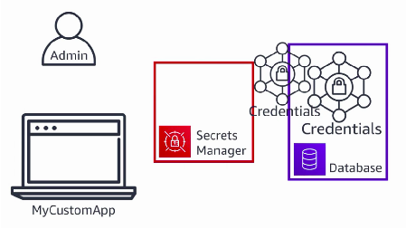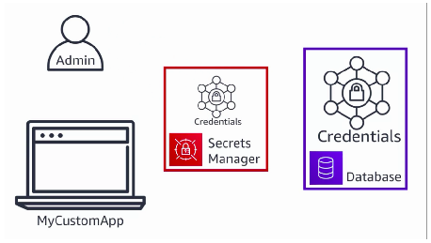

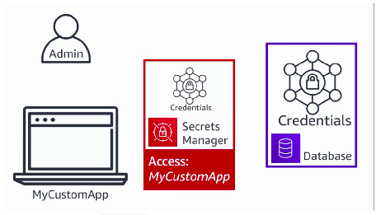

1. The application makes a call to Secrets Manager using its credentials that it has from the associated IAM role. And because the admin allowed for the application to have access, the application is then allowed to retrieve the credentials.

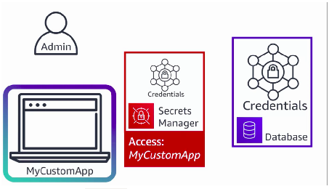

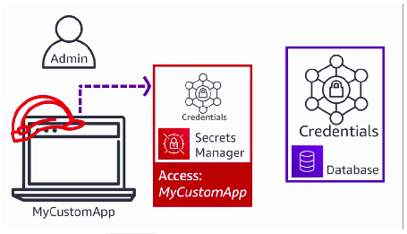

1. Once the credentials are retrieved, they are stored in a non-persistent way.

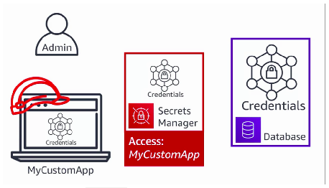

1. then the credentials can be used to access the database.

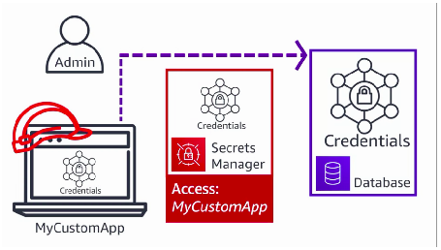

## 

## 

## 

## **AWS Well-Architected**

The Well-Architected Framework has been developed to help cloud architects build secure, high-performing, resilient, and efficient infrastructure for their applications.

Based on five pillars C-O-R-P-S.

* operational excellence
* security
* reliability
* performance efficiency
* cost optimization

The Framework provides a consistent approach for customers and partners to evaluate architectures, and implement designs that will scale over time.

The AWS Well-Architected Tool is now available. The user guide can be located here.

# **Part 3: AWS Fundamentals: Migrating to the Cloud**

## **Defining what we mean by Migration**

Cloud migration is the process of moving data, applications, or other business elements to a cloud computing environment.

Whether it is a server you want to retire, some data you want to move, or an entire networked environment that needs a new home, there are various types of cloud migrations an enterprise can perform.

All of these methods involve taking some portion of our environment and moving it to the cloud.

Depending on the migration type you choose to perform, your migration will involve more or fewer AWS services.

**Five phases of the migration process**

When evaluating migrations to AWS, the patterns seen around migrating to the cloud commonly follow a five phase approach.

**1** - migration preparation and business planning.

**2** - portfolio discovery and planning.

**3 & 4** - designing, migrating, and validating applications.

**5** - operate

#### **(Phase 1) - Migration Preparation and Business Planning**

planning and preparation will be where most of the time and effort are spent.

While individual, non-crucial, stand-alone systems may have the ability to be quickly moved over with little planning, it's because these provide minimal risk for impact, should an issue occur. In most cases, the inter-connectivity of the various components need more than just several hours of operational work. These types of migrations require very detailed and insightful planning and preparation for both the technical and business sides of the operation.

***Why do we start with migration preparation and business planning?***

Here is when the right objectives are determined and getting an idea of the types of the benefits you will see begins.

It starts with some foundational experience and developing a preliminary business case for migration, which requires taking objectives into account, along with the age and architecture

of the existing applications and their constraints.

#### **(Phase 2) - Portfolio Discovery and Planning**

In phase two, we need to take a deeper look at our IT portfolio.

The goal is to establish where our dependencies are between our applications, and begin thinking about what types of migrations might work best for each.

Not every application is likely to fall into the same migration strategy. This phase, with a focus on application discovery, is our best opportunity for building a clear use case and business case for each application.

Depending on the age of your environment to be migrated, you may even identify applications

that fit clearly into the retire strategy. The AWS application discovery service can assist with this

process by gathering information about your environment.

**(Phase 3 & 4) - Design, Migration and Application Validation**

Phase one involves planning and analysis, phase two involves planning and analysis. Moving on to phases three and four will still involve planning and analysis, but will also bring you into the times for action.

With phases three and four, we're still planning with our designs, but we then migrate and validate. Here the focus starts to shift from the portfolio level to the individual application level, where you're designing, migrating, and validating each application.

Each application is designed, migrated, and validated according to one of the six common application strategies, or the six R’s,

Specifically,

that is the need for each application to be designed, migrated, and validated according to

what's necessary for those specific components. Just like with other areas of building and architecting, applications need to be looked at individually.

Their needs require assessment, and then they need to be treated in the ways that best fit their use cases.

This is not the time to try and force a one size fits all type of mentality.

#### **(Phase 5) - Operate**

So far, in phases one through four, we have discovered our applications, planned their migrations, and implemented those strategies.

In phase five, operate, we look at the ongoing operation of our applications and systems

in the cloud and look to continue iterating.

We've now created a new foundation that can be built on to further improve our operating environment.

During the planning phases, you may have found applications that were good candidates for retirement, but due to dependencies, were unable to be removed from the environment. This is the phase that we begin to look at how to turn off some of these old systems.

Phase five is an ongoing phase, taking all of the information and lessons learned from our migration and working towards continual improvement.

There are many migration partners available to help you better operate in the cloud and become more proficient in your migrations. These companies have expertise in all phases of the migration process and can help with implementation, planning, or even training on migration technologies.

## **Cloud Adoption Framework - Hybrid Environment**

### **A​WS Cloud Adoption Framework (AWS CAF)**

AWS Professional Services created the AWS Cloud Adoption Framework (AWS CAF) to help organizations design and travel an accelerated path to successful cloud adoption. The guidance and best practices provided by the framework help you build a comprehensive approach to cloud computing across your organization, and throughout your IT lifecycle. Using the AWS CAF helps you realize measurable business benefits from cloud adoption faster and with less risk.

## **Perspectives in the AWS CAF**

The [AWS Cloud Adoption Framework (AWS CAF)](https://aws.amazon.com/professional-services/CAF/) organizes guidance into six areas of focus, called perspectives. Each perspective covers distinct responsibilities owned or managed by functionally related stakeholders.

### **AWS CAF Business Perspectives**

Business

People

Governance

The business perspective is there to help you move from separate strategies for business and IT, to a business model that integrates IT strategy.

The people perspective focuses on preparing teams for cloud adoption, by updating staff skill, and organizational processes, to include cloud based competencies.

The governance is about the integration of IT governance, and organizational governance. It provides guidance on identifying and implementing best practices for IT governance, and on supporting business processes with technology.

**AWS CAF Technical Perspective**

Platform

Security

Operations

The platform perspective helps you design, implement, and optimize the architecture of AWS technology, based on business goals and objectives, by helping to provide strategic guidance

for the design, principles, tools, and policies you use to define AWS infrastructure.

The security perspective helps you to structure the selection and implementation of controls.

The operations perspective helps you to run, use, operate, and recover IT workloads, to levels that meet the requirements of your business.

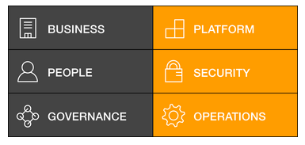

This content is part of [Amazon Web Services (AWS) Prescriptive Guidance](https://docs.aws.amazon.com/prescriptive-guidance/latest/mrp-solution/overview.html), which provides time-tested strategies, guides, and patterns to help accelerate your cloud adoption

### **6​ Strategies for Migrating Applications to the Cloud (6 R’s)**

[This post](https://aws.amazon.com/blogs/enterprise-strategy/6-strategies-for-migrating-applications-to-the-cloud/) outlines 6 different migration strategies we see customers implement to migrate applications to the cloud. Using this knowledge, you can begin to outline a plan on how you’ll approach migrating each of the applications in your portfolio, and in what order.

### **6 Application Migration Strategies: “The 6 R’s”**

#### Rehost

#### Replatform

#### Repurchase

#### Refactor

#### Retire

#### Retain

You should gain a thorough understanding of which migration strategy will be best suited for certain portions of your portfolio.

It is also important to consider that, while one of these six strategies may be best for migrating certain applications, another strategy might work better for moving different applications in the same portfolio.

Evaluate the needs of the specific applications, then find the approach or combination of approaches that will work best for each use case.

**1 ) Rehost - Otherwise known as “lift-and-shift.”**

Rehost commonly referred to as lift and shift, is a direct migration where you're trying to pick up

and move your applications or environments directly into the cloud, while trying to make as few changes as possible.

This is also known as forklifting. While trying to migrate, it is common to want to optimize as soon as possible, but you may also find that applications are easier to re-architect once they are already running in the cloud. This happens partly because your organization will have developed better skills to do so, and partly because the hard part migrating the application data and traffic, has already been accomplished.

With rehosting, your goal is often just to try and get to the cloud as quickly as possible, while maintaining the stability functionality and security of your existing system.

**2) Re-Platform - I sometimes call this “lift-tinker-and-shift.”**

Where rehosting was all about getting to the cloud quickly, replatforming is about gaining some optimization while migrating.

So instead of a lift and shift restriction, we're looking more at lift, tinker, and shift.

Overall, this wouldn't look too different. You're still trying to maintain the stability and functionality, but you may also want to find some ways that will immediately make things easier in the long run.

Maybe not major changes, like going from a monolithic server environment to a service oriented architecture, but something simple to handle.

Take for example, your database. Databases vary in complexity and overhead to run, and this doesn't change when you move from running a DB server in your local environment to a DB engine running on an Amazon EC2 instance.

What if you had a database that didn't require a lot of heavy customization?

You're essentially just running it on a server containing a mildly optimized engine and your data. In this case, why not run the database in Amazon Relational Database Service, or RDS?

This would not only enable you to maintain your database functionality, but you would also eliminate some of the management tasks while gaining features like high availability and automated maintenance actions.

Times like this, when you're moving to a similar system, that provides some additional benefits, can really help to optimize without a full re-architecting of your applications.

**3) Repurchase -   Moving to a different product.**

In the repurchase strategy, you're making the decision to move to a different product or licensing model.

An example of this strategy could be to use the migration as an opportunity to upgrade to a newer version of a product, or maybe to move from a commercial license to an enterprise license, or vice versa.

The important distinction is that you aren't fundamentally changing the design of the application or system.

I most commonly see repurchasing as a move to a SaaS platform. Moving a CRM to Salesforce.com, an HR system to Workday, a CMS to Drupal, and so on

**4) Refactor / Re-architect -  Re-imagining how the application is architected and developed, typically using cloud-native features.**

For the refactor or re-architect strategy, you're typically driven by a strong business need to add features, scale, or performance that would be difficult to achieve in the existing environment.

Even though this strategy can sometimes be the most expensive when calculating hours spent,

it can often yield the best results, since it allows for taking full advantage of the benefits that the cloud offers.

If you're working in an environment with a lot of legacy applications or systems that have been around seemingly forever,

Are you looking to migrate from a monolithic architecture to a service-oriented (or server-less) architecture to boost agility or improve business continuity (I’ve heard stories of mainframe fan belts being ordered on ebay)? This pattern tends to be the most expensive, but, if you have a good product-market fit, it can also be the most beneficial.

**5) Retire -  Get rid of it.**

The retire strategy can be implemented to help clean up and reduce the assets to be migrated.

By removing the applications no longer in use, it allows you to direct your attention towards migrating and maintaining the resources that matter.

Once you’ve discovered everything in your environment, you might ask each functional area who owns each application. We’ve found that as much as 10% (I’ve seen 20%) of an enterprise IT portfolio is no longer useful, and can simply be turned off. These savings can boost the business case, direct your team’s scarce attention to the things that people use, and lessen the surface area you have to secure.

**6) Retain -  Usually this means “revisit” or do nothing (for now).**

Maybe you’re still riding out some depreciation, aren’t ready to prioritize an application that was recently upgraded, or are otherwise not inclined to migrate some applications. You should only migrate what makes sense for the business; and, as the gravity of your portfolio changes from on-premises to the cloud, you’ll probably have fewer reasons to retain.

The final strategy is to retain things as is. This decision can be made for a variety of reasons.

Sometimes there are applications that you are just not ready to migrate. Or, in some cases, the business feels more comfortable keeping them on premises. If you've recently just gone through an application re architecture or upgrade process, you might not be ready to prioritize making even more changes.

As you make your way through your IT portfolio, each system and application should receive consideration in how it's migration is going to be handled. There is no one-size-fits-all approach to migrations, so taking the time upfront to plan will lead to the least headaches and most success.

### **How to Migrate**

The [four-phase migration process](https://aws.amazon.com/cloud-migration/how-to-migrate/) is designed to help your organization approach a migration of tens, hundreds, or thousands of applications. While each phase is a common component of a successful migration, they are not discrete phases, but an iterative process.

## **Rehosting and Re-platforming**

### **Scaling Consideration**

One of the major motivations and benefits to migrating to the cloud is the **scalability.**

Depending on your application, there are all sorts of things that may change how you're scaling. Some of the things we're going to look at today :

* scaling constraints
* session data management
* major scaling methodologies

**1) Constraints**

This is important to cover because not everything can scale in the same way. If you have a,

* limited number of licenses,
* getting more requires a lot of time
* Approval or just a lot of processes to work through,

dynamically scaling can be very difficult.

Or perhaps your application just can't support the downtime it would take to change the underlying architecture so that it can handle more of a workload. In these cases, architecting in such a way so that you don't have to dynamically scale would be the way to go.

Scaling Strategies ( just some of the ways you can work around these constraints)

* Managed cache and queues ( help to not lose requests when scaling is limited )
* Offloading unnecessary work from unscalable servers
* Stale data was life-cycled off of the server to conserve storage and not over-provision and overspend. ( working with a caching server, and increasing its resources is going to be difficult, perhaps it would be easier if stale data was life-cycled off the server to conserve storage )

**2) Session Data Management**

If your application has session data that you're trying to maintain but also need to scale to adjust the changes in demand, the easiest thing to do is just store your session data off the instance.

Using off-server session storage can really help provide scaling in what could otherwise be a very constrained environment. Using data stores like caches can really help to maintain functionality while not limiting your scaling capabilities.

**3) Major Scaling Methodologies**

There are two different types of scaling,

**horizontal and vertical scaling**

**1 - Horizontal scaling ( scaling out)**

***Horizontal scaling or scaling out is when we add more resources and distribute across them.***

The benefit of this is:

* it incurs no downtime for your original resource.
* As the load continues to grow, we can continue to add more and more resources, and spread the load across them.
* Once your load subsides and we need less resources, we can scale back in to the original number.
* This is done with little to no impact to your end user.

**2 - Vertical scaling**

.

***With vertical scaling, you maintain the same logical resource but you're making that resource more capable.***

Adding things like memory, storage, or compute power so that that resource can handle more of a workload.

With this type of scaling, you don't have to distribute requests across multiple, because you do still have that one same logical resource.

But there are some limitations:

* there typically is some downtime when you are vertically scaling.
* while you're scaling, you typically scale up but I guess you don't scale back down.

### **High Availability**

**High availability is building in such a way that allows for increased uptime, or availability.**

Designing for the highest levels of availability is always a good practice, and moving into a cloud environment like AWS makes this easier than trying to achieve the same levels of availability in a traditional environment.

**Something to consider when trying to add higher levels of availability:**

From there, you'll just want to keep some things in mind as you move towards building and optimizing your migrated environments in AWS.

A primary tenet here is to avoid single points of failure. If the failure of any single component or node would cause a negative impact to the system as a whole, look for ways to minimize the impact. In some cases, this could mean running more than one instance of a component, and in other situations, it could mean having a replacement that can easily be launched should the primary fail.

* Another way to help build towards higher availability is to utilize ways to distribute traffic and requests across multiple endpoints or nodes.

Using load balancers is a major way this can be accomplished. Also, you'll want to have some scalability.

In AWS, simply by using managed services, you achieve, or can enable, some fault tolerance just by how the services themselves scale. These services can provide a much easier path to high availability than if you were trying to just build it out manually.

Other services enable individual resources to become scalable by either providing horizontal or vertical scaling.

* Monitor your environments.

Monitoring can help you identify expected trends, trigger actions for anything outside of normal behavior,and help you to automate recovery of anything that might fail within your environment.

This is incredibly important and cannot be stressed enough.

AWS has several services for both the monitoring and logging, any actions you might want to take, and events you may want to be notified of.

### **Considerations with Migrating DB vs Applications**

There is no single migration method for everything. Depending on the type of application or component, the specific method used for its migration is very important.

While we are not going to get into specific migration details here,

* decoupling the migration of your databases and datastores from your other applications and components.

you're dealing with the incredibly important resource of data. The data needs to be secure, reliable, and have varying levels of accessibility.

When migrating applications, much of the time and energy goes into ensuring consistent or maybe even improved performance.

Planning and preparation is put into being ready when the switch finally happens and there is rarely any middle phase to worry about between environments. With your data, because this is often one of the most crucial components of your application's environment, there may still be access requirements before, during, and after the migration.

This is one of the reasons that database and datastore migration is so important to consider and plan when handling the migration.

Though we won't discuss the actual migration just yet, what I want to cover are some of the important planning and analysis steps.

questions about your database will be well-known before your migration is even a discussion.

Things like the size, schema, types of tables and engine specific limitations are usually topics

that are regularly discussed and reviewed.

If you haven't done any other database updates or moves in a while, you'll likely need additional research when looking for information about access patterns and frequencies, connectivity methods, security, object sizes, and more. The questions continue to grow when you start considering any changes to the schema, infrastructure, or engine that might occur as part of the migration.

This may seem like a lot but understanding these things will greatly help when handling the migration and can save you a lot of time and headache down the line.

**Requirements:**

The requirements of your database for normal operation while migrating and in your new environment will all need to be analyzed.

* Platform review and consideration.
* key parameters of your new environment.
* Can your app afford downtime? If yes how long?
* Data migration-now or later?

These are just some of the questions that come to the surface when you start looking into the requirements.

* Part of this planning is also to understand your network.

This is very straightforward. You will need to know the limitations of your network, how much of your bandwidth is available for you to use, how much of your network utilization can your database handle in both your source and destination locations.

In some circumstances, this can be adjusted temporarily in order to facilitate a faster migration, but in other cases, you may have to figure out a way to work with what's already in place.

Keep in mind that during the migration, you may be placing additional load on the database. How much of an additional load and for how long is going to depend on the migration methods.

* Team and personal considerations

Another area to look into is planning your talent. Someone needs to know the source and destination database engines which can be multiple people if any changes are being made. Somebody needs to know about servers, ports, and firewall rules, and how to handle the network requirements from a practical operations perspective as opposed to just theoretical.

In many cases, this is too much for a single person to handle. So planning and gathering who is going to be involved becomes very important.

* Develop meaningful timeline

The last item I want to cover for now is planning your time. Database migration projects often include refactoring of the application and database code, and also the schema.

All of this is a time-consuming and iterative process. The refactoring process alone can take anywhere from a few weeks to several months depending on the complexity of your application and database.

If you have hard dates, be realistic about what you can achieve. Remember that even in the best of circumstances, migration might be slower than anticipated.

These are just some of the areas for you to focus on when looking at how database migration differs from direct application migration.

### **AWS Server Migration Services**

**AWS Server Migration Service or SMS for short is a tool available in AWS specifically meant to enable an easier transfer of your virtual resources directly into your AWS cloud environment.**

SMS is an agentless service, which makes it easier and faster for you to migrate up to thousands of on-premise workloads to AWS. The service allows you to automate, schedule and track incremental replications of live server volumes and makes it easier for you to coordinate small and large scale server migrations.

**AWS Server Migration Service requirements:**

* The service is currently only available for VMware vSphere, Microsoft Hyper-V, and Azure virtual machines.

Keep an eye out for any updates to the supported source environments by checking the AWS Server Migration Service documentation.

* SMS replicates your server VMs as cloud-hosted Amazon Machine Images.

This does not move VMs into functions or any other area of AWS but it does allow for you to launch your server VMs as Amazon EC2 instances.

* To use SMS to help you transfer server VMs from your origin environment into AWS, you must use a connector.

The server migration connector is a free BSDVM that you install in your on-premise virtualization environment.

The connector aids in the creation of appropriate permissions and network connections that allow SMS to execute tasks in your virtualized environments.

Once setup has been completed, you are able to migrate up to 50 concurrent VM migrations per account.

The SMS Service talks with the server migration connector in order to ease the task of migrating

from the supported platforms.

Testing is also simple to automate because the migrations create EC2 AMIs which can easily be launched and tested for verification of successful migrations.

Monitoring of your migrations is made possible by Amazon CloudWatch and logging and auditing can be done through AWS CloudTrail.

These are great to help with providing continuous visibility in your migrations and enabling you to setup events and alarms based on the log entry and metrics that you see, which then help you to automate actions based on the behavior you're seeing during your migrations.

### **VM Import and VM on AWS ( Server Migration Service)**

Planning for a migration also involved renting a moving van, or contracting a moving company.

There was the time spent unplugging all the cabling.

Pulling servers from racks.

Packing them up in boxes.

Loading up trucks.

Driving to new location.

Unloading boxes.

Putting servers into their new homes.

And honestly my favorite part, re-cabling everything .

Then came everyones favorite part, turning it all on and

hoping everything worked.

Which rarely happened.

Then the world started going virtual.

We had fewer physical servers to manage.

But a move or migration still looked

an awful lot like before.

After all, those virtual machines had to live on a

physical server somewhere.

At AWS, we like to say that we help remove the

undifferentiated heavy lifting,

allowing you to focus on what matters to your business.

Well in the case of migrations,

that can literally mean heavy lifting.

Have you ever tried to move a loaded

storage area network appliance?

Hard drives weigh alot.

Moving your VM's to the cloud,

will likely require lifting nothing more than a

keyboard and mouse or maybe your laptop.

We have several services that can assist with the

virtual heavy lifting like

VM import/export, and AWS server migration service.

VM import/export enables you to

easily import

virtual machine images from your existing

environment to AWS,

as Amazon EC2 instances or Amazon Machine Images, AMIs.

This enables you to migrate applications and work loads

to Amazon EC2, copy your VM image catalog to EC2,

or create a repository of VM images

for backup and disastor recovery.

Once your applications and work loads have been imported.

You can run multiple instances from the same image.

And you can create snapshots to backup your data.

For most VM import needs we recommend that you use

the AWS Server Migration Service,

since it automates the import process.

The AWS server migration service or SMS.

Automates the migration of your on premisis,

VMware vsphere, Microsoft Hyper-V

and Azure virtual machines to the AWS cloud.

Leveraging SMS to Manager server migration can add

several benefits.

It can simplify the process overall.

Requiring just a few clicks in the AWS management console

once everything is set up.

With VM import/export and AWS server migration service

at your side.

The migration of your virtual machines to AWS

couldn't be easier.

## **AWS Migration Hub**

### **Introduce AWS Migration Hub**

one important area to bring up is the need to monitor your migrations.

Migrating is not just something you can set and then forget. You need a way to identify what is happening, how well it's going, if everything is running as expected, and various other areas.

This can all be especially difficult if you are using multiple tools across multiple AWS and partner solutions.

**AWS has a service called AWS Migration Hub. Using Migration Hub allows you to choose the AWS and partner migration tools that best fit your needs while providing visibility into the status of migrations across your portfolio of applications.**

This also provides the ability to see metrics and progress for individual applications,

regardless of the tools being used.

This allows you to quickly get progress from updates across all of your migrations, easily identify and troubleshoot any issues, and reduce the overall time and effort spent on your migration projects while providing a single place to monitor migrations in anyAWS region where your migration tools are available.

In order to view your assets in Migration Hub, you perform discovery using an AWS discovery tool or by migrating with an integrated migration tool.

Once you've performed discovery or started migrating, you can explore your environment from within Migration Hub. When the migration completes, Migration Hub also shows details about the resources that have been created by the migration.

For servers migrated by AWS Server Migration Service, CloudEndure Migration, and other migration services and partners, Migration Hub provides links to the AMIs created or running Amazon EC2 Instances.

For databases migrated by AWS Database Migration Service, Migration Hub provides the target endpoint ID which can be used as a search filter on the Database Migration Service Management Console.

So while Migration Hub does not automate the steps of the migration, it does provide a single place for you to track the progress of the applications you are migrating.

### **AWS Application Discovery Service**

In phase two of preparing for your migration, the focus is on discovery and planning.

The AWS Application Discovery Service helps you to plan your migration to the AWS cloud

by collecting usage and configuration data about your on-premises servers.

Application Discovery Service offers two ways of performing discovery and collecting data

about your on-premises servers;

* agentless
* Agent-based

**Agentless discovery**

works with VMware vCenter, and can be performed by deploying the AWS Agentless Discovery Virtual Appliance.

After the discovery connector is configured it identifies virtual machines and hosts associated with vCenter.

The discovery connector collects configuration information about your servers, like server host names, IP addresses, Mac addresses, and disc resource allocations.

The discovery connector also collects metrics about the VMs. These data points can be extremely useful in your migration planning activities, especially if you are using the replatform approach.

It can inform decisions like what type and size of EC2 instance to use. Knowing both the average and peak utilization metrics for things like CPU, RAM, and disk I/O, you can make a more informed decision about how to design your environment in AWS.

It's important to note, however, discovery connectors cannot look inside each of the VMs, so it cannot figure out what processes are running on each VM, or what network connections exist.

*If you need insights into that type of information, then using an agent-based approach will be required.*

**Agent-based discovery**

can be performed by deploying the AWS Application Discovery Agent on each of your VMs and physical servers.

The agent will then collect static configuration data, similar to the discovery connector. In addition to those static config details, the agent will record detailed time series systems performance information, inbound and outbound network connections, and processes that are running.

You can export this data to perform an analysis and to identify network connections between servers for grouping servers as applications.

The Application Discovery Service is integrated with our AWS Migration Hub, which helps to create a single pane of glass view into migration progress.

After the service has performed its discovery, you will be able to view the discovered servers, group them into applications, and then use the Migration Hub to track the migration status of each application.

All of the data that is collected by the Application Discovery Service can be exported for analysis using tools like Amazon Athena and Amazon QuickSight.

Overall, the AWS Application Discovery Service helps you to obtain a snapshot of your current state of your data center servers, and the data collected helps to create a cost-optimized migration plan based on your unique business requirements.

### **Introduction All Labs**

here to give you folks a quick introduction into what you're gonna be doing in your labs.

Now I have four of these for you.

So, let me give you the scenario so you can play along.

We're gonna say that you work for a small fashion magazine

in New York, who happens

to use a very popular blogging engine called Ghost

for their main website.

Now as it's a relatively small company, you're only

one of two techs

and you've been volunteered by your boss

to help them migrate the website from on prem

to the AWS Cloud.

Sounds like fun, huh?

Well your boss says he's happy to manage the domain name

and can point it to the new migrated Cloud version

once you're done.

And luckily for you he has also volunteered

the other tech to set up the network infrastructure

in the Cloud,

meaning you can just focus on migrating the app itself

along with this database.

So at this stage, you're not that familiar

with what they even have on prem.

All you know is what the other tech told you

via instant chat earlier today.

He told you there are two boxes.

One is an app server running Ghost

and the other is a database server running MySQL,

and he thinks they're both running Ubuntu.

Real helpful, right?

Gotta love all that detail.

So, you're going to roll up your sleeves

and decide you're gonna break down this migration

into a few steps.

Naturally, you're gonna be doin' a dry run here

and just experimenting, not actually switching over

from the live site.

Once you know your best plan of action

however, through experimenting,

then you can do the real migration.

So here's your current line of thinking.

Number one, find out

what you're dealing with technically, on prem.

Number two, while keeping the existing site live,

use a tried and true method for making a copy

of your data, and using it to see the new resources

in the Cloud.

Number three, you'll do it again.

I.e. run another experiment.

This time, trying a different method to see if one way

is maybe better than another.

Finally, four, you're gonna research and experiment

with AWS tools and services that you think can assist you

in migrating your app.

And you figure by going through this journey,

you'll come out the other side

with a really solid perspective on what needs to be done

and can help your boss migrate in the best way possible.

Sound like a plan?

So your first goal, lab one,

will be to poke around the existing on prem network

and discover exactly what you're gonna be working with.

Now as this is just a lab,

we obviously don't have an on prem system for you

to migrate from, nor a real domain name.

What we have done is set up a system in an AWS region,

specifically US-West two, and we can pretend

that this is your on prem network.

We've also set a network up in another AWS region,

US-East one, which will act

as the eventual Cloud target network.

And luckily, your work colleague has already set

that up for you.

This means all you have to focus on

is experimenting with app and database migration.

Get the idea?

Okay, so now we know the scenario

and I've given you the 30,000 foot view of the labs,

join me in the next video

where I'll briefly cover what you'll be doing in lab one.

Okay, see you all soon.

#### **Lab 1 Introduction**

[Rick] So I mentioned it in my previous video.

The purpose of this lab is to discover what you're about to migrate.

As a reminder, your on-prem is actually an AWS region, us-west-2.

And at this stage, you know very little

about the application.

You only know that you have two servers running up on two:

one for the ghost app, and one for MySQL.

Your work colleague was pretty light on the detail there.

But you know, that's okay,

because you're gonna find out everything

you need to know, during this lab.

This is what we call the discovery process.

You can almost think of yourselves

as detectives poking around the system to get the facts.

So what are you gonna need to do first?

Well, I'll have you log in to both machines

and install a discovery agent on each one,

and that way you can start collecting some facts, or data.

Then I'll have you poke around the servers for a bit

and find out what each app is actually doing

how the machines are set up to talk to each other,

that kind of thing.

And I'll get you making notes of any configuration settings.

You'll then look at all that information,

and aggregate all your findings

to help you understand what and how to migrate.

You will be trying various migration options

in later labs.

But for now, I just want you focused

on getting an agent on those machines,

and have you poke around there, playing detective.

Don't worry, you're not going to need to do any coding.

These labs are mostly press this,

read that, type this, et cetera.

It should be pretty easy for you

to get through most of the steps.

I just want you to pay close attention

to all the lab instructions,

and if you get stuck or something just isn't working,

head over to the forums and seek help

from either us, or your peers.

Okay, I'm outta here.

Good luck.

And I'll see you soon.

**Security, Volume and data consideration**

#### **Multi-environment Security and Communications**

- [Seph] While this isn't a security specific course,

security should always be considered.

Whether you're building a multi-tiered

globally accessed application

or you're discussing migration

of your environments like we are here,

security needs to always have a place in the conversation.

With the migration discussion,

our talking points aren't different

from many of the topics that would normally be covered.

Our focus is will likely be things you've heard before

as we'll be talking about protecting your data in transit,

protecting your data at rest,

and protecting access to your data for use.

And while these may not be new topics,

it is important to understand them in the context

of a multi-environment communication.

When securing data in transit,

our goal is to make sure we can communicate easily

between environments while protecting the data.

This is where you try to reduce the risk

of unauthorized exposure

by defining and enforcing requirements

and implementing controls.

You definitely want to make sure you have

defined data protection in transit requirements

and encryption standards based on data classification

to meet your organizational, legal,

and compliance requirements.

Also enforce your defined encryption standards

to ensure that meeting these requirements is not optional.

Additionally, ensuring that there are tools

and controls in place to help you with enforcement

of your standards will go a long way

towards helping you stay secure in transit.

The first and one of the easiest things you can do

is just to use authenticated

network communication protocols.

Using IPsec tunnels and transport layer security or TLS

to encrypt in transit will go a long way

to reduce the risk of data tampering or loss.

Additionally, setting up automated tools

to help identify when other issues or risk become apparent

can also be very helpful.

Using a tool or detection mechanism

to automatically detect attempts

to move data outside of defined environment boundaries

can be very helpful in identifying any threats

to your security and help prevent data exposure.

With data at rest,

encryption is really the biggest point here.

You will really want to make sure you have established

and enforced encryption methods in place

for everywhere data is held in your environment.

In addition to this, your key management solutions

will play a big part in your encryption for your data.

Depending on the services within AWS

and your current environments resources that you're using,

there are several options that you can look into

for helping you to maintain data security at rest.

For instance, many of the data store services with AWS

have options that are simple to implement

where you essentially turn on encryption for that service.

For your current environment,

if you are not already using

an encryption key management solution,

it will be important to evaluate

and find a solution as soon as possible.

And I know it can reduce the level of desired performance

depending on the resources or AWS services you're using

when you start to implement encryption mechanisms

but that is why it's important

to have these conversations early on

so that any additional performance overhead

encountered by your security measures

can be considered for your migration expectations.

When it comes to securing your data use while migrating,

we're focusing on general data access and permissions.

As with other areas of access control and permissions

that we usually talk about with AWS,

using a least-privilege access model

is going to be a great mindset to keep.

Users and applications should only have access

to the specific data they need

should be given access for only when they need it

and should only be able to access

how you want them to access it.

Depending on the datastore options

you have available to you,

the level of granularity you're able to provide

in terms of what each user can access will vary.

It's just important to take the extra work

to make sure that no one has access to more than they should

or at least that they only have access

to the appropriately classified data.

For limiting when they should have access,

using AWS services and automated mechanisms

that allow you to limit time users have to access data

will become very helpful.

Sometimes, this can be done in a policy.

Other times, you need to look at automation jobs or workers

they can open and close connectivity methods

to ensure that data is only accessed when necessary.

And for limiting how you want users to access,

that's when we go back to enforcement of the methods

that you established when looking

at protecting your data in transit.

Making sure only secured connections and protocols are used

helps to avoid the accidents that can occur

when those become optional instead of required.

Well, that's all that I have for you

in terms of multi-environment security.

I know this was all very broad and theoretical

but a lot of the specifics will depend on what resources,

tools, and services you have available to you

and what features they provide in terms of security.

Make sure you check the course notes

for links to provide additional information

around securing your environments

and keep thinking about how those concepts

can be implemented in your multi-environment setup

as you're migrating.

I'll see you later.

#### **Data Considerations When Migrating**

[Sean] The tools for migrating data to the AWS Cloud

are either unmanaged or AWS-managed.

This illustration displays some options

for data migration,

depending on the volume of data

and the velocity of migration.

Unmanaged migration tools are the easy,

one-and-done methods to move data

at small scales from your site

into Amazon cloud storage.

These include options like rsync

or the Amazon S3 and Amazon S3 Glacier

command line interfaces.

AWS-managed migration tools help you

manage the data migration tasks more efficiently

and can be further classified into two broad categories:

tools that optimize or replace the internet,

like direct connect,

and tools that provide a friendly interface to Amazon S3.

If you have large archives of data or data lakes

or in a situation where bandwidth

and data volumes are simply too large,

you might want to lift and shift the data

from its current location straight into AWS.

You can do this either by using

dedicated network connections

to accelerate network transfers

or by physically transferring the data using AWS Snowball.

If your data stores can gradually migrate over time

or when new data is coming from many non-cloud sources,

consider methods that provide a friendly interface

to Amazon S3.

These migration services can leverage

or complement existing installations,

like backup and recovery software or a SAN.

Several AWS technology partners

and third-party solution providers

also offer tools for migrating data to AWS.

For a list of vendors who partner with AWS

to provide data migration solutions,

check out the course notes.

#### **Lab 2 Introduction - Backing up to Amazon S3**

Welcome back to this axis.

I trust after the last discovery lab,

you have a really good picture

of what you'll be migrating.

Let's recap, what we know so far?

Well, we have an EC2 running

a ghost app using an EBS drive,

a MySQL database running on

the other EC2 again with an EBS drive,

and we have our data from

the agents installed on the Machines.

We also have some idea about

the configuration settings that we

used for the ghost app, and MySQL.

Now, armed with all this information,

the question now is,

how to move it from one place to another?

How do you get a copy of your on-prem database,

in US West 2 over to the Cloud in US East 1,

and how do you get the static consent from

your ghost app over that too?

Well, you have options.

But what are you going to suggest to your boss?

You know your fashion magazine website

can take some downtime,

but you have to minimize that,

and you think it probably makes sense to provide options

rather than present a one-size fits all solution.

So as you want to try different methods of migration,

if you think you start off with the most obvious one,

a simple SQL dump,

and restore along with the EBS snapshot for the updater.

Here the steps I'll have you take: Number 1,

you'll use a MySQL dump to make a copy of

your on-prem database data, and pop in S3,

number 2, you'll take an EBS snapshot of your ghost

static content which can again be stored in S3, 3,

you'll create a ghost app server in US East 1,

and seed a new EBS drive with that snapshot,

and 4, you'll create

a MySQL database and seed it using a restore,

and that's about it for this lab.

Best of luck, and hopefully

by the time you're done with this lab,

you'll have a working version of

your on-prem fashion website running in the Cloud.

## **Week 2 Readings/Resources**

In Week 2 we continued our conversation on preparation through planning and analysis. Our goal here is to continue to stress how important the preparation phases of a migration are before taking any major actions. Additionally, getting a clear picture of your application portfolio becomes a bigger part of the conversation because you need to better know how each component, function, and resource is going to migrate, and how they will work together in the new environment.

### **E​lastic Beanstalk**

With Elastic Beanstalk, you can quickly deploy and manage applications in the AWS Cloud without having to learn about the infrastructure that runs those applications. Elastic Beanstalk reduces management complexity without restricting choice or control. This can be a useful tool for you to utilize when testing functionality of your applications in AWS. Checkout these Elastic Beanstalk [tutorials](https://docs.aws.amazon.com/elasticbeanstalk/latest/dg/tutorials.html) and [concepts](https://docs.aws.amazon.com/elasticbeanstalk/latest/dg/concepts.html) for more info.

### **T​he Security Pillar**

It is important, while evaluating your portfolio, to evaluate the ability to protect your information, systems, and assets. Security should be a major part of the planning, and should be considered from early in the process all the way through to operational phases of your migrations. Here's more info about the [Security pillar](https://wa.aws.amazon.com/wat.pillar.security.en.html). You can also checkout the following articles to learn about how to protect your data [in transit](https://wa.aws.amazon.com/wat.question.SEC_10.en.html) and [at rest](https://wa.aws.amazon.com/wat.question.SEC_9.en.html).

### **A​WS Migration HUB**

[AWS Migration Hub](https://aws.amazon.com/migration-hub/faqs/) provides a rich web experience that helps you understand your existing IT assets as well as view and track progress of application migrations. It lets you collect and view data about on-premises resources, group those resources into applications, and track the progress of those applications as you migrate to AWS.

### **W​hat Do You Need to Know Before Your Start?**

Database migration is a complex, multiphase process, which usually includes assessment, database schema conversion script conversion, data migration, functional testing, performance tuning, and many other steps. Read this blog for more info: [Database Migration - What Do You Need to Know Before You Start?](https://aws.amazon.com/blogs/database/database-migration-what-do-you-need-to-know-before-you-start/)

### **Migration Delivery Partners**

[Migration Delivery Partners](https://aws.amazon.com/migration/partner-solutions/) help customers through every stage of migration, accelerating results by providing personnel, tools, and education in the form of professional services. These partners either are, or have a relationship with, an AWS audited Managed Service Provider to help you with ongoing support of AWS workloads.

#### **Storage discussion**

#### **Amazon EFS, Amazon EBS, & Amazon S3**

- [Seph] When moving from an environment

where you have limited storage solutions,

it's nice to know that you have flexibility

to find the best solutions

to use when concerning your storage choices in AWS.

For this session we'll quickly review

three of the most commonly used storage solutions

available for you.

Starting with the most commonly used

and default block storage mechanism in AWS,

Amazon Elastic Block Store or EBS.

This provides block level storage volumes for use

specifically with EC2 instances.

EBS volumes behave like raw, unformatted block devices

that you can mount as devices to your instances.

And while you can mount multiple volumes

on the same instance,

each volume can only be attached to one instance at a time.

You can create a file system on top of these volumes

or use them in any way you would use a block device

such as a hard drive.

Additionally you can dynamically change the configuration

of a volume attached to an instance.

Within EBS there are several configurations open to you

and the volume types that you can choose

include both SSD and traditional HDD options.

The general purpose volume is the most common type

and the default volume used by Amazon EC2.

General purpose SSD volumes

provide strong levels of performance

for a wide variety of workloads.

The provision IOPS SSD or PIOPS volumes

offer you some of the highest performance SSD volumes

for mission critical low latency

or high throughput workloads.

You also have the ability to adjust

the level of performance you may require.

These are best utilized when you need consistent

and high levels of performance.

For our HDD volumes

we have another two options for you to consider.

For the throughput optimized volumes,

these are for frequently accessed

throughput intensive workloads.

While it's not the fastest type of storage in EBS,

it is a great balance of cost and functionality.

The other type of HDD EBS volume is the cold HDD volume.

These are going to be best suited for scenarios

where the lowest cost block storage is of utmost importance.

The major difference between throughput optimized

and cold HDD is unsurprisingly enough, the throughput.

Both are designed to be cost effective options.

If you're planning a higher throughput need,

but still with lower overall IO per volume,

then the throughput optimized would be the way to go.

If on the other hand you need a higher IO on the volumes,

the SSD options are still going to be better choices.

So that's about EBS.

But the title of this video also mentions

that we'll be talking about Amazon Elastic File System.

So where is it?

Well lucky for you that's my next topic on this video.

Elastic File System, also known as EFS

allows you to create a file system,

mount the file system on EC2 instances

and then read and write data to and from your file system.

And while that may sound strikingly familiar

to what we just covered, it does.

There are some major differences though.

First off EFS can be mounted

to multiple EC2 instance at the same time.

This enables you to have a shared file system

for multiple servers.

Secondly EFS is just that, a shared file system.

EFS is a file storage system that uses NSFv4

and currently supports versions 4.0 and 4.1,

though we do recommend that you use the most recent version.

EFS does provide another difference that you can utilize

and this becomes incredibly important

while running multi environment workloads

like when migrating.

That other difference is that your AWS housed EFS

can be mounted to by on premise servers.

So now that we've looked at EBS and EFS,

let's take a look at our last topic for this section,

Amazon Simple Storage Service, also known S3.

S3 is an object storage system that was intentionally built

with a minimal feature set

that focuses on simplicity and robustness.

To use S3, all you do is create a bucket

which is a container for your objects

and then start loading in the objects.

The objects are fundamental entities stored in S3

which consist of the object data and metadata.

While the objects' data is opaque to S3,

the metadata is a set of name-value pairs

that describe the object.

In S3 once you've created the bucket,

you can work with objects either through API

or directly through the console.

Though S3 is a natively internet based service,

meaning that access is provided

through internet accessible endpoints,

it does not mean that there's any loss or compromise

on how secure your data is.

Through access control lists, bucket policies,

encryption options and additional security features,

you have full and granular control

on how you grant access to objects in your buckets.

In terms of migration, S3 is unique in that it can be used

not only to store objects for your applications

to utilize after migration,

but can also be a great location to store images,

backups, database dumps and other components

that are used while migrating.

So while you're planning out your migration,

be thinking about what the best storage option

for your various workloads might be.

Test and experiment with them

and find out what provides the most optimal performance

to meet your needs.

#### **Storage - AWS Snowball & AWS Snowmobile**

- [Sean] Migrating your workloads

doesn't just involve moving around virtual machines.

It likely also involves moving large amounts of data.

Sure, copying a couple gigabytes of data to the cloud

wouldn't take that long.

But what if you've got several hundred terabytes of data?

Even if you're lucky enough to have

a high-speed internet connection,

it will still take days, if not weeks, to upload.

Let's do some quick math.

Let's say you've got 80 terabytes of data

that needs to be moved,

and you've got a one gigabit connection to the internet.

The business has decided

that we're allowed to use the entirety of the connection

for the duration of our transfer.

So, how long are we looking at?

Well, a terabyte is about 1,000 gigabytes.

So, we've got 80,000 gigs to copy.

A one gigabit connection

is being measured in bits, not bytes.

So, we've got to divide by eight,

leaving us with 0.125 gigabytes per second of upload.

So, 80,000 divided by 0.125,

divided by 60 seconds in a minute,

divided by 60 minutes in an hour,

divided by 24 hours in a day.

It looks like we'll be done in just over a week.

Your business can go a week without internet, right?

Assuming a week of downtime

isn't going to fly with management,

we can look into other options

for migrating the data.

AWS Snowball is a physical device

that can be connected directly to your network

in the data center,

and leverage the local network to copy the data.

An AWS Snowball device can currently

hold up to 80 terabytes,

and is protected by AWS Key Management Service

to encrypt the data.

Using Snowball, you can import and export data

between your on-premises data storage locations,

and Amazon S3.

The Snowball is its own shipping container,

and its E-ink display changes

to show your shipping label

when Snowball's ready to ship.

But what if you have a lot of data to move?

Not gigabytes or terabytes, or even petabytes,

but exabytes of data?

Well, we've got a moving truck for that.

Literally, a semi truck.

Well, technically it's the shipping container

on the back of the truck,

but it's called AWS Snowmobile.

And this storage on wheels service

holds up to 100 petabytes of data.

Check out the notes on the video

for a link to the launch announcement,

and more information.

Moving data is the real bulk of the work

for a migration.

It's important to make sure

it's done efficiently, and securely.

Depending on how much data you need to move,

AWS Snowball could be the right choice.

#### **AWS Storage Gateway and AWS DataSync**

- [Seph] There are times when whether during a migration

or just wanting to have AWS cloud back storage

for your on-premises resources,

you need to be able to connect across environments.

AWS Storage Gateway utilizes a VM image

in your on-prem environment

that securely connects to the gateway endpoint within AWS.

This allows you to connect your local storage resources

to the AWS cloud and enables you to add availability,

fault tolerance, and scalability to your storage mechanisms.

For solutions, Storage Gateway offers file-based,

volume-based, and tape-based options.

File Gateway, the file-based solution

supports a file interface into Amazon Simple Storage Service

or S3 and it enables you to store and retrieve objects in S3

using industry-standard file protocols

such as Network File System, NFS,

and Server Message Block or SMB.

A Volume Gateway provides cloud back storage volumes

that you can mount as iSCSI devices

from your on-premises application servers.

With this volume-based solution,

you do have two configuration options.

There are cached volumes and stored volumes.

Cached volumes allows you

to store your data in S3 and retain a copy

of frequently accessed data subsets locally.

Stored volumes can be a solution

for when you need low-latency access to the entire dataset.

All of the data is stored locally

and snapshots can be made from the on-prem storage

and used to either recover local volumes

or create volumes inside of your AWS accounts.

Moving on, the last type of gateway

I want to mention is the Tape Gateway.

With a Tape Gateway,

you can durably archive backup data into AWS.

A Tape Gateway provides a virtual tape infrastructure

that scales seamlessly with your business needs

and eliminates the operational burden

of provisioning, scaling, and maintaining

a physical tape infrastructure.

Another tool that can assist

when you're working between environments

like when migrating or transitioning

to a hybrid environment is AWS DataSync.

DataSync is a data transfer service

that simplifies, automates, and accelerates

moving and replicating data

between on-prem storage systems and AWS storage services

over the internet or AWS Direct Connect.

Currently, DataSync supports transfers

between NFS to Amazon Elastic File System

or Amazon Simple Storage Service.

This may sound somewhat similar to Storage Gateway

but the major differences are that DataSync primarily

is utilized to transfer from an NFS source

and the destination can be the EFS.

Similar to Storage Gateway,

DataSync uses an agent which is a virtual machine

that is used to read or write data

from on-prem storage systems.

The agent is currently deployed on a VMware ESXi hypervisor

and you use DataSync Management Console or the API

to setup and activate your agent.

With these tools, hopefully you have some additional ideas

of how you can manage data transfer

and access across environments.

The course notes will have more on Storage Gateway,

DataSync, and their options.

I encourage you to take a look.

#### **Storage - AWS DMS Overview**

- [Seph] As we mentioned earlier in the course,

migrating your databases can be a very difficult task.

Outside of all of the planning and analysis, you have

to set up the necessary network connections,

find a time that works for adding the additional load

to your active DB, take a back up of all of the necessary

data in your database, and enable for updates

to the database to be replicated to the new environment,

and you have to do this without negatively affecting

your running application and ensuring the security

and integrity of the data.

When working with AWS, there is a service that,

while it won't completely remove the work needed

to migrate between database environments,

it will help to lighten the load.

AWS Database Migration Service, or DMS, is a tool

that makes it easier to migrate relational databases,

data warehouses, NoSQL databases,

and other types of data stores.

You can use it to migrate your data into the AWS cloud,

between on-premises, or between a combination of cloud

and on-premises setups.

Whether performing one-time migrations

or ongoing replications to keep environments in sync,

DMS can help you with the managing of the tasks.

Also, if you need to perform a schema change while migrating

there is an accompanying tool with DMS

called AWS Schema Conversion Tool which supports converting

your existing database schema from one database engine

to another.

To perform a migration, DMS connects to the source data

store, reads the source data, and formats the data

for consumption by the target data store where it can then

load the data into the target.

DMS also provides the ability to monitor the migration

so that you can keep an eye on everything happening.

We'll be going into more detail with DMS

and the Schema Conversion Tool later, but that should

provide you a good starting point until next time.

#### **Storage - AWS DMS Core Features**

- [Sean] So far, we've covered how to migrate

servers and data to the cloud.

Now I'd like to talk about database migrations.

It should come as no surprise

that AWS has a service aimed squarely

at helping you to perform this task.

It's called the AWS Database Migration Service or DMS.

You can use DMS to migrate your data

to and from most widely-used commercial

and open-sourced databases.

The service supports migrations

to and from the same database engine, like Oracle to Oracle,

and also migrations between different database platforms

such as Oracle to MySQL or MySQL to Amazon Aurora.

You can also use DMS to migrate your on-premises database

to a database running on Amazon EC2 instances.

DMS can be configured to perform an on-going replication

which can allow you to migrate databases with zero downtime.

AWS Database Migration Service

also provides a schema conversion tool,

which we'll cover more in-depth later,

to help convert stored procedures in Oracle and SQL Server

to equivalent code in the Amazon Aurora

MySQL dialect of SQL.

When a piece of code cannot automatically be converted

to the target language, DMS will clearly document

all locations that require manual input

from the application developer.

You can use AWS Database Migration Service

for both one-time data migration

into RDS and EC2-based databases

and also for continuous data replication.

DMS will capture changes on the source database

and apply them in a transactional

consistent way to the target.

Continuous replication can be done from your data center

to the databases in AWS or in the reverse,

replicating to a database in your data center

from a database in AWS.

Just a quick note, to use AWS DMS,

one endpoint must always be located in an AWS service.

Migration from an on-premises database

to another on-premises database is not supported.

We'll be taking a look at DMS in this week's lab.

#### **Storage Schema Conversion**

- [Sean] During the video on the Database Migration Service,

I mentioned a very powerful tool,

called the Schema Conversion Tool.

This tool allows you to take an existing database,

and convert its schema to a different engine.

I thought it would be helpful to show you a quick example

use case of the tool in action,

and show you the report it can generate.

For this example, I've set up an EC2 instance

running SQLServer.

This will also be the server that I run the tool

and do the demo from.

What we're looking at is that server.

We're going to pretend that

this is our on-premises SQLServer for the demo.

Since we're on the machine,

let's take a look at what we'll be converting.

I've loaded up a sample database,

called BikeStores.

We can take a look at the database,

and we see that there are multiple tables

that we'll need to convert.

If we do a quick query on one of the tables,

we can see that there are several columns

and rows of data that will need to be converted.

Looks like we have about 1400 customers

listed in the table.

Before we're able to start converting,

we'll need to set up our destination database.

Since we want to make full use of AWS,

I'll be converting to

an Amazon Aurora MySQL compatible database.

In the AWS management console,

we'll jump over to the Relational Database Service, RDS.

We'll click create database,

and since Aurora is the default option,

we just need to change a few items.

We'll name the database SCT-target,

and the rest can be left at defaults.

Now we can create the database.

We can see in the console

that our database is currently creating.

After a few minutes,

it will show as available and we can continue.

Now we'll move over to the Schema Conversion Tool,

which I've already installed.

We'll need to create a new migration project.

I'll leave the default name and location.

Under the engine type, we'll select SQLServer,

and after clicking next,

the tool will analyze the database

to find available schemas.

We'll select our BikeStores database,

click next, and the tool will begin to analyze the database.

Once the analysis is complete,

a summary report is generated,

which tells us how much of the data

that SCT will be able to convert.

We'll come back to this data in a few moments.

To configure our target,

we need some information

from our newly created database instance.

Specifically the endpoint address.

Which we'll enter in the server name field.

Once we fill in the rest of the fields,

we can test the connection.

Then proceed once successful.

After clicking finish,

we're shown the Schema Conversion Tool project page.

To get a nice assessment report,

we can go to the view,

assessment report view.

On this page we see that SCT will be able to convert

100% of our database objects.

I've also created a database, AdventureWorks,

that SCT has identified some issues with.

Let's take a look at the assessment report

to see what actions it recommends.

We can see under the action items tab,

that there are several issues listed.

If we drill down into one of the specific examples,

we can see the code that currently exists

in the SQL database,

and the tools recommendation to perform a manual conversion.

Depending on your database,

you may or may not run into conversion issues like this.

That's a quick look at the assessment capabilities

of the Schema Conversion Tool.

The tool can be used in conjunction with the

Database Migration Service to convert your database schemas,

and to migrate objects to a new target.

I've added links in the course notes for additional reading.

#### **Storage - Amazon Aurora (Serverless)**

- [Seph] While we're talking about data store options,

it's important to bring up Amazon Aurora.

Aurora is a MySQL and PostgreSQL compatible database

engine offering within Amazon Relational Database Service,

known as RDS.

Aurora is designed to provide multiple times

the throughput of traditionally available database engines,

but without having to make drastic changes

in how your applications access your data.

It is a fully managed and distributed system

that is able to meet the higher levels of performance

by utilizing an SSD-backed virtualized storage layer

specifically built for database workloads.

Additionally, Aurora's storage is fault tolerant

and self-healing.

Disc failures are repaired in the background

without loss of database availability.

Amazon Aurora Serverless, which is a configuration

that can be used for Aurora, is an auto-scaling

solution, where the database will automatically

start up, shut down, and scale capacity up or down

based on your applications needs.

It enables you to run your database without

the difficult task of database capacity management.

In the context of migration, especially when

you start looking for how you can optimize your applications

performance in the cloud, solutions like Aurora and

Aurora Serverless can be very helpful.

Aurora allows you to manage using the DB class sizes,

and reads can be scaled out by distributing requests

across the read replicas.

If the workload changes, the DB class size

and number of replicas can be adjusted

to meet the changes in demand.

While this is a functionality that exists,

it's best suited toward predictable workloads.

With Aurora Serverless, you can create a database endpoint

without specifying the DB instants class size.

Instead, you set the minimum and maximum capacity.

The database endpoint connects to a proxy fleet

that routes the workload to the fleet of resources

that are automatically scaled.

Database client applications don't need to change

to use the proxy fleet.

Aurora Serverless manages the connections automatically.

The reason that the scaling is so rapid

is because it uses a pool of "warm" resources

that are always ready to service requests.

I highly recommend that you look further into

Aurora and Aurora Serverless to see

if they possibly fit your optimization needs when migrating.

The course notes will guide you to the documentation

for these options, and I'll talk to you later.

**Networking**

#### **AWS Direct Connect & Amazon Route 53**

- [Sean] During a migration, there will come a time

when you need to connect your network to AWS.

Depending on your migration,

you might even be running in a hybrid scenario,

systems both on-premises and in AWS.

Beginning with the discovery phase,

we'll have a need for agents to report their findings

back to AWS.

During the migration,

we'll need to be able to transfer data,

like our virtual machines, storage volumes, and databases.

After the migration, we'll need to be able to

perform tasks like monitoring, ongoing replication,

and potentially additional data transfers.

AWS services are delivered over the internet.

For many actions and activities

we can simply use the AWS management console

or AWS service APIs,

which only require an internet connection to access.

Many administrative tasks can be accomplished

in the management console.

When we start getting into automation and tools,

which Seth will talk more about,

we begin to get away from the management console

and begin interacting with AWS APIs.

However, when we want to talk with our own resources

running inside of AWS, there are very few occasions

when we would want to make those connections

or perform those tasks over the open internet.

I wanted to quickly cover two options that we have

to securely make the connection

from your on-premises network

to your virtual private cloud and AWS services.

The first option is one that many people

will be familiar with, VPN over the internet.

There's several options for creating

and configuring a VPN connection.

And we're not going to dive into that in this course.

The important part for our migration

is to understand that this connection

establishes a secure tunnel or link

from your network to AWS.

With the right configuration,

the resources that you have running in AWS

can be seen as an extension of your on-premise network.

In this example, we're still using our internet connection

to talk with AWS, and our resources in AWS,

but the VPN tunnel allows for that communication

to happen securely.

If your migration or operational requirements

need dedicated bandwidth to talk to AWS,

or you have a requirement to not use

the open internet for communication,

there's AWS Direct Connect.

Direct Connect links your internal network

to a Direct Connect location over a standard one gigabit

or 10 gigabit ethernet fiber optic cable.

With this connection in place,

you can create virtual interfaces directly to the AWS cloud,

for example, to Amazon EC2 and Amazon S3, and to Amazon VPC,

bypassing the need for public internet in your network path.

You can also establish a VPN tunnel

over the Direct Connect link,

allowing for a secure tunnel of communication

from your on-premises resources to the resources in AWS.

These connection options can allow for AWS

to act as an extension of your network,

which enables smoother data transfers,

migration cutovers, and ongoing replications.

Network design is an important part

of your AWS infrastructure.

During the migration planning phase

you'll want to ensure you plan

for how your systems will talk to each other.

#### **Lab 3 Introduction**

[Rick] Hi again.

So you have now figured out how to migrate

a database server and a Ghost app to the cloud.

Brilliant.

But you think,

are there better ways to achieve the same thing?

Well in this lab,

you're gonna experiment with that idea.

Specifically, I'm gonna have you leverage AWS

Database Migration Service

You won't have to remigrate the app server.

You can leave that there.

Instead, I'll just have you focus

on migrating the database, yes, again.

But this time,

the approach will be pretty similar to to last one.

However, in this lab,

we're going to have you experiment a bit.

Well, why not right?

And I'm gonna have you replatform

over to Amazon Aurora.

After completing this lab,

you will see the advantages of using

AWS Database Migration Service

versus the previous approach.

Are you ready?

Okay, have fun.

Lab 3

[*version_1.1.0]

*©2019 Amazon Web Services, Inc. and its affiliates. All rights reserved. This work may not be reproduced or redistributed, in whole or in part, without prior written permission from Amazon Web Services, Inc. Commercial copying, lending, or selling is prohibited.*

*Errors or corrections? Email us at aws-course-feedback@amazon.com*

*Other questions? Contact us at* [*https://aws.amazon.com/contact-us/aws-training*](https://aws.amazon.com/contact-us/aws-training)

# **Exercise: Migration Options for MySQL Using Percona Xtra Backup and Re-platforming to Amazon Aurora using the AWS Database Migration Service**

After completing this exercise, you should be able to use a third-party tool called Percona XtraBackup to successfully migrate a MySQL database. You should also be able to use AWS Database Migration Service to migrate and replatform to Amazon Aurora.

## **Story**

In the last exercise, you created a myslqdump of the database (DB) data and copied it to an Amazon Simple Storage Service (Amazon S3) bucket. You used that to restore (or seed) a newly prepared MySQL database in the target Region. You also copied over the Ghost application using an Amazon Elastic Block Store (Amazon EBS) snapshot.

In this exercise, you will try two methods to migrate the database. In the first part, you will use third-party software to create the backup files so that you can do a hot backup of the data. You will use that to create and seed a target MySQL database.

In the last part of this exercise, you will use AWS Database Migration Service (AWS DMS) to migrate the on-premises us-west-2 MySQL database **directly** to Amazon Aurora in us-east-1. Using this more automated approach, you are essentially migrating and re-platforming.

## **Strategy**

The first part of this exercise will be very *similar* to the previous exercise. You will do the following:

* From the AWS Cloud9 IDE, you will use a third-party tool (**Percona XtraBackup**) on the on-premises (us-west-2) database instance to carry out a backup of the database data to Amazon S3.
* You will use **Percona XtraBackup** to seed a prepared blank MySQL database in the target Region .

In the second part of this exercise, you will **do the migration all over again**. However, this time you will follow the instructions in the **AWS DMS** console to do a full database migration from Amazon Elastic Compute Cloud (Amazon EC2)-MySQL (us-west-2) to Amazon Aurora (us-east-1) to experience the ease of automating a **migration** and a **re-platform** using Amazon DMS.

## **Prepare the exercise**

## **Accessing the AWS Management Console**

1. At the top of these instructions, click Start Lab to launch your lab.
2. A Start Lab panel opens displaying the lab status.
3. Wait until you see the message "**Lab status: ready**", then click the **X** to close the Start Lab panel.
4. Choose Details and Show and then Download PEM
5. Close the credentials window.
6. At the top of these instructions, click AWS

This will open the AWS Management Console in a new browser tab. The system will automatically log you in.

**TIP:** If a new browser tab does not open, there will typically be a banner or icon at the top of your browser indicating that your browser is preventing the site from opening pop-up windows. Click on the banner or icon and choose "Allow pop ups."

Arrange the AWS Management Console tab so that it displays along side these instructions. Ideally, you will be able to see both browser tabs at the same time, to make it easier to follow the lab steps.

# **Part 1 - Database Migration Using Percona XtraBackup**

In Steps 1-4, you will use the **Percona XtraBackup** process to perform a database migration.

## **Step 1: Use AWS Cloud9 to Install Percona XtraBackup 2.4 on the On-premises (us-west-2) Database EC2 Instance.**

You will start by heading over to the on-premises Region (us-west-2) and using AWS Cloud9, where you will shell into your existing database instance, install Percona on it, and initiate a *Percona style* backup.

📓 *Amazon Aurora MySQL can restore a DB cluster from files that were created using Percona XtraBackup. Percona XtraBackup is an open-source, free MySQL hot backup software that performs non-blocking backup. With the introduction of Percona XtraBackup 8.0, Percona XtraBackup 2.4 will continue to support MySQL and Percona Server 5.6 and 5.7 databases. Due to the new MySQL redo log and data dictionary formats, the Percona XtraBackup 8.0.x versions will only be compatible with MySQL 8.0.x and the upcoming Percona Server for MySQL 8.0.x.* For MySQL 5.7 migration, you must use Percona XtraBackup 2.4. For earlier MySQL versions, use Percona XtraBackup 2.3 or 2.4.

💁‍♂ As you are using MySQL 5.7 on your on-premises EC2 database instance, you are going to use Percona XtraBackup 2.4 for this.

1. From the AWS Management Console, got to the **Services** menu and search for **Cloud9**. *Make sure you are in the US West (Oregon) Region.*
2. Choose **Open IDE**. *Close the other AWS Management Console tab.*
3. To upload the PEM file, choose **File** and **Upload Local Files**. Either drag and drop the labsuser.pem file or choose **Select files** and browse to the location where you downloaded the labsuser.pem file.
4. Go to the AWS Cloud9 terminal and run the following command to ensure that you are in the correct environment directory:
5. cd ~/environment
6. To change permissions of the .pem file so that only the root user can read it, run the following command:
7. chmod 400 labsuser.pem
8. To ssh into your database EC2 instance, run the following command:
9. ssh -i labsuser.pem ubuntu@10.16.11.80  
   #type yes when it asks, "Are you sure you want to continue connecting (yes/no)"
10. To confirm that your database is operational, run the following command:
11. mysql -u ghost -p  
    #Enter password: oranges
12. At the mysql prompt, run the following command:
13. show databases;  
    You should see:
14. +--------------------+  
    | Database |  
    +--------------------+  
    | information_schema |  
    | ghost_prod |  
    | mysql |  
    | performance_schema |  
    | sys |  
    +--------------------+  
    5 rows in set (0.00 sec)  
    ⚠️ If you do not see ghost_prod in there, it means it has not populated yet. Grab a cup of coffee and run the show databases; command again UNTIL it is there. You can also check the state of the population process by going to the **Services** menu and seraching for CloudFormation. From the AWS CloudFormation console, make sure it says creation complete  
    As you can see, **mysql** is running here with your ghost_prod database already in there.
15. Type exit to exit the **mysql** prompt.  
     You should see this:
16. mysql> exit  
    Bye  
    ubuntu@ip-10-16-11-80:~$
17. Now, as you are on the on-premises database EC2 instance (which is running **Ubuntu 16.04.2 LTS**), run the following commands to install **Percona XtraBackup 2.4** and prepare to do your backup:
18. wget https://repo.percona.com/apt/percona-release_latest.$(lsb_release -sc)_all.deb
19. sudo dpkg -i percona-release_latest.$(lsb_release -sc)_all.deb
20. sudo apt-get update
21. sudo apt-get -y install percona-xtrabackup-24

Now you will create an S3 bucket. The naming convention for your bucket should be the date + your initials + perforce-backup, for example:2019-07-07-rh-perforce-backup

1. To create your S3 bucket in the us-east-1 Region, run the following command, making sure to replace the example bucket name with your unique bucket name:
2. aws s3api create-bucket --bucket 2019-07-07-rh-perforce-backup --region us-east-1  
   You should see something like this example:
3. {  
    "Location": "/2019-07-07-rh-perforce-backup"  
   }

💁‍♂ You can disregard the / in terms of your bucket name. You will need this bucket name later in this lab.

1. You know from the previous two exercises that the EBS volume and your database are mounted to a folder called ghost-db. To navigate to it and inspect what's in there, run the following commands:
2. cd /ghost-db
3. ls  
   You should see:
4. lost+found mysql  
   This output is what you would expect to see.
5. To exit from the folder, enter:
6. cd ~
7. Now it is time to create the backup. To create the backup, run the following Perforce command:
8. sudo xtrabackup --backup --stream=tar --user=ghost --password=oranges | gzip -c > /home/ubuntu/xtrabackup.tar.gz  
   You should see something similar to this example:
9. ...  
      
    191001 16:54:52 Executing FLUSH NO_WRITE_TO_BINLOG ENGINE LOGS...  
    xtrabackup: The latest check point (for incremental): '4135171'  
    xtrabackup: Stopping log copying thread.  
    .191001 16:54:52 >> log scanned up to (4135180)  
      
    191001 16:54:52 Executing UNLOCK TABLES  
    191001 16:54:52 All tables unlocked  
    191001 16:54:52 [00] Streaming ib_buffer_pool to <STDOUT>  
    191001 16:54:52 [00] ...done  
    191001 16:54:52 Backup created in directory '/home/ubuntu/xtrabackup_backupfiles/'  
    191001 16:54:52 [00] Streaming <STDOUT>  
    191001 16:54:52 [00] ...done  
    191001 16:54:52 [00] Streaming <STDOUT>  
    191001 16:54:52 [00] ...done  
    xtrabackup: Transaction log of lsn (4135171) to (4135180) was copied.  
    191001 16:54:52 completed OK!
10. Now run:
11. ls ~  
    You should see:
12. percona-release_latest.xenial_all.deb xtrabackup_backupfiles xtrabackup.tar.gz  
    Congratulations! You now have your backup, which is the Perforce equivalent of mysqldump. Next, you will move the backup from the us-west-2 Region to the S3 bucket you created in the target us-east-1 Region. 💁‍♂ *It is a Percona restore requirement to have the backup in the same Region as the target machine.*
13. To move your backup files to your S3 bucket, run the following command, making sure to replace the <FMI> (or <Fill Me In>) with your unique bucket name, e.g., 2019-07-07-rh-perforce-backup.
14. aws s3 cp /home/ubuntu/xtrabackup.tar.gz s3://<FMI> --region us-east-1  
    You should see the following:
15. upload: ./xtrabackup.tar.gz to s3://<FMI>/xtrabackup.tar.gz  
    💁‍♂ Your colleague already set up the AWS Identity and Access Management (AWS IAM) role for the database EC2 instance to allow write access to these backup files directly to Amazon S3 in the on-premises Region. This is why that S3 copy command worked when you ran it.  
    📓 **Percona** does allow you to use replication to set up *FULL synchronizing* of the MySQL DB cluster with the MySQL database so that ongoing changes can be synchronized. However, this requires additional network configuration changes and is outside the scope of this exercise.  
    In this step, you have used **Percona** to create a more efficient backup than the standard mysqldump that you used in the previous exercise. You can now use this backup to efficiently create and seed a MySQL database.

## **Step 2: Seed the Target MySQL Database From Your New Percona Backup.**

You could create (and seed) your target MySQL database from the Amazon Relational Database Service (Amazon RDS) console. However, it is sometimes faster to just use a CLI command.

In this step, you will use the restore command to create an RDS-MySQL database from your **Percona** backup that is stored in your us-east-1 S3 bucket.

📓 There are a few things to note about your RDS-MySQL database:

* You will use a db.t2.large.
* You will be using the MySQL password for the admin user, and not for the ghost user.  
  ⚠️ You will still create the ghost user later on because it will not have been copied over during the **Percona** backup. This is because a **Percona** backup does not copy the **users** database or any stored procedures.
* You will need to provide an **IAM role** in the restore command, which will be different for you.  
  Your IAM role will look similar to the following example:
* arn:aws:iam::xxxxxxxxxxxxx:role/xxxxxxxxxxxxxxxxxxx-MigrationRole-xxxxxxxxxxxx
* To retrieve your IAM role, do the following:

1. From the AWS Cloud9 IDE, choose **AWS Cloud9** and then choose **Go To Your Dashboard**.
2. Choose the **Services** menu and search for **IAM**.
3. Choose **Roles**. Search for MigrationRole and note the **role ARN** not the *instance profile ARN*.  
    💁‍♂ If you see multiple roles, click on the one beginning with the letter c, and copy down its Role ARN.  
   The role ARN will look similar to this example:
4. arn:aws:iam::544487673545:role/c6060a57348u294892t1w544487673545-MigrationRole-HK5Z5O7TF1EO  
   📓 You can only back up from **Percona** files that are in the same S3 Region as your target RDS Region (us-east-1), which is where your backup is stored.

* You will use ghost-db-mysql as the database identifier.

1. Run the following command to upgrade the awscli so that you have access to the restore-db-instance:
2. pip3 install awscli --upgrade --user  
    You should see:
3. Successfully built PyYAML  
   Installing collected packages: docutils, jmespath, six, python-dateutil, urllib3, botocore, s3transfer, PyYAML, pyasn1, rsa, colorama, awscli  
   Successfully installed PyYAML-3.11 awscli-1.11.13 botocore-1.4.70 colorama-0.3.7 docutils-0.12 jmespath-0.9.0 pyasn1-0.1.9 python-dateutil-2.4.2 rsa-3.2.3 s3transfer-0.1.9 six-1.10.0 urllib3-1.13.1  
   You are using pip version 8.1.1, however version 19.2.3 is available.  
   You should consider upgrading via the 'pip install --upgrade pip' command.

💁‍♂ * For the following step, do not exit to your AWS Cloud9 environment home. You can run these commands while in the DB instance, which you should currently be in.*

1. Run the following restore command from your current AWS Cloud9 terminal in us-west-2, making sure to replace the first<FMI> with **your** S3 bucket name, and the second <FMI> in quotes with **your** Role ARN:
2. aws rds restore-db-instance-from-s3 --db-instance-identifier ghost-db-mysql --db-instance-class db.t2.large --engine mysql --source-engine mysql --source-engine-version 5.7.22 --s3-bucket-name <FMI> --s3-ingestion-role-arn "<FMI>" --allocated-storage 100 --master-username admin --master-user-password foobarfoobar --region us-east-1  
    For example:
3. aws rds restore-db-instance-from-s3 --db-instance-identifier ghost-db-mysql --db-instance-class db.t2.large --engine mysql --source-engine mysql --source-engine-version 5.7.22 --s3-bucket-name 2019-07-07-rh-perforce-backup --s3-ingestion-role-arn "arn:aws:iam::544487673545:role/c6060a57348u294892t1w544487673545-MigrationRole-6NJ6743A3YS2" --allocated-storage 100 --master-username admin --master-user-password foobarfoobar --region us-east-1   
    You should see something *similar* to this example:
4. {  
    "DBInstance": {  
    "PerformanceInsightsEnabled": false,  
    "MasterUsername": "admin",  
    "MonitoringInterval": 0,  
    "CopyTagsToSnapshot": false,  
    "IAMDatabaseAuthenticationEnabled": false,  
    "EngineVersion": "5.7.22",  
    "DBSecurityGroups": [],  
    "DomainMemberships": [],  
    "DBInstanceStatus": "creating",  
    "AutoMinorVersionUpgrade": true,  
    "DBParameterGroups": [  
    {  
    "ParameterApplyStatus": "in-sync",  
    "DBParameterGroupName": "default.mysql5.7"  
    }  
    ],  
    "CACertificateIdentifier": "rds-ca-2015",  
    "Engine": "mysql",  
    "DeletionProtection": false,  
    "StorageType": "gp2",  
    "DBSubnetGroup": {  
    "DBSubnetGroupName": "default",  
    "VpcId": "vpc-0795557937fcf1eef",  
    "SubnetGroupStatus": "Complete",  
    "DBSubnetGroupDescription": "default",  
    "Subnets": [  
    {  
    "SubnetStatus": "Active",  
    "SubnetIdentifier": "subnet-0594a4eaa3679ace9",  
    "SubnetAvailabilityZone": {  
    "Name": "us-east-1d"  
    }  
    },  
    {  
    "SubnetStatus": "Active",  
    "SubnetIdentifier": "subnet-07bb60abcefd09dfb",  
    "SubnetAvailabilityZone": {  
    "Name": "us-east-1f"  
    }  
    },  
    {  
    "SubnetStatus": "Active",  
    "SubnetIdentifier": "subnet-04b20b2049f0daa0e",  
    "SubnetAvailabilityZone": {  
    "Name": "us-east-1c"  
    }  
    },  
    {  
    "SubnetStatus": "Active",  
    "SubnetIdentifier": "subnet-08534b0a24f04c7d0",  
    "SubnetAvailabilityZone": {  
    "Name": "us-east-1e"  
    }  
    },  
    {  
    "SubnetStatus": "Active",  
    "SubnetIdentifier": "subnet-08ab30724872ac16f",  
    "SubnetAvailabilityZone": {  
    "Name": "us-east-1a"  
    }  
    },  
    {  
    "SubnetStatus": "Active",  
    "SubnetIdentifier": "subnet-075af8d9e2733236a",  
    "SubnetAvailabilityZone": {  
    "Name": "us-east-1b"  
    }  
    }  
    ]  
    },  
    "MultiAZ": false,  
    "PendingModifiedValues": {  
    "MasterUserPassword": "****"  
    },  
    "BackupRetentionPeriod": 1,  
    "OptionGroupMemberships": [  
    {  
    "OptionGroupName": "default:mysql-5-7",  
    "Status": "in-sync"  
    }  
    ],  
    "AllocatedStorage": 100,  
    "PreferredBackupWindow": "04:10-04:40",  
    "DBInstanceClass": "db.t2.large",  
    "PreferredMaintenanceWindow": "wed:09:44-wed:10:14",  
    "DBInstanceArn": "arn:aws:rds:us-east-1:544487673545:db:ghost-db-mysql",  
    "DBInstanceIdentifier": "ghost-db-mysql",  
    "StorageEncrypted": false,  
    "AssociatedRoles": [],  
    "PubliclyAccessible": true,  
    "DbInstancePort": 0,  
    "DbiResourceId": "db-4VIVFE3VVKDXACEYTE6BRTT7KE",  
    "ReadReplicaDBInstanceIdentifiers": [],  
    "LicenseModel": "general-public-license",  
    "VpcSecurityGroups": [  
    {  
    "Status": "active",  
    "VpcSecurityGroupId": "sg-0938fee7bf28599e8"  
    }  
    ]  
    }  
   }  
    It can take *10-20 minutes* for the Aurora database to spin up.
5. To confirm that your Aurora database is ready, run the following command:
6. aws rds describe-db-instances --db-instance-identifier ghost-db-mysql --region us-east-1 --query DBInstances[0].DBInstanceStatus  
    Keep running that command until it says "available". It may remain in the "creating" state for a while.  
    ⚠️ Do not move on to the next step until it is "available".

**Congratulations!** You have restored Aurora with your Percona backup.

1. You can now exit out of the database instance and return to the AWS Cloud9 environment:
2. exit  
   #ubuntu@ip-10-16-11-80:~$ exit  
   #logout  
   #Connection to 10.16.11.80 closed.

## **Step 3: Confirm that the ghost-prod Database is in the RDS-MySQL Database.**

You will need to switch to the target Region us-east-1 for this step.

1. Go to the IAM console tab, which should still be open.
2. Choose **Services** and choose **EC2**.
3. At the top right, switch to **US East (N. Virginia).**
4. From the left-hand navigation, choose **Instances** and choose the **ApplicationInstance**. *Note the VPC and Subnet ID as you will need them later. They should be called Cloud9 VPC and Cloud9 subnet.*
5. Choose **Services** and **Cloud9**.
6. Choose **Create environment**.
7. Name the environment C9-us-east.
8. Choose **Next step**.
9. Scroll down to **Network settings (advanced)**. For **Network (VPC)** choose the VPC you noted in step 4. For **Subnet** choose the subnet you noted.
10. Choose **Next step** and then choose **Create environment**.  
     You now need to open the network settings and use Security Groups to allow Amazon Aurora to talk to the Ghost application instance that is also in us-east-1.
11. Using your new **Cloud9** instance in us-east-1, you first need to get the Public IP address of the application instance:
12. aws ec2 describe-instances --region us-east-1 --filters "Name=tag:Name,Values=ApplicationInstance" | grep -i -m 1 "PublicIpAddress"  
    You should see output similar to the following example:
13. "PublicIpAddress": "18.209.245.108,
14. Choose **AWS Cloud9** and **Go To Your Dashboard**.
15. Choose **Services** and search for **RDS**.
16. At the top right, confirm that you are in the **US East (N. Virginia)** Region.
17. From the left-hand navigation, choose **Databases**.
18. Select the **ghost-db-mysql** hyperlink.
19. Choose the **Connectivity & security** tab and scroll down to **Security group rules**. Note the sg-xxxxxxxxx under **Security group**. *You will need this in a moment*.
20. Choose **Services** and **VPC**.
21. On the left choose **Security Groups** and choose the *sg* you made a note of earlier.
22. Choose the **Inbound Rules** tab.
23. Choose **Edit rules** and choose **Add Rule**.
24. For the **Type**, choose **MySQL/Aurora**. This will populate **Protocol** and **Port Range**.
25. Leave the **Source** as **Custom** and enter the application instance IP address that you noted above. 💁‍♂ Use /32 at the end like this: 18.209.245.108/32. Choose **Save rules** and **Close**.  
    Now that your network allows your Ghost application instance to talk to Amazon Aurora, you can log in to the application instance and test the database contents using a MySQL client already installed on that machine. *Close the Security Groups tab that is open.*
26. Retrieve the RDS endpoint, as you will need this in a bit to tell the Ghost application where to look for its database. From the AWS Cloud9 terminal in us-east-1, run the following command:
27. aws rds describe-db-instances --db-instance-identifier ghost-db-mysql --region us-east-1 | grep Address  
    It will give you an Amazon Aurora host name similar to this example:
28. "Address": "ghost-db-aurora.czvran13tqn0.us-east-1.rds.amazonaws.com"
29. Run the following commands to log into the application instance in us-east-1 and get the Private IP address:
30. aws ec2 describe-instances --region us-east-1 --filters "Name=tag:Name,Values=ApplicationInstance" | grep -i -m 1 "PrivateIpAddress"
31. ssh ubuntu@<PrivateIpAddress>  
    #type yes when it asks, "Are you sure you want to continue connecting (yes/no)"  
    The password is:
32. M1gration01L@B;
33. Using the MySQL client on that machine, try hitting the RDS Aurora endpoint to check that your security group modifications worked and that you have access to your DB cluster. Replace the <FMI> below with the host name you got earlier for your Aurora cluster.
34. mysql -u ghost -p -h <FMI>  
    #Enter password: oranges  
    For example:
35. mysql -u ghost -p -h ghost-db-aurora.ciphfxqewljg.us-east-1.rds.amazonaws.com
36. To verify that the ghost_prod database shows up, type the following at the MySQL prompt:
37. show databases;
38. You should see the following:
39. +--------------------+  
    | Database |  
    +--------------------+  
    | information_schema |  
    | ghost_prod |  
    | innodb |  
    | mysql |  
    | performance_schema |  
    | sys |  
    +--------------------+  
    6 rows in set (0.08 sec)
40. Choose the ghost_prod database:
41. use ghost_prod;
42. Verify that the tables exist:
43. +------------------------+  
    | Tables_in_ghost_prod |  
    +------------------------+  
    | accesstokens |  
    | actions |  
    | api_keys |  
    | app_fields |  
    | app_settings |  
    | apps |  
    | brute |  
    | client_trusted_domains |  
    | clients |  
    | integrations |  
    | invites |  
    | members |  
    | migrations |  
    | migrations_lock |  
    | mobiledoc_revisions |  
    | permissions |  
    | permissions_apps |  
    | permissions_roles |  
    | permissions_users |  
    | posts |  
    | posts_authors |  
    | posts_tags |  
    | refreshtokens |  
    | roles |  
    | roles_users |  
    | sessions |  
    | settings |  
    | subscribers |  
    | tags |  
    | users |  
    | webhooks |  
    +------------------------+  
    31 rows in set (0.08 sec)
44. To exit out of the MySQL client but remain in the application instance, type exit once:
45. exit

## **Step 4: Configure and Test the Ghost Application.**

1. As you are already in the target application instance, you can change to the ghost-user:
2. su ghost-user  
   #Password: pears
3. Change the directory to where your Ghost application is stored:
4. cd /ghost-app/ghost
5. To edit the file config.production.json, run the following sed command, making sure to replace <FMI> with your RDS endpoint:
6. sed -i 's/10.16.11.80/FMI'/ /ghost-app/ghost/config.production.json  
    For example:
7. sed -i 's/10.16.11.80/ghost-db-mysql.clahfmyp8re3.us-east-1.rds.amazonaws.com'/ /ghost-app/ghost/config.production.json
8. To verify the changes, run the following command:
9. cat config.production.json | grep rds  
    You should see that host has been updated with your RDS endpoint:
10. "host": "ghost-db-mysql.clahfmyp8re3.us-east-1.rds.amazonaws.com",
11. Because you are logged in as ghost-user, you can restart Ghost:
12. ghost restart  
     You should see something similar to the following example:
13. + sudo systemctl is-active ghost_ghostblog  
    + sudo systemctl restart ghost_ghostblog  
    ✔ Restarting Ghost
14. You can run a ghost status command and access your Ghost site using the URL that is now using your RDS endpoint:
15. ghost status
16. Exit out of ghost-user and out of the application instance:
17. exit  
    exit

**Congratulations!** You have migrated your MySQL database to RDS-MySQL using **Percona**.

Now, you will stop your Ghost application and delete that RDS database. You will then use AWS DMS and do this over again just to see how much easier it is. 😜

# **Part 2 - Database Migration Using AWS Database Migration Service**

Now in Steps 5-7 you are going to use AWS DMS, which makes it easy to migrate your on-premises database from the AWS DMS console.

## **Step 5: Create an Aurora Database for AWS DMS.**

*Ensure you are in us-east-1, which is your target region.*

1. Choose **AWS Cloud9** and choose **Go To Your Dashboard**.
2. Choose **Services** and under **Database** choose **RDS**. In the upper right, make sure you are in the **US East (N. Virginia)** Region.*
3. Choose **Create database**.
4. For **Engine options** choose **Amazon Aurora**.
5. Choose **Next**.
6. Under **Capacity type**, leave **Provisioned** checked.
7. Under **Multi-AZ deployment**, choose **No**.
8. In the **Settings** section, name the cluster ghost-aurora-dms.
9. For the **Master username**, enter ghost.
10. For the **Master/Confirm password**, enter foobarfoobar.
11. Choose **Next**.
12. For **VPC**, choose the **Cloud9 VPC**.
13. For **Public accessibility**, check **Yes**.
14. Under **VPC security groups**, choose **Choose existing VPC security groups**. Select the sg with **DBGroup** in the name.
15. For **DB cluster identifier**, use ghost-aurora-dms.
16. Under **Encryption**, choose **Disable encryption**.
17. Under **Monitoring**, choose **Disable enhanced monitoring**.
18. Under **Performance Insights**, choose **Disable Performance Insights**.
19. Under **Deletion protection**, remove the check for **Enable deletion protection**.
20. Choose **Create database**.  
    It may take several minutes before the cluster spins up. *Do not move onto the next step until the status of the cluster and all instances below it are available.*

## **Step 6: Set up the AWS Database Migration Service**

1. Choose **Services** and under **Migration & Transfer** choose **Database Migration Service**.
2. Choose **Create replication instance**. Type ghost-db-replication under the **Name** field.
3. Under **Replication instance configuration**, choose **VPC** and select the **Cloud9 VPC**.
4. Under **Advanced security and networking configuration** and **VPC security group(s)** choose the *sg* with **DBGroup** in the name.
5. Choose **Create**. This may take several minutes. *Before moving on wait for the status to change to available.*
6. Under **Resource management**, choose **Endpoints**.
7. Choose **Create endpoint**, and then choose **Source endpoint**.
8. Name the endpoint ghost-db-replication-source.
9. Under **Source engine**, choose mysql.
10. Under **Server name**, enter **10.16.11.80**. For **Port**, enter **3306**.
11. For **Username**, use ghost. For **Password**, use oranges.
12. Under **Test endpoint connection**, make sure the **Cloud9 VPC** is selected as well as your replication instance ghost-db-replication.
13. Choose **Run test**. It should be successful.
14. Choose **Create endpoint**.
15. On the right, choose **Create endpoint**.
16. Choose **Target endpoint**.
17. Choose **Select RDS DB instance**, and from the drop-down list choose your **RDS Instance**. It should be ghost-aurora-dms.
18. It will populate everything except the password. Use the password foobarfoobar.
19. Under **Test endpoint connection**, under VPC, choose the **Cloud9 VPC**. Leave the **Replication instance** as ghost-db-replication.
20. Choose **Run test**.
21. After it succeeds, choose **Create endpoint**.
22. On the left under **Conversion & migration**, choose **Database migration tasks**.
23. Choose **Create task**.
24. Type ghost-db-migration for the **Task identifier**. Choose your **Replication instance** from the drop-down list. It should be ghost-db-replication.
25. Choose your **Source database endpoint**: ghost-db-replication-srouce. Then choose the **Target database endpoint**: ghost-aurora-dms.
26. Under **Table mappings**, choose **Add new selection rule**.
27. Under **Schema**, choose **Enter a schema**, and under **Schema name**, type ghost_prod .
28. Choose **Create task**. Wait for the status to change to **Load complete** before proceedign to the next step.

## **Step 7: Test Your RDS Endpoint**

1. Choose **Services** and under **Database** choose **RDS**.
2. Choose **Databases** and then choose the ghost-aurora-dms database. Copy down the **Endpoint name** with the Type **Writer**.  
   For example: ghost-aurora-dms.cluster-ctc3juarhalw.us-east-1.rds.amazonaws.com
3. Go back to AWS Cloud9 in us-east-1. To log into the database instance and test the connectivity to the RDS endpoint, run the following command:
4. ssh ubuntu@10.16.11.80  
   #type yes when it asks, "Are you sure you want to continue connecting (yes/no)"  
   Password is
5. M1gration01L@B;
6. To connect to the RDS endpoint database, run the following command:
7. mysql -u ghost -p -h <FMI>  
   Enter password:foobarfoobar  
   ​  
    For example:  
     
    mysql -u ghost -p -h ghost-aurora-dms.cluster-ciphfxqewljg.us-east-1.rds.amazonaws.com  
   Enter password:foobarfoobar
8. To make sure your database is there, enter the following at the MySQL prompt:
9. show databases;
10. +--------------------+  
    | Database |  
    +--------------------+  
    | information_schema |  
    | awsdms_control |  
    | ghost_prod |  
    | mysql |  
    | performance_schema |  
    +--------------------+  
    5 rows in set (0.01 sec)
11. You can also make sure your tables are intact:
12. use ghost_prod;
13. show tables;
14. +------------------------+  
    | Tables_in_ghost_prod |  
    +------------------------+  
    | accesstokens |  
    | actions |  
    | api_keys |  
    | app_fields |  
    | app_settings |  
    | apps |  
    | brute |  
    | client_trusted_domains |  
    | clients |  
    | integrations |  
    | invites |  
    | members |  
    | migrations |  
    | migrations_lock |  
    | mobiledoc_revisions |  
    | permissions |  
    | permissions_apps |  
    | permissions_roles |  
    | permissions_users |  
    | posts |  
    | posts_authors |  
    | posts_tags |  
    | refreshtokens |  
    | roles |  
    | roles_users |  
    | sessions |  
    | settings |  
    | subscribers |  
    | tags |  
    | users |  
    | webhooks |  
    +------------------------+
15. Exit out of the MySQL client and out of the instance:
16. exit  
    exit

**Optional Step**

You can also edit the Ghost application to use your new RDS cluster as well as update the config file to use your new password.

1. To find the Private IP address of your application instance, run the following command:
2. aws ec2 describe-instances --region us-east-1 --filters "Name=tag:Name,Values=ApplicationInstance" | grep -i -m 1 "PrivateIpAddress"
3. Use the Private IP address to log back into the application instance:
4. ssh ubuntu@FMI  
   ubuntu@FMI's password: M1gration01L@B;
5. Switch to the ghost-user:
6. su ghost-user  
   Password: pears
7. Change to the directory where your Ghost application is stored:
8. cd /ghost-app/ghost
9. Use your favorite editor to edit the config.production.json file and change the following:
10. Example:  
    ​  
    Before:  
    "host": "ghost-db-mysql.clahfmyp8re3.us-east-1.rds.amazonaws.com",  
    "password": "oranges",  
    ​  
    After:  
    "ghost-aurora-dms.cluster-clahfmyp8re3.us-east-1.rds.amazonaws.com",  
    "password": "foobarfoobar",
11. Restart the Ghost application:
12. ghost restart
13. + sudo systemctl is-active ghost_ghostblog  
    + sudo systemctl restart ghost_ghostblog  
    ✔ Restarting Ghost  
     You are now running your Ghost application using your new RDS cluster endpoint.
14. To see the status, run the following command:
15. ghost status
16. Browse to the new IP address, which is at port 2368. You should see that the blog has been moved successfully and is now using your RDS cluster as the back-end database.

**Congratulations!** You have completed this exercise. You can now migrate a database from an EC2 instance to RDS-MySQL using Percona XtraBackup. You also know how to use Amazon DMS to migrate and re-platform to RDS-Aurora.

#### **Deployment Strategies**

- [Seph] All right, so let's say, theoretically,

you're up and running in AWS.

You've taken the time to plan, evaluate,

and move the necessary components over.

You've tested the applications

and are pretty sure they're going to be okay.

Now, that it's all running,

how are you going to do the actual cut-over?

Can you afford any downtime?

Is there a risk of data loss?

What do you do if you experience any errors

that you weren't expecting?

As with all of the other questions

we've presented in this course,

these are important to ask early

and to have a plan in place long before it's needed.

So let's talk about two main deployment or cut-over methods.

The first one is called the red-black.

In the red-black method, you have your original environment,

you have the new environment, and they're both running.

You've set up the records and DNS for both endpoints

and data is being replicated across the environments.

Once everything is ready to go,

you simply switch the DNS over to the new environment.

There, you're done.

Well, sort of.

In this method, you still keep

the original environment running

and if you experience any issues

with the migrated application,

you can cut back to the original.

The next method commonly referred to as blue-green

is very similar.

Setup is the exact same with both environments

being up, tested, and running and DNS setup is still there.

The big difference here is that your cut-over

needs to be more gradual.

With this setup, instead of an instant cut-over,

you're only shifting a small percentage

of traffic at a time, maybe 5%, maybe 10.

It's up to you how you want to manage it.

The major reason for this is to avoid downtime.

In red-black, if you have an issue

once traffic has been shifted,

the application could be down

until you're able to move traffic

back to the original environment

which could negatively impact any users of the application.

With blue-green, issues are less widespread

and the number of affected users due to an issue

is easier to manage.

Though that doesn't mean blue-green

is without its limitations.

One of those limitations is that

in order to do a blue-green deployment,

you have to be using a DNS service

that gives you the ability to control

the amount of traffic going to each endpoint.

While Amazon Route 53 does have this capability,

not all DNS services do.

Another limitation of blue-green

is that this method requires a lot more management.

Shifting the traffic over little by little

can require some manual effort

which may not be wanted.

Outside of that, there is a major consideration

to keep in mind for both of these methods

and that is you need to have monitoring in place

to evaluate if any issues are encountered.

If you aren't able to identify that errors are occurring,

then it's difficult to know whether you need

to move back to the original environment or not.

Well, that's it for now.

Keep these deployment methods in mind

and make sure you're evaluating which is best

for the specific application you'll be migrating.

## **Week 3 Readings/Resources**

Week 3 carries further the conversation of preparation, but looks further into the specific AWS services and resources that can help you by either assisting in the transfer of your data, or by acting as your data storage solution within AWS. It is important to evaluate and test the AWS resources you’ll be using just as much as you tested and evaluated your on-prem resources and applications.

### **AWS Storage Services**

AWS has many storage services that you are able to utilize for both block and object storage options, and within those services there are multiple options for you to evaluate. Finding the correct tool for the specific needs you have will be one of the most important tasks while you’re migrating. Checkout the following links to learn more about each topic:

* [A​mason Elastic File System (Amazon EFS)](https://docs.aws.amazon.com/efs/latest/ug/how-it-works.html)
* [Amazon Elastic Block Store (Amazon EBS)](https://docs.aws.amazon.com/AWSEC2/latest/UserGuide/AmazonEBS.html)
* [A​mason EBS Volume Types](https://docs.aws.amazon.com/AWSEC2/latest/UserGuide/EBSVolumeTypes.html)
* [A​mason Simple Storage Service (Amazon S3)](https://docs.aws.amazon.com/AmazonS3/latest/dev/Introduction.html)

### **Data Transfer**

Just as you should understand that secure data transfer is important, you should also consider that there are different types and styles of data transfer between environments. Whether a one-time migration, or ongoing data synchronization across environments, there are tools within AWS that can assist. Checkout the following links to learn more about each topic:

* [A​WS Storage Gateway](https://docs.aws.amazon.com/storagegateway/latest/userguide/WhatIsStorageGateway.html)
* [A​WS DataSync](https://docs.aws.amazon.com/datasync/latest/userguide/how-datasync-works.html)
* [A​WS Snowball](https://docs.aws.amazon.com/snowball/latest/ug/snowball-transfer-client.html)
* [A​WS Snowball FAQs](https://aws.amazon.com/snowmobile/faqs/)

### **AWS Server Migration Services**

[AWS Server Migration Service (AWS SMS)](https://docs.amazonaws.cn/en_us/server-migration-service/latest/userguide/server-migration.html) automates the migration of your on-premises VMware vSphere, Microsoft Hyper-V/SCVMM, and Azure virtual machines to the AWS Cloud. AWS SMS incrementally replicates your server VMs as cloud-hosted Amazon Machine Images (AMIs) ready for deployment on Amazon EC2. Checkout [AWS Server Migration Service FAQs](https://aws.amazon.com/server-migration-service/faqs/) for more info.

### **Amazon Aurora**

Amazon Aurora is a fully managed relational database engine that's compatible with MySQL and PostgreSQL. You already know how MySQL and PostgreSQL combine the speed and reliability of high-end commercial databases with the simplicity and cost-effectiveness of open-source databases. The code, tools, and applications you use today with your existing MySQL and PostgreSQL databases can be used with Aurora. Here's a quick [overview of Amazon Aurora](https://docs.aws.amazon.com/AmazonRDS/latest/AuroraUserGuide/CHAP_AuroraOverview.html) and [how Aurora Serverless works](https://docs.aws.amazon.com/AmazonRDS/latest/AuroraUserGuide/aurora-serverless.how-it-works.html).

### **AWS DMS and AWS SCT**

With AWS DMS, you can perform one-time migrations, and you can replicate ongoing changes to keep sources and targets in sync. Checkout [How AWS Database Migration Service Works](https://docs.aws.amazon.com/dms/latest/userguide/CHAP_Introduction.html) for more info. If you want to change database engines, you can use the [AWS Schema Conversion Tool (AWS SCT)](https://docs.aws.amazon.com/SchemaConversionTool/latest/userguide/CHAP_Welcome.html) to translate your database schema to the new platform. You then use AWS DMS to migrate the data.

#### **Automation - AWS API Centricity**

[Seph] AWS is API centric.

Hopefully you find that news relieving.

Over the past few weeks

we've been looking at a lot of the tools

that AWS has that help with

merging environments when migrating.

But if you had to work with those tools manually,

one by one, only through a management console,

it would likely drive you crazy.

So to make life easier,

AWS is API centric.

What I mean by this is that a large majority

of AWS services and tools

have directly accessible APIs that you

can use for creating, configuring,

and managing the services you employ.

The reason I bring this up is because

especially when you're trying to handle

the very difficult and sensitive task

of migrating data in applications

across environments,

handling everything manually is

going to cause a lot of headache,

a lot of trouble shooting,

and timing is gonna be very difficult

to predict and test on a large scale.

If, on the other hand,

you're able to automate many of the tasks,

the scale of what you can do grows exponentially.

Essentially it goes from a mad scientist

running around, flipping all of the levers and switches,

to a better equipped mad scientist

monitoring what's going on

while their assistants are able

to handle all of the tasks.

To access the APIs within AWS,

there are a couple of options.

One, you can use the various SDKs

that provide access to the interfaces

and two, you can use the

AWS Command Line Interface, or CLI.

Both of these give you direct access

that allows you to fine tune

and test what you need to do

and takes away a lot of the manual effort

that you would otherwise have to deal with.

The power of these are that they allow

you to create scripts and applications

to handle a lot of the work

not only during migration,

but also when managing, optimizing,

and configuring your environment post migration.

It is very important that using the APIs

becomes habit as soon as possible.

If you're not already familiar,

I highly suggest you start with

the AWS CLI.

This is a toolset that is easy to install locally

and gives you the ability to do

anything you would be able to do

in the management console and more.

Try out different tasks,

test your various scripts,

and see how it can help you.

#### **AWS System Manager & AWS Cloud Formation**

[Seph] Continuing on with the discussion about automation,

there are some additional tools

that should be reviewed.

Here we're going to look at AWS Systems Manager

and AWS CloudFormation.

CouldFormation, which many of you

are already familiar with,

is an infrastructure and configuration automation tool

that enables codified infrastructure.

CloudFormation gives you the ability

to have one or more templates

that can be used to create, configure,

and update your infrastructure

through the CloudFormation engine.

This becomes very helpful in migrating

because it gives you the ability

to quickly spin up test environments

that will look exactly like your production environment.

You can test configurations,

spin up the full environment with a few clicks

or a single command,

and then tear it down once you've

gotten the data you're looking for.

The biggest learning curve with CloudFormation

comes in creating templates.

But luckily for you there's a lot of documentation

and reference material on this,

as well as various tools that can help you

put a template together from either

sample templates or from scratch.

Moving on, with AWS Systems Manager,

you have a way to do exactly as the name suggests.

You are managing your systems.

Systems Manager gives you a path

into the servers you are running

that enables you to run commands,

schedule updates, and manage various other tasks

from a single point.

When managing a fleet of servers,

the ability to run a command on

the entire fleet without having to

directly connect to any of the servers individually

saves time and effort.

Another major benefit of this is that

it allows you to manage systems

not just in AWS,

but also with your on premises servers.

It has this ability because it uses an agent,

the systems manager agent, or SSM agent,

that can be installed on both Amazon EC2 instances,

as well as your servers running locally.

As long as they have some connectivity to AWS,

you can have a single access point

to manage cross environment fleets.

These tools are just some of the

additional options you have

when it comes to automating tasks

that can aid in migration.

The notes have some links that will

further share some of the features

that they provide,

as well as ways to get started.

I highly suggest you take a look.

**Migration Tools**

#### **Overview and TSO Logic**

[Seph] Over these few weeks, we have looked at how important

planning is, when it comes to migrating.

Brought up important questions when evaluating both

where you are, and where you're wanting to go.

Looked at a lot of tools, that can help with your migration.

Now, I wanna talk about one of the solutions

that helps you with everything, as opposed to

just one aspect of the migration.

TSO Logic is a solution that exists within AWS

to provide insight into what you currently have,

and give you options

into what you may want to utilize, in AWS.

This can be done as a pre-migration step,

or as an ongoing analysis to ensure that you are always

running each application in the best place,

with the right software,

even as your environment and prices change.

TSO Logic provides discovery of your existing resources

to help identify what you are running in your compute,

storage, data base, and other areas.

To help evaluate what your total cost of ownership, or TCO,

is for various applications.

We then are able to use predictive analytics to help

determine the best fit for your workloads in the cloud.

Using data-driven methodology, and continuous visibility

will help to provide on-going insights,

and predictive analytics for all of your workloads.

TSO Logic, as well as many other tools, can help you

with both specific parts of your environment,

as well as full migration assistance.

I highly recommend looking at what options you have,

and finding what will help make your migration

as easy as possible.

#### **Migration Tools - Cloud Endure**

- [Seph] Another tool in the toolbox to help you

with migrating is called CloudEndure.

It's actually a little misleading

to call CloudEndure a tool.

It's more of a fine-tuned machine

that enables a much easier end-to-end migration into AWS.

CloudEndure migration simplifies, expedites,

and automates large-scale migrations from physical,

virtual, and cloud-based infrastructure to AWS.

It automatically converts any application

running on supported operating systems,

enabling full functionality on AWS

without compatibility issues.

Continuous data replication takes place in the background

without application disruption or performance impact

which ensures that data is synced in real-time

and minimizes cutover windows.

When migration cutover is initiated,

CloudEndure executes a highly-automated

machine conversion and orchestration process,

allowing even the most complex applications

and databases to run natively in AWS.

The continuous data protection engine works in memory,

neither taking snapshots nor writing any data to disk,

which means near-zero impact on performance.

Furthermore, CloudEndure is designed

for large-scale migrations and enables the replication

of data from thousands of machines simultaneously

without performance impact.

After initial replication,

you can spin up all of your machines in parallel

as well as execute any post-migration scripts

at scale as necessary.

You can also manage the entire migration life cycle

and verify your readiness for cutover

directly from the CloudEndure console.

Lastly, CloudEndure gives you the control

to test your target machines as often as you like

in preparation for cutover by just clicking a button.

It also provides you with the ability

to quickly and easily shift your environment to AWS

from existing physical or virtual data centers,

private clouds, or other public clouds.

As you can see, while you can work on migrating

your environments yourself,

using the tools and creating your own applications

and automation scripts to handle your environment transfer,

tools like CloudEndure can help

to make the whole ordeal much easier.

The notes will have further information on CloudEndure.

Make sure you review them

to see if this might be a good solution for you.

#### **Lab 4 Introduction**

[Rick] Okay, great.

You made it all the way through to the final week's lab.

Congratulations.

Let's recap on what you now know.

You know how to move an application

from on-prem to the cloud,

how to move a database from on-prem to the cloud

in a conventional way,

and how to use AWS Database Migration Service.

You even know how to prepare an environment for Aurora

and move a MySQL database over to it.

So, you're probably thinking

what do I have in store for you in this final lab.

Well, I'm gonna have you migrate all over again.

I know you probably hate me right now,

but this time you'll be leveraging

a cool new AWS service called CloudEndure.

CloudEndure helps you automate

and standardize your migration in many ways.

And you'll see that as you progress through this final lab.

Now, it's not 100 percent automated.

You don't just push a button and throw some fairy dust on it

and it's all magically migrated.

But it is gonna help you with some of what I like to call,

you know, the grunt work.

So, yes, you're gonna start over from scratch.

But with CloudEndure by your side, you will be fine.

This lab will walk you through all the steps necessary

to do your app migration using the AWS console.

Specifically, you'll be using the new CloudEndure console.

And by the time you complete this final lab,

you should have a good grasp on app migration methodologies

and which tools you could use to help you,

such as DMS and CloudEndure.

Okay, I think I'll say my goodbyes here,

as I know that you folks will have no trouble

completing this final successfully.

So, I'm going to leave you in the capable hands

of the rest of the team.

Best of luck.

Enjoy this last lab and I'll see you all on the next class.

Rick, out.

[version_1.0.0]

# **Exercise: Installing the CloudEndure Agent**

After completing this exercise, you should be able to use CloudEndure Migration to migrate your on-premises machines to the AWS Cloud.

* Install the CloudEndure Agent
* Migrate to AWS

## **Story**

You have been given a new task. You have been asked to check the feasibility of migrating the Ghost application and database to the AWS EU (Frankfurt) Region (eu-central-1).

You know that CloudEndure Migration can work across Regions, so this time you decide to use CloudEndure Migration to see if the entire migration process can be automated. You will not re-platform to Amazon Aurora.

## **Strategy**

* Sign up for a CloudEndure Account, confirm your email, and login to the portal.
* Create an AWS Identity and Access Management (AWS IAM) policy that CloudEndure Migration can use.
* Create a CloudEndure project.
* Edit a post in your on-premises us-west-2 Ghost application that touches the database and the Ghost application static filesystem to understand where your data is stored.
* Use the AWS Cloud9 IDE to shell into both machines in us-west-2 and install the CloudEndure Agent.
* Use the CloudEndure Migration console to complete the migration to eu-central-1.
* Test the Ghost application in the target Region (eu-central-1) to confirm that the migration was successful.
* Destroy your CloudEndure project to clean up your environment.

## **Prepare the exercise**

%Access Console%

## **Preliminary Steps: Register with CloudEndure Migration and Set Up an IAM User and Policy.**

You will need a CloudEndure account to complete this exercise.

To sign up for a free account, do the following:

1. Go to<http://www.cloudendure.com>.
2. Choose **Get Free Migration Licenses** and enter your email.
3. Confirm your email and login.
4. After you are logged into the CloudEndure User Console, keep the browser tab open because you will come back to it later when you set up the CloudEndure Project.

You will also need to set up an **IAM user** and an **IAM policy** that CloudEndure Migration can use to access AWS resources and an IAM policy.

To create the IAM policy:

1. From the AWS Management Console, go to the **Services** menu and search for **IAM**.
2. Choose **Policies**.
3. Choose **Create policy**.
4. Choose the **JSON** tab. Paste in the following policy from the site here:
5. https://aws-tc-largeobjects.s3-us-west-2.amazonaws.com/DEV-AWS-MO-Migration/lab-4-cloud-endure/iampolicy.json
6. Choose **Review policy**. Ignore warnings.
7. Name the policy CloudEndure and choose **Create policy**.

To create the IAM user:

1. From the left-hand navigation, choose **Users**, and then choose **Add user**.
2. Name the user CloudEndure and choose **Programmatic access**.
3. Choose **Next: Permissions**.
4. Choose **Attach existing policies directly**.
5. Search for and select the **CloudEndure** policy that you created above.
6. Choose **Next: Tags**.
7. Choose **Next: Review**, and then choose **Create user**.
8. Copy the **Access key ID** and choose **Show** to see the **Secret access key**.

**NOTE**: Make sure to copy the access key ID and secret access key because this is the **only** time you will be able to see them. You will need these security credentials when you create your CloudEndure project in the next step.

## **Step 1: Create a New CloudEndure Project.**

1. Go back to the CloudEndure User Console. In the top left, choose the + sign to **Create New Project**.
2. Name the project ghost-migration and for **Project type** choose **Migration**. The target infrastructure Amazon Web Services and a license specific to you should auto-populate.
3. Choose **CREATE PROJECT**.
4. Choose **START**, and then choose **CONTINUE**.
5. Paste in the **AWS Access Key** and **Secret Access Key** of your CloudEndure IAM user.
6. Choose **SAVE**. For **Migration Source** choose **AWS US West (Oregon)**.
7. For the **Migration Target** choose **AWS EU (Frankfurt)**.
8. Leave the settings as default and choose **SAVE REPLICATION SETTINGS**.
9. On the **Project setup complete** pop-up choose **SHOW ME HOW**.
10. You will see instructions for **Linux machines** on the CloudEndure's website. These instructions will help you download and install the CloudEndure Agent, so *keep this page open so that you can refer to it soon.*
11. Return to the AWS Management Console. Choose **Services** and search for **Cloud9**. At the top right, make sure **US West (Oregon)** is selected.
12. Choose **Open IDE**. *After the AWS Cloud9 IDE opens you can close the other AWS console tab.*
13. Upload the PEM file. To do this, choose **File** and **Upload Local Files**. Either drag and drop the labsuser.pem file or choose **Select files** and browse to where your downloaded the labsuser.pem file.
14. To find the Private IP address of your application instance, run the following command:
15. aws ec2 describe-instances --filters "Name=tag:Name,Values=ApplicationInstance" | grep -i -m 1 "PrivateIpAddress"  
    This should give you the IP address of your application instance and look similar to this example:
16. "PrivateIpAddress": "10.16.10.45" # yours may be different
17. To shell into this on-premises us-west-2 application instance, run the following commands:
18. cd ~/environment
19. chmod 400 labsuser.pem
20. ssh -i labsuser.pem ubuntu@<FMI> #using your IP above  
    #type yes when it asks, "Are you sure you want to continue connecting (yes/no)

Now you need to prove that changes actually get propagated (migrated), so you need to make some changes to the application.

1. To get the Public IP address and visit your on-premises Ghost website, run the following curl command:
2. curl http://169.254.169.254/latest/meta-data/public-ipv4  
   You should see something similar to this example: 💁‍♂ Yours will be different.
3. 54.71.249.79
4. Open the following URL in a new browser tab, replacing <FMI> with your Public IP address:
5. http://<FMI>:2368  
   You should see something similar to this example:  
   

Now you want to adjust the site using the Ghost admin panel in such a way that the database and filesystem will get touched. You can then check that your changes were carried over in the migration.

1. Go to the admin panel of the site:
2. http://<FMI>:2368/ghost #using your Public IP as the <FMI>  
   📓 You will need to follow the steps to creating the Ghost account on that machine, as shown below:  
   
3. Choose **Create your account**.
4. For site title use:
5. myghostapp
6. For full name, use your name. You will need to provide an email (although it won't actually send an email because that has not been set up for this exercise).
7. You can choose any password you like, or you can just use the following password:
8. foobarfoobar55
9. Under **Last step: Invite staff users**, at the bottom choose **I'll do this later**.  
      
   You should see your admin area, which should look similar to this example:  
   
10. On the far left, choose **Posts**.
11. Choose **New post**!

[image-20190829115446142](https://labs.vocareum.com/web/927076/79622.0/ASNLIB/public/docs/lang/en/images/image-20190829115446142.png)

1. Put your cursor on the Post Title and change it. Write the title as Test. It is important that you use the word Test because it will help us query the Database for it later.
2. Write anything you like in the text body, for example:  
   
3. To check the filesystem, upload an image. It can be an image of anything you like, but the image file must be called cat.jpg so that you can search for it later.  
   💁‍♂ A quick Google search will help you find a nice cat picture. ;)  
   Alternatively, you may use this one:
4. https://upload.wikimedia.org/wikipedia/commons/thumb/2/28/Tortoiseshell_she-cat.JPG/800px-Tortoiseshell_she-cat.JPG  
   To use this image, open it in your browser. Then choose "Save as" and name it cat.jpg.
5. In the Ghost admin area, choose the gears icon that you should see in the top right. You should see this:  
     
   Click the upload post image and provide that cat.jpg
6. **Close** the upload screen (the cross in the top right).
7. From the top right, choose **publish**. Publish as "**Set it live now**".



1. After it is published, return to the main site:
2. http://<FMI>:2368 #using your Public IP as above  
   You should see this:  
     
      
   OK, great. You have added an image that will touch the Ghost filesystem, and you have added text that will affect the database.  
   Now you need to install the CloudEndure Agent on this machine so that CloudEndure can migrate all this over to Europe.

### **Step 2: Install the CloudEndure Agent on the Application Instance.**

In this step, you will install the CloudEndure Agent on the application instance that's running your Ghost application.

Before you install the agent, you need to remove the UserData associated with your application instance.

1. Return to the **Cloud9** tab where you should still be logged into the us-west-2 application instance. Run the following command, replacing <FMI> with your Instance ID:  
   **NOTE**: You can get *your* ApplicationInstance Instance ID from the us-west-2 Amazon Elastic Compute Cloud (Amazon EC2) console.
2. sudo rm /var/lib/cloud/instances/<FMI>/user-data.txt*
3. Run the following command to download the **CloudEndure** agent installer:
4. wget -O ./installer_linux.py https://console.cloudendure.com/installer_linux.py
5. Return to the CloudEndure User Console and look at the code that is under the **Then run the Installer and follow the instructions** section.  
    You will see **For linux machines** that the above wget was mentioned. You have done that bit, so now just use the code that is below the text **Then run the Installer and follow the instruction**:  
   It will look a bit like this example, but you will need to use the code that appears on your page:
6. #YOUR CODE WILL BE DIFFEENT  
    #This is just an example  
   sudo python ./installer_linux.py -t AFF0-C206-1754-6321-E628-54AA-4535-4CCC-A45B-6A5C-9180-E931-97D8-4316-F008-64EF --no-prompt  
   After you run that in AWS Cloud9 and the installation completes, you should see something *similar* to this example:
7. The installation of the CloudEndure Agent has started.  
   Running the Agent Installer for a 64 bit system...  
   ​  
   Connecting to CloudEndure Console... Finished.  
   All disks for replication were successfully identified.  
   Downloading CloudEndure Agent... Finished.  
   Installing CloudEndure Agent... Finished.  
   Adding the Source machine to CloudEndure Console... Finished.  
   Instance ID: i-0b2de155574f4a0f5.  
   Installation finished successfully.  
   When Ghost saves images, it does it by year/month and creates the original copy of the image as well as a transcoded version. So take a look at that while you are in here.
8. Run the following command, replacing 2019/10 with **today's** year/month accordingly, for example:
9. ls /ghost-app/ghost/content/images/2019/10  
    If your changes are touching the mounted EBS filesystem as expected, you should see the following:
10. cat.jpg cat_o.jpg
11. Exit out of the application instance:
12. exit  
    #ubuntu@ip-10-16-10-247:~$ exit  
    #logout  
    #Connection to 10.16.10.247 closed  
    What about the database? 🤔 That would have been updated with your "Test" post, too, right?  
    Yes it is, but that text goes over to the database instance, not this application instance. You will check that the database was updated in the next section.  
    OK, one machine done. Awesome! Now add the CloudEndure Agent to the database instance.

### **Step 3: Install the CloudEndure Agent on the Database Instance.**

1. Your database instance will be at 10.16.11.80. To SSH into your database instance, run the following command:
2. ssh -i labsuser.pem ubuntu@10.16.11.80  
   #type yes when it asks, "Are you sure you want to continue connecting (yes/no)
3. Before you install the agent, you need to remove the UserData associated with your database instance. Run the following command, replacing <FMI> with your the Instance ID of your database instance:  
   💁‍♂ *You can get this by going to the EC2 console inus-west-2 and looking for the database instance.*
4. sudo rm /var/lib/cloud/instances/<FMI>/user-data.txt*
5. You will go through very similar steps as you did when you installed the agent on the application instance:
6. wget -O ./installer_linux.py https://console.cloudendure.com/installer_linux.py
7. Return to the CloudEndure Uer Console and copy the code that is under the **Then run the Installer and follow the instructions** section. You may need to choose the question mark at the top right and choose **How to Add Machines** to see the instructions again.  
   ⚠️ Yours will be different, this is just an example
8. sudo python ./installer_linux.py -t AFF0-C206-1754-6321-E628-54AA-4535-4CCC-A45B-6A5C-9180-E931-97D8-4316-F008-64EF --no-prompt  
    After the install finishes, you should see something similar to the following example:
9. The installation of the CloudEndure Agent has started.  
   Running the Agent Installer for a 64 bit system...  
   ​  
   Connecting to CloudEndure Console... Finished.  
   All disks for replication were successfully identified.  
   Downloading CloudEndure Agent... Finished.  
   Installing CloudEndure Agent... Finished.  
   Adding the Source machine to CloudEndure Console... Finished.  
   Instance ID: i-00fcc9c29c6c0f44f.  
   Installation finished successfully.
10. While you are in your on-premises database instance, see where your "Test" post information went:
11. mysql -u ghost -p  
    #Password:oranges
12. At the MySQL prompt, issue the following:
13. show databases;  
     You should see:
14. +--------------------+  
    | Database |  
    +--------------------+  
    | information_schema |  
    | ghost_prod |  
    | mysql |  
    | performance_schema |  
    | sys |  
    +--------------------+  
    5 rows in set (0.00 sec)
15. To select the **ghost_prod** database, run the following commands:
16. use ghost_prod;
17. SELECT * FROM posts WHERE title = "Test";  
     You should see some really pretty output like this 😉, similar to the following:
18. +--------------------------+--------------------------------------+-------+------+--------------------------------------------------------------------------------------------------------+----------------------+--------------------------+---------------+---------------------------------+----------+------+-----------+--------+------------+------------+------------------+-----------+---------------------+------------+---------------------+------------+---------------------+--------------+----------------+--------------------+--------------------+----------+----------+----------------+---------------+---------------+---------------------+-----------------+---------------+  
    | id | uuid | title | slug | mobiledoc | html | comment_id | plaintext | feature_image | featured | page | status | locale | visibility | meta_title | meta_description | author_id | created_at | created_by | updated_at | updated_by | published_at | published_by | custom_excerpt | codeinjection_head | codeinjection_foot | og_image | og_title | og_description | twitter_image | twitter_title | twitter_description | custom_template | canonical_url |  
    +--------------------------+--------------------------------------+-------+------+--------------------------------------------------------------------------------------------------------+----------------------+--------------------------+---------------+---------------------------------+----------+------+-----------+--------+------------+------------+------------------+-----------+---------------------+------------+---------------------+------------+---------------------+--------------+----------------+--------------------+--------------------+----------+----------+----------------+---------------+---------------+---------------------+-----------------+---------------+  
    | 5d681faea4671620bacec6e8 | 715f563f-9d49-413f-8815-0e0920315a10 | Test | test | {"version":"0.3.1","atoms":[],"cards":[],"markups":[],"sections":[[1,"p",[[0,[],0,"cats are cool"]]]]} | <p>cats are cool</p> | 5d681faea4671620bacec6e8 | cats are cool | /content/images/2019/08/cat.jpg | 0 | 0 | published | NULL | public | NULL | NULL | 1 | 2019-08-29 18:55:42 | 1 | 2019-08-29 19:04:01 | 1 | 2019-08-29 18:56:23 | 1 | NULL | NULL | NULL | NULL | NULL | NULL | NULL | NULL | NULL | NULL | NULL |  
    +--------------------------+--------------------------------------+-------+------+--------------------------------------------------------------------------------------------------------+----------------------+--------------------------+---------------+---------------------------------+----------+------+-----------+--------+------------+------------+------------------+-----------+---------------------+------------+---------------------+------------+---------------------+--------------+----------------+--------------------+--------------------+----------+----------+----------------+---------------+---------------+---------------------+-----------------+---------------+  
    1 row in set (0.00 sec)  
    As you can see, it references the cat.jpg in the application "content" file system. The text that is there reads "cats are cool", which of course they are. 😜
19. Now that everything is in order, you can exit out of MySQL and out of the database instance by running the following commands:
20. exit
21. exit  
    #logout  
    #Connection to 10.16.11.80 closed.
22. Return to the CloudEndure User Console to complete the next step.

## **Step 4: Ghost configuration**

In the CloudEndure User console, on the **Machines** tab you can check the data replication progress:



After the data replication progress is complete (which *can* take a while), both instances should have a flag and a rocket icon in the **STATUS** column. The Migration Lifecycle tab will also say **Ready For Testing**.



1. Select both instances. Choose **LAUNCH 2 TARGET MACHINES** and choose **Test Mode**.
2. Choose **CONTINUE**. The progress can be tracked at **Job Progress** at the left. Wait for the icons **next to** the Rockets to both turn **purple**.  
   
3. Return to the AWS Cloud9 tab.
4. Choose **AWS Cloud9** at the left and choose **Go To Your Dashboard**.
5. Choose **Services** and **EC2**. At the top right, change to the **EU (Frankfurt)** Region.
6. Choose **Instances** and choose the **ApplicationInstance**. *Note the VPC and Subnet ID as you will need them later. They should be called Cloud9 VPC and Cloud9 subnet.*
7. Choose **Services** and **Cloud9** in the **Frankfurt region**.
8. Choose **Create environment**. Name it lab4and choose **Next step**.
9. Under **Network settings (advanced)**, choose the **Cloud9** VPC. For the **Subnet**, choose the **Cloud9** subnet.
10. Choose **Next step**, and then choose **Create environment**. *Do some cleanup and close all the AWS tabs except for the new Cloud9 tab in* ***Frankfurt***.
11. Upload the PEM file by choosing **File** and **Upload Local Files**. Either drag and drop the labsuser.pem file or choose **Select files** and browse to the location where you downloaded the labsuser.pem file.
12. Run the following command:
13. chmod 4000 labsuser.pem
14. To get the Private IP address of the target application instance, run the following command:
15. aws ec2 describe-instances --region eu-central-1 --filters "Name=tag:Name,Values=ApplicationInstance" | grep -i -m 1 "PrivateIpAddress"  
     **NOTE**: *Take note of this IP address, as you will need it later.*You should see output similar to this example:
16. "PrivateIpAddress": "10.16.10.177",
17. To get the Public IP address of the target application instance, run the following command:
18. aws ec2 describe-instances --region eu-central-1 --filters "Name=tag:Name,Values=ApplicationInstance" | grep -i -m 1 "PublicIpAddress"  
    You should see output similar to this:
19. "PublicIpAddress": "3.124.67.235",  
     Again, *take note of this IP address, as you will need it later.*

Currently, you have a clone of the Ghost application in the target (Frankfurt) Region, so it will have the same configuration information as the Ghost application in the old Region and will not match the new database in the target Region. It will still be pointing to the old database instance in us-west-1, which is not what you want. You will need to update the Ghost configuration on the target application instance.

1. To log into the target application instance, run the following command:
2. ssh -i labsuser.pem ubuntu@<FMI> #using your PrivateIPAddress above  
   #type yes when it asks, "Are you sure you want to continue connecting (yes/no)
3. Now update the necessary configuration files, which is in the ghost-app mount (/ghost-app) owned by the ghost user. You need to assume that user first so that you can stop and start the Ghost process on this machine.
4. su ghost-user  
   Password: pears
5. To get the contents of the /ghost-app/ghost/config.production.json file and find the current IP address, run the following cat command:
6. cat /ghost-app/ghost/config.production.json | grep url  
   ​  
   Output:  
   "url": "http://34.221.65.58:2368",
7. To update the file, run the following sed command, replacing the <FMI>s:
8. sed -i 's/FMI/FMI'/ /ghost-app/ghost/config.production.json  
   For example:
9. sed -i 's/34.221.65.58/3.124.67.235'/ /ghost-app/ghost/config.production.json
10. Next, you need to remove the following line since there will be symlinks pointing to the old IP:
11. "process": "systemd",  
     "paths": {  
     "contentPath": "/ghost-app/ghost/content"  
    To do that, run the following command to do that:
12. sed '/systemd/d' /ghost-app/ghost/config.production.json

There are a few more changes you need to make before you are done.

1. You need to log back in as ubuntu user to change ownership of the mount destination. To do this, run the following sudo command:
2. sudo chown -R ghost-user:ghost-user /ghost-app/ghost/
3. To re-create the correct symlinks using your new Public IP address, run a set up (systemd) as ghost (as you are currently ghost user):
4. ghost setup systemd
5. Then restart Ghost:
6. ghost start  
   You should see the following:
7. ghost-user@ip-10-16-10-177:/ghost-app/ghost$ ghost start  
   ℹ Ensuring user is not logged in as ghost user [skipped]  
   ℹ Checking if logged in user is directory owner [skipped]  
   ✔ Checking current folder permissions  
   ✔ Validating config  
   ✔ Checking memory availability  
   ✔ Starting Ghost  
   ​  
   ------------------------------------------------------------------------------  
   ​  
   Your admin interface is located at:  
    ​  
    http://3.124.67.235:2368/ghost/  
   💁‍♂ This IP addres will be different for you.
8. Now try viewing the Ghost website in the target AWS Frankfurt Region.  
   For example:
9. http://3.124.67.235:2368  
   If everything migrated successfully to the Frankfurt Region, then you should see the following:  
   

**Congratulations!** You have completed this exercise. You successfully migrated the database (where the word **Test** is stored). Also, the application EBS mount migrated with the application instance, which is where the cat picture is coming from.

**Optional Step** Edit the post further (/ghost) so you can see it working in Frankfurt and acting independently, that is, not linked with the source Ghost application in us-west-2.

## **Cleanup Steps**

1. Delete your CloudEndure project by choosing **PROJECT ACTIONS** and **Delete Current Project**.
2. Choose **DELETE PROJECT**.

You have now completed all the course labs. We hope you had fun!

%Lab Complete%

#### **Migration Acceleration Program (MAP)**

- [Sean] As we've seen over the last few weeks

there are a number of tasks that you'll need to perform

in order to plan, prepare, and perform your migration.

The good news is you don't have to do it alone.

The AWS Migration Acceleration Program, MAP,

is designed to help enterprises

that are committed to a migration journey.

MAP was created to provide consulting, support, training,

and service credits.

The goal is to reduce any associated risks

with migrating to the cloud,

to build a strong foundation for the operation,

and to help offset the initial costs.

The program includes guidance and methodologies

for migrating legacy systems as well as a suite

of automation tools to help speed up

more common migration scenarios.

AWS also maintains a partner Competency Program,

which allows companies in our partner network

to demonstrate and prove their expertise

in areas like migrations.

Successful completion of a migration can be aided

by leveraging the knowledge and/or tools

of migration partner solutions.

There are several different types of partners

that can assist with your migration.

Migration delivery partners are able to help

with every stage of a migration, including getting hands-on.

Migration consulting partners provide expertise and training

to help enterprises quickly develop specific capabilities

or achieve specific outcomes.

Migration technology partners provide the tooling

and automation to help with all phases of a migration

from discovery, to workload migration, to data migration.

A migration isn't likely to be something

that you tackle completely on your own.

When it comes to migrations, the best approach

is to leverage all the tools and experience

at your disposal.

**Review and Recap**

#### **Recap - Migration Types**

[Seph] As we're drawing to a close for our course on migration,

I wanted to take a moment

to quickly review the application migration types.

What we covered in this course were,

as we frequently call them, the six Rs.

They consist of: Rehost, replatform, repurchase,

refactor, retire and retain.

Starting with retain,

this focuses on identifying components

that are either not ready, or not necessary, to migrate.

Oftentimes, when retaining will be used,

it is important to consider

if and how your migrated infrastructure

and your retained infrastructures will need to communicate.

And set up the appropriate and secure channels to do so.

With retire, you still need to identify

what components may not need to be migrated,

but, for the purpose of evaluating,

what will not be needed by both the migrated environments,

as well as any retained components.

Once the evaluation is completed,

the unnecessary pieces are eliminated

and the applicable components are migrated.

With refactoring, also seen as rearchitecting,

you'll look not only at what needs to be migrated,

but also at how that particular application

might be rearchitected to better utilize the advantages

provided by the AWS cloud.

Shifting from a traditional architecture

to a service-oriented architecture, for example,

could be one way that you refactor your application

to move into the cloud.

Now, repurchase, replatform and rehost are all very similar,

but of course have their minor differences.

With rehost, you were looking at

as close as a one-to-one migration as possible.

In this case, you are looking to move quickly,

with minimal changes.

With replatform, you are still looking at a similar move,

but also considering what might provide a small

and easy optimization to your performance or usability.

For example, replacing a server running a database engine

with an Amazon Relational Database Service instance.

This could make your database usage a bit easier,

while maintaining or improving performance.

And with repurchase,

you are looking at places like the AWS Marketplace

for ready-to-run services configured for the cloud,

that will get you features that you're looking for

without requiring you to custom-build a solution.

Something that might fit into this category

would be purchasing a firewall from the AWS Marketplace,

instead of trying to import or configure your own

on an Amazon EC2 instance.

Over the course of the class,

we focused on rehost and replatform,

but it is important that you look into all of these options

for your possible utilization.

The last thing I want to say about these,

is that it is very important

that you look at your application's specific needs,

to find the method that will work

for the various use cases you will encounter.

Trying to force a single method for all of your migrations

will bring about a lot more problems than solutions.

Individually evaluate, make your plans, test your plans,

and then reformat the plan, if necessary.

As we stated earlier, the more effort you put forth

on the front end of your migration,

with evaluation and planning,

the easier the actual work will be.

#### **Next Steps - Partners**

[Seph] We've spent the past several weeks talking about

the importance of planning and analyzing your migration,

looking at services that can help during different phases

of your migration, and even briefly discussed

some of the AWS tools and partners

that can help with the full migration.

That final topic is where I want to focus in this video.

When migrating large enterprise applications,

in all reality, it's going to be better to utilize

a third party for your migration.

One of the reasons for this is simply

the level of knowledge needed.

It's a lot to ask of people internally tasked

with migration to become experts

in all of the services they're going to be using.

The steep learning curve to go from novice to expert

can be overwhelming, and mistakes are easily made.

With AWS partners, they have built the knowledge up

over years of experience working with

and helping other customers migrate to AWS.

And that brings us to another reason: experience.

AWS partners aren't working on their first migration

but have been doing migrations and consulting for a while.

They have been hands-on, have seen a wide variety

of scenarios and use cases, and can offer solid advice

with other questions you may have

around migrating your applications.

And lastly, AWS partners often help to provide

faster migration timelines than would be possible

if you had to learn, evaluate, and test the services

while also trying to analyze your infrastructure

and plan your migration needs and steps.

When it comes to crucial or large applications

and environments, we highly recommend looking

to an AWS partner to help.

It is still important for you to learn about

what they are doing, and the services involved,

in order to be able to ask the right questions

and easily get going once migrated.

But the partners themselves can help greatly

with the actual migrations you need to do.

The course notes will have linked to our partner page.

I highly recommend you look through these

to help you identify when you might need a partner,

the options you have, and which partners might work best

for your needs.

## **Week 4 Readings/Resources**

In this last week of the course it’s time to take the conversation from just focusing on what to do into looking at how to make migration easier. While there are many things that can help with migration tasks, automation of tasks and partner solutions are two areas that can quickly provide a lot of assistance.

### **Make Migration Easier**

Tools like the [AWS Command Line Interface,](https://docs.aws.amazon.com/cli/latest/userguide/cli-chap-welcome.html) [AWS Systems Manager](https://docs.aws.amazon.com/systems-manager/latest/userguide/what-is-systems-manager.html), and [AWS CloudFormation](https://docs.aws.amazon.com/AWSCloudFormation/latest/UserGuide/cfn-whatis-howdoesitwork.html) all provide methods for you to automate actions being taken will not losing control over what you are doing. These enable the ability to make API calls to AWS in order to launch, configure, and manage services as well as giving access for control and management tasks within your servers’ systems. Here are additional resources that you might want checkout:

* [Working with SSM Agent](https://docs.aws.amazon.com/systems-manager/latest/userguide/ssm-agent.html)
* [A​WS CloudFormation Templates](https://aws.amazon.com/cloudformation/aws-cloudformation-templates/)

### **A​dditional Migration Resources**

AWS provides many tools to give you more of a hands-off approach to your migration tasks. Whether handling assessment, planning, or full application migration, there are several tools within AWS to utilize.

* [Mi​grate to AWS with Confidence](https://aws.amazon.com/cloud-migration/#tools-and-services)
* [T​SO Logic](https://tsologic.com/)
* [C​loudEndure](https://www.cloudendure.com/live-migration/aws/)

### **Migration Delivery Partners**

[Migration Delivery Partners](https://aws.amazon.com/migration/partner-solutions/) help customers through every stage of migration, accelerating results by providing personnel, tools, and education in the form of professional services. These partners either are, or have a relationship with, an AWS audited Managed Service Provider to help customers with ongoing support of AWS workloads.

# **Part 4 : AWS Fundamentals: Building Serverless Applications**

# 

#### **Welcome to AWS Fundamentals: Creating a Serverless Bot**

- [Rick] Welcome to AWS Fundamentals:

Building Serverless Applications.

By now, you've probably heard of the buzzword, serverless.

Ever wanted to know what that actually means?

Ever wanted to know how to build data-driven applications

in the cloud that're fully serverless?

Well, you're in the right place.

(cheerful music)

Hi, my name is Rick,

and I'm the technical architect for this course.

As the name implies, we're going to focus

on building a serverless application.

This course won't be just videos.

You'll be able to do exercises at your own pace,

so you get some hands-on experience

with our serverless products and services.

Although there are tons of serverless offerings from AWS,

we only have a few sessions together,

and so we have to be a little bit savvy

with which services we choose to include.

We decided on these.

Amazon Lex, Amazon API Gateway,

Amazon CloudFront, AWS Lambda,

Amazon S3, Amazon CloudWatch,

AWS IAM, and Amazon DynamoDB.

Now, that's an awful lot of content to get through,

but don't worry,

even if these things are brand new to you,

we'll take it real slow.

Besides, we have some stellar instructors on hand

to help you through each week,

along with some fun exercises along the way,

so you can get some hands-on experience actually using them.

So here's how the exercises are designed.

Each exercise is going to build a serverless component,

and as we progress through the course,

each one will tie into the other.

This way, the end result will give you a website

that touches on everything you've learned.

I'm going to ask you to refer to the course notes

about how to set up your environment for these exercises.

Anyway, I bet you're keen to get started and

build a serverless application, right?

Or at least find out what serverless means.

So before we jump into the lessons,

I'd really like you to meet the instructors.

This won't take long.

Then Wes, you'll met him in a second,

will introduce what we're going to cover in this first week.

Then I'll come back and talk to you about

your first exercise of the week.

Okay, let's get to know the trainers.

## **Course Welcome Notes**

Welcome to "AWS Fundamentails: Building Serverless Applications"! This is our second class in our AWS Fundamentals series on Coursera. This course, will focus on what you need to know to help you build serverless applications. We strongly recommend that you complete the prior class, [Going Cloud Native](https://www.coursera.org/learn/aws-fundamentals-going-cloud-native) before starting this class.

"Serverless" is designed to run over four weeks, though all of the content will be available from the start, and you can proceed at your own pace.

Throughout this class there will additional reading and other resources.

As part of the course, there are hands-on exercises where you will have the opportunity to use AWS services to build upon the content that we cover in the presentations. You will do this using your own AWS account. The exercises are designed to run within the [AWS Free Tier](https://aws.amazon.com/free/). If you don't alreay have an AWS account. You can find instructions [here](https://aws.amazon.com/premiumsupport/knowledge-center/create-and-activate-aws-account/) to create one. If you already have an account, you should be good to go.

So, welcome to "Building Serverless Applications on AWS" as we say at Amazon, "Work hard. Have fun. Make history"

Adam, Bobbie, Jon, Rick, Wes, and Allen

#### **What are we Building?**

[Rick] So, you just met our instructors.

Well, remember Wes?

Who can forget Wes, right?

Well he's going to talk to you in a sec

about what we're going cover in week 1,

and he'll talk to you about what is serverless,

and what that even means.

But before I hand you over to him,

I just want to explain what we're going to cover

in terms of these weekly compounding exercises.

Now, in my intro earlier, I shared with you

which services we're going to cover

throughout the whole course.

But what I haven't shared with you yet

is what we're actually going to build.

So, what is the most important, pressing question

in our lives today?

I know what mine is.

It's not, what's the meaning of life?

It's not, how can pizza taste so great in New York?

No, the most pressing question in my life is,

is it too cold for my cat to go out?

You all have cats, right?

Yeah, you all have cats.

Well, if you don't, you can at least pretend you do,

so you can play along.

So this website is just a bit of fun.

It's actually a really great way,

even though it's fun, it's a great way

to expose multiple services to you

that are all serverless,

and they're going to build upon each other,

and it doesn't take much mental gymnastics

to map out some, or all of these concepts,

into actually useful applications.

So, what I will do, is before each exercise,

I'm going to have one of the team introduce you

to a new core serverless concept,

maybe a demo or two, just to touch on some

relevant high-level paradigms.

Because this will help you hit the ground running

when you actually do the exercises.

Naturally, I've included copious notes

and exercise guides to help you along.

And don't worry if you're not a programmer.

This course is introductory level.

It's not designed for hardcore developers,

although you might get something out of it if you are.

But you won't be writing any code.

At most, it will be a copy and a paste here and there.

By the end, you should have a working cat-weather,

voice-enabled, data-driven, serverless website.

Now, obviously the website itself is just a bit of fun,

but our aim is that joining this iterative process,

you'll actually learn a lot of really cool stuff

relating to serverless that you can take out there

into the real world.

All right, take it away Wes.

#### **What do we mean by Serverless Computing?**

**The serverless architecture is a way to build and run applications and services without having to manage the infrastructure behind it.**

* Your application still runs on servers, of course, but the server management is done by AWS.
* You no longer have to provision, scale, and maintain services to run your applications, databases, or storage systems.

With the serverless architecture,

* you can execute your code only when needed, and scale automatically from a few requests per day to thousands of requests per second.
* you only pay for the compute time you consume. There is no charge when your code's not running.
* You can run code for virtually any type of application or backend service, all with zero administration.

Why use serverless?

* serverless enables you to build modern applications with increased agility and lower total cost of ownership.
* Building serverless applications means that your developers can focus on their core product, instead of worrying about managing and operating servers, or runtimes, either in the cloud, or on premises.
* This reduced overhead lets developers reclaim time and energy that can be spent on developing great products, with scale, and that are reliable.

What are the benefits of serverless?

**Serverless has four main benefits.**

1. no server management.

There's no need to provision, or maintain any servers. There's no software or runtimes to install, maintain, or administer. All of that is taken care of for you.

1. flexible scaling.

Your application's going to be scaled automatically by adjusting its capacity through toggling the units of consumption.

For example, throughput or memory, rather than units of individual servers.

1. you pay for value.

You pay for a consistent throughput, or execution duration, rather than by the server unit.

1. automated high availability.

Serverless provides built-in availability and fault tolerance.

You don't need an architect for these capabilities since the servers running the application provide them by default.

A serverless model, therefore is inherently highly available.

## 

## **Create a Simple Boot**

### **Amazon Lex**

**Chatbots - chat robot**

Why would we need a chat robot?

If you think about a chat interaction you may have had with a support team, think how long you waited in line.

In many cases, what I was asking was fairly simple and could have been executed by asking me a few questions ahead of time. This means that when it was my turn with the agent, I was bogging them down for a few minutes, while they couldn't attend to anyone else. The majority of those minutes were spent on the agent asking me questions or redirecting me to another agent for my particular problem.

What if instead I could have asked my questions or told what I wanted to do already in the chat ahead of time?

Then if I was missing information to complete what I was trying to do, I could have been asked a few more questions. So, what I'm looking for here is a robot. However, this machine needs to be highly engaging, and provide conversational experiences through texts or even voice.

Okay, so what are our requirements here?

I need a bot that can take both text and may send over a chat in Facebook, Messenger, Slack, or via SMS or an audio input. If the input method is text, the machine can start parsing what I have typed.

However, if it's voice, the bot needs to take that input and recognize what was said to transfer the audio to text.

**That's what we call "automatic speech recognition," or, for short, ASR.**

Let's take an example here. I would like to book a hotel in Boston for 5 nights. I'm either sending this data as text, or I could also use my voice, so let's add this voice in here. If I was to use my voice, then it needs to be converted into this text that you see at the bottom. "I would like to book a hotel in Boston for 5 nights," and that's what automatic speech recognition will do for us. So, the voice data plus automatic speech recognition equals to "I would like to book a hotel in Boston for 5 nights."

As humans, it's very easy for us to understand that the user wants to book a hotel. We also understand that it's in Boston and that there are 5 nights.

For a machine though, it's a bit more complex. It needs to act as a human to parse that text, to recognize the intent of the text. It needs to deduce what the speaker actually means, and not just the words that they say here.

**That is what we call "natural-language understanding," or NLU.**

In this case, the bot will need to figure out that it's a hotel that the customer needs. So, in this case, it's a hotel. And figure out that they have already provided information about the city where they're trying to go to.

So, this is Boston, in this case. And, it's for 5 nights. If we were to start a hotel search for this data here, we will need some more information.

For example, for which date?

This is where the agent has an interaction, a back and forth, with the customer. For a human, replying with their voice or text isn't an issue.

So if the user used the text to interact with that human, they will be able to reply back with that text. If it was with voice though, it's a little bit different. The human can reply back with their voice.

However, for a chatbot replying with text isn't much of an issue, but if the customer used their voice to do the interaction, the chatbot also needs to reply back with the same modality that was used by the customer in the first place.

So, the customer, instead of using the chat, will use audio again. The process of translating this text that you see on the left-hand side that the robot wants to send into a voice data, that is what this process right here is what we will call **"text to speech."**

Now, think about our agent example from earlier. That agent will need to ask those questions to the customer and wait for their answer to start that processing. In fact, that agent also needs to ensure that the city, the date, the type of bed, are all viable answers.

What if the user provides a date that was in the past because the questions or the question was misunderstood? Well, that's time that the agent isn't spending with another customer.

If we were to replace the introduction of this interaction with a chatbot, it could ask all of those questions to the customer in a conversation, and send the data back to the agent that is already validated.

It could validate all of the entries from the user and even provide some information back to know

if there are availabilities for the dates requested before forwarding it to the agent.

This was an example of a call center application.

There are many other use cases, like a personal assistant to order groceries or booking medical appointments.

It could be used for enterprise productivity, where the chatbots can be integrated with enterprise backend systems, such as an inventory management program or HR system. They can be built to check sales numbers, marketing performance, inventory status, or perform employee onboarding.

In the end, it's a modality of interaction with a machine via text or voice.

**The three components required for that are:**

**automatic speech recognition,**

**natural-language understanding,**

**and text to speech.**

**This sounds like a lot of work.**

You'll need to hire some machine learning experts that aren't scared of mathematics, like I am,

to start building all of those three functionalities.

Once they are done with building those functionalities, which will take time, you'll finally be able

to build your backend processing. Think about the amount of time that this will take.

Meanwhile, your customers are waiting for you to provide more options. How can we accelerate this time to build those functionalities?

AWS already built those.

Have you heard of Alexa?

Most know her as the answering voice from the Echo device suite, as you can see here. But she can be heard from many other devices, as well. This sounds all great for physical devices, but what we are looking for here is a way to add a chatbot on our website or maybe in our Slack channel, or even our Facebook page.

Well, let me introduce you to a service named **Amazon Lex**.

**It provides the advanced deep learning functionalities of automatic speech recognition and natural-language understanding that powers Amazon Alexa.**

So, let's add Lex into here.

But what about the third functionality here for text to speech?

Well, this is solved by using the **Amazon Polly service.**

**Amazon Polly is a text to speech service that uses advanced deep learning technologies**

**to synthesize speech that sounds like a human voice.**

As of today, it includes over 50 lifelike voices, spread across 28 languages.

Those are two different services.

While Lex integrates with Polly automatically, when the user interacts with Lex via speech, it sends this text to synthesize to speech to Polly, which in turn returns an audio file that is then sent back to the user.

This means that the barrier of entry for those three functionalities is minimal as you don't need

a machine learning background to develop any of those. You simply use a service with a pay-as-you-go model.

#### **Amazon Lex Walkthrough Part 1**

[Jon] In the previous lecture,

we discussed what a chatbot is

and then learned that Amazon Lex

is the service to use to build one.

In this lecture, I will demonstrate

how to use Lex using the AWS console.

Instead of building an entire bot from scratch,

I will use a sample.

This way, if you want to follow

what I do during the demonstration, you can.

Let's start at the Lex console.

Lex is available in four different Regions, as of today.

You can see all of those Regions here.

Let's start with creating the bot by clicking Get Started.

You can see two main options here,

where I can decide to create my own custom bot

or use a sample.

Let's look at the sample for a few minutes.

Here, you can see the definition of the bot.

I have BookTrip as my bot name.

This bot contains something that we call an "intent."

An intent is a particular goal

that the user wants to achieve.

So, the user sends a few utterances.

The utterances are things like, "I'd like to book a hotel."

So, the utterance is sent into the bot.

The bot will now look at part of all of its utterances

and will try to match it to one of those intents.

This time, it's pretty easy. It's the BookHotel intent.

Next, we don't have all of the information

to be able to book a hotel.

So, we need to start asking

a few more questions toward the user.

Well, those questions are sent

via something we call a "prompt."

This prompt, as you can see, is, "Sure, which city?",

will ask the user for that question.

The user will now answer that question

by saying, "New York City."

And then, that will fill something that we call a "slot."

A slot is data that the user must provide

to fulfill the intent.

They are required slots.

And then, the bot will need to have the answer

to every one of the slots

to be able to fulfill this entire intent.

Once all of the required slots have been filled,

it is now time to ask the user,

"Are you sure you want

to book the hotel in New York City?"

Make sure that we confirm all

of those slots that have been filled.

If the user answers, "Yes." It's time to fulfill this bot

or fulfill this intent.

The fulfillment is the business logic required

to fulfill your entire goal, your intent, here.

So if you have to make a call toward your backend

to say, "Hey, I am ready.

I'm done with the input of the user.

I want to send that toward my backend

to book my entire hotel."

There are two ways to interact with Lex

if you remember our previous lecture.

You either send the data as text,

or you send it as a spoken statement.

When you interact with Lex using speech,

it makes use of Amazon Polly to convert prompt

and confirmation text to speech.

This is why Lex requires a role

to allow the service to call Polly.

Here's our role.

We will discuss roles on week three,

so I'm not going to go through it now.

The last step to create this bot is to specify

if this bot is subject

to the Children's Online Privacy Protection Act.

In this case, I'm not subject to COPPA.

So, I'm going to answer no.

Let me show you the create your own options here,

the custom bot.

You can see here a few more options

that aren't asked when I use a sample.

Don't worry though, all of those options

are configurable in the settings of the sample bot.

Here, we can see the language is set to English.

That is currently the only language supported by Lex.

Next, we have the Output voice option

to pick the different English life-like voice

that Polly is going to use.

There is another option here called "Session timeout."

This is used to specify how long the information

of the user that was passed

as session attributes should be kept.

I'll go into more detail about this concept

in a later lecture.

Let's go back to booking our trip

with the sample BookTrip bot.

I will answer no to COPPA here, and then I will hit Create.

Let me explain the Editor.

On the left menu, you can see a list of intents.

So, I have BookCar, and I have BookHotel.

Below, you can find the slot types.

That is a list of custom slot types,

which I will discuss later in this lecture.

You can also find the Error Handling section below.

Let's take a look at it.

In the case where the bot can't match the ask of a user

to an utterance in an intent, it will retry twice,

as you see it right here.

By sending the clarification prompt,

that you can see at the top here.

"Sorry, what can I help you with?"

You can add more prompts,

and it will randomly select one of them,

which makes the bot seem a lot more human.

In the case where it can't understand

what the user wants to either do

by not being able to match it

with an utterance in an intent

or when a user doesn't provide a valid answer to a prompt,

one of the hang-up phrases will be used.

In this case, it's, "Sorry,

I am not able to assist at this time."

Let's go back to the BookCar intent.

I will close this prompt here

saying the bot was successfully built,

and I will remove the screen on the right-hand side

so we have more space here.

We have three utterances here.

You can see make a car reservation,

reserve a car, and book a car.

You don't need to specify each one of the possibilities

as Lex utilizes natural language understanding

deep learning algorithms to expand those sample utterances.

Sometimes though, you may need to add a few more utterances

that the model doesn't associate properly.

I'll skip the AWS Lambda piece initialization here,

because I will talk about it in week four.

Next, we have slots.

Let's take a look at the second slot here, PickUpDate.

We see that it's required,

because there is a check mark next to it,

which means that we won't be able to fulfill this intent

until this slot is filled.

Next, the slot is a type built in amazon.date.

There are many built-in slot types,

and all will start with the amazon prompt, as you see there.

This particular one will take a date entered by a user

and transform it to a date that machines can understand.

For example, using "tomorrow"

and transforming that to 2019-02-21.

A machine can understand that.

Then, we have the prompt.

You can configure what question is asked

of the user to fill this slot.

Again, you enter a few of them.

"What day do you want to start your rental?"

Then, Lex will randomly select one.

You can specify the maximum amount of retries, as well here,

in case the user enters a wrong entry,

until Lex returns a hang-up phrase

we saw earlier in the error handling.

Also, you can specify different utterances here

that the user may use to answer the question.

Typically, those aren't required

for simple answers, like the date.

But sometimes, the user may bury the answer

into a very long sentence, and Lex can't find it.

That's where you will add the utterances here.

Let's take a look at another slot here.

CarType.

It is the last slot.

Does that matter?

Well, the order is what Lex uses

to order the different prompts it will ask to the user.

So yes, it does matter.

The slot type this time is CarTypeValues.

That doesn't start with Amazon.

So, it is a custom slot type.

Let's take a look at it.

CarTypeValues.

The slot resolution option is important here.

You can specify to restrict values

to only the ones you add below.

Restrict to slot values and synonyms.

You can then add synonyms,

which will match back to the original value

on the left-hand side.

If a user specifies a synonym,

the actual value on the left-hand side

is what will be sent back as the result

or as the fulfillment of this slot.

So, that makes it easier on your business logic.

Alternatively, you can configure the slot type

to expand on the values.

Slot values will be used as training data,

and the slot is resolved to the value provided by the user

if it's singular to the slot values.

There are many slots here. As you can see, there are five.

It seems like there will be a lot of back and forth

between the bot and the user

to fulfill every single one of those slots one at a time.

What if the user was to provide a few

or all of the slots via the utterance?

Well, let's check it out via the BookHotel intent

to see that example.

You can see that the first utterance

references some slots this time - nights and location.

To do so, you use the curly bracket

and the name of the slot in between.

Now, that means two less slots to fill

with prompts for the user.

Isn't that great?

When all of the slots are filled,

it will be good to confirm with the user

that everything that was understood by the model is right.

The confirmation prompts provides that.

You can see, here again, we are using curly brackets.

If the user finds an issue with the answers,

they can insert or cancel by saying, "No."

Which means we will reply, "Okay,

I have canceled your reservation in progress."

At that point, the user will have to start again

by invoking the intent via its utterance.

If everything is fine,

the user confirms that everything is right by saying, "Yes."

And then, the fulfillment can start.

This can either be done via Lambda,

which we will discuss later in the course,

or by sending back the parameters to the client.

Once the client has all of that data,

it can be sent to any backend of their choice.

Think using JavaScript here to make an Ajax call,

with everything that the bot has understood,

to your business logic.

The response section can be used to pass final messages

back to the user or even give them the option

to move to another intent at the end of their conversation.

We've now created our sample bot.

In the next lecture, I will modify the bot

and introduce you to versioning and publishing.

See you there.

#### **Amazon Lex Walkthrough Part 2**

- [Jon] In the previous lecture, we built a bot from the samples.

Now, let's do some changes to our bot.

But first, you need to understand the concept of "versions."

Bots, intents, and custom slot types all have versions.

So, version for the bot, a version for the BookHotel intent,

and even my slot type has a version here.

Why are those versions required?

It's to create immutable versions of your bot.

You may have a bot version you use for dev, beta, and prod.

They may each use a different version of intent,

and those intents may use a different version

of a slot type.

The idea is to make sure that nothing changes

once you publish a version of your bot.

You can only edit the latest version

of each of those constructs.

Let's do a change by adding another utterance

and save my intent.

I'll add "Book a room."

You can see that the version of my intent

is still set to Latest.

The reason for that is that the new version of intents

only gets created once the bot is built.

First, I will save my intent at the bottom of this page.

And then, I will build this intent.

Amazon Lex is now building

a machine learning model for our bot.

This sounds way simpler than doing all of the work myself,

no math required here. [Laughing.]

This should take less that 1 minute,

with the power of recording, we'll fast forward that a bit.

My bot is now successfully built.

You can see now that I have two versions of my BookHotel.

Before we move on with the bot versions,

let's make sure that this bot is actually working.

I can do that using the test bot interface on the right,

and I can now interact with my bot

either via text or voice.

Let's first try by text.

Book a hotel in Boston.

Whoa, this wasn't part of our utterance.

Look at our utterance on the left-hand side.

Yes, remember what I said about utterances?

They are just samples.

And the machine learning model that was built

is doing the job of doing natural language understanding.

You don't need to think of every use case.

That's why the model is there.

You can also see that it detected

that I said Boston as the location

below, in the summary here.

Location?

Boston.

It's now asking me to fill in other slots in here.

What day do you want to check in?

I will enter "tomorrow."

Wait, tomorrow?

That's not a date.

Well, it kind of is.

The bot took care of translating "tomorrow" into a date,

as you can see it in the summary, where it was translated

to 2019-02-21.

We now need an amount of night.

How many nights will you be staying?

Three.

The bot again translated the word "three" into the number 3.

So, it's easier for our backend.

Finally, I need to enter my room type.

What type of room would you like - queen, king, deluxe?

Let me enter "king" here,

as I love having all the space in the world in my bed,

even if it's just for one in there.

You can see all of the slots have been filled

at the bottom of the screen.

There's none of them that are null, now.

The next step is for confirmation prompt.

Okay. I have you down for an amount of night.

Perfect, that's what the bot is returning me.

I can revise the answers that were sent.

Everything looks good to me.

Let me answer "go for it."

The intent fulfillment has now been executed.

And if you remember our choice from earlier,

I said to return the data back to the client

with what the model has interpreted.

You can see every one, all of the data that Lex found.

Let's try using my voice this time.

I'm going to look at the BookCar.

I don't need to, but it's just for you to follow me.

The way this web interface works

is that once you click the microphone icon,

it will start recording.

You need to click it again to submit the audio clip to Lex.

Let's try it.

- [Jon] I want to book a car.

- [Computer] In what city do you need to rent a car?

- [Jon] Wait, it just talked to me.

How can that be?

Lex only does speech recognition

and natural language understanding.

It doesn't do text to speech.

Oh yeah, I remember now.

Lex uses Amazon Polly, the service that does text to speech.

Great.

Now that I understand what's happening,

let's converse with our bot.

- [Jon] Seattle.

- [Computer] What day do you want to start your rental?

- [Jon] The day after tomorrow.

- [Computer] What day do you want to return the car?

- [Jon] On Saturday.

- [Computer] How old is the driver for this rental?

- [Jon] Oh, my age.

Well, this is something very strange that happened to me

when I hit 25.

I just stopped aging.

My official documents are

just getting more wrong every year.

So, 25.

- [Computer] What type of car would you like to rent?

Our most popular options are economy, midsize, and luxury.

- [Jon] Midsize.

- [Computer] Okay. I have you down for a midsize rental

in Seattle from February 22, 2019, to February 23, 2019.

Should I book the reservation?

- [Jon] Sure.

Great.

Sounds like this worked.

I'll encourage you to play with Lex a bit more

and try a few other utterances.

If you see that one doesn't work

the way that you are expecting it,

apply what we have learned in this lecture

to add an utterance to get the bot to understand you,

and don't forget to build the intent again.

Now that we built our bot

and tested it to make sure it does what it's supposed to do,

it's time to deploy this bot.

However, as you can see,

it's still pointing to our latest version.

I could point my application

to this latest version and be done with it,

but if I make any modifications, what do you think happens?

I'm impacting my users,

which isn't great for customer satisfaction.

So, I want my application to point to a version.

Version 1, 2, 3.

But wait!

That would mean that each time I modify my bot

I need to redeploy my application?

That sounds pretty bad.

Yeah, that would be.

That's why you shouldn't do that.

Instead, you should use an alias.

Let's see that in action.

I'll click Publish.

It asks me to create an alias version

or update an alias version.

An alias points to a version,

so you can still only have one deployment of your code.

Let me create a new alias.

I'll call that "prod"

and hit the Publish button.

This will take a minute or so to publish.

So, what did I just do?

Well, by clicking Publish, it creates

a new version - version 1.

And an alias name "prod" is created,

pointing to version 1 of our bot.

Now that version 1 of our bot points to two intents,

BookCar still at version 1 and BookHotel

that's now at version 2.

Now, I can go in my application

and make it point to the prod alias,

without having to worry about making changes to the bot as

the only way to impact the application

will be to publish the bot again

and then change the prod alias to point to that new version.

That's a lot of mistakes in a row,

if you were to have that problem.

As you can see, BookTrip has been published.

You can see version 1 of our bot right here.

It uses version 1 of BookCar

and version 2 of BookHotel intent.

I'm ready to use this bot in production, now.

Before we leave, I want to show you the Monitoring tab here.

It shows metrics over time to understand

how your bot is being used and things like latency

for the execution of your bot.

The other important piece I wanted to show you

is the Utterances section here.

It is currently empty, which is normal.

You can use it to view utterances

that your bot did not recognize.

Utterance statistics are generated once a day.

You can see a utterance that was not recognized,

how many times it was heard,

and the last date and time that utterance was heard.

It can take up to 24 hours for missed utterances

to appear in the console,

and data is typically generated overnight.

So, don't wait for it yet.

From this interface, you can select an utterance

that was missed and add it to your intent.

So, this is a good practice to review this list

when you deploy new intents in your bot.

In the next module, you will put to use

what you have learned about Lex to do an exercise.

Rick is waiting for you.

Thanks for watching.

### **Exercise 1.1 Creating a Simple Bot with Lex**

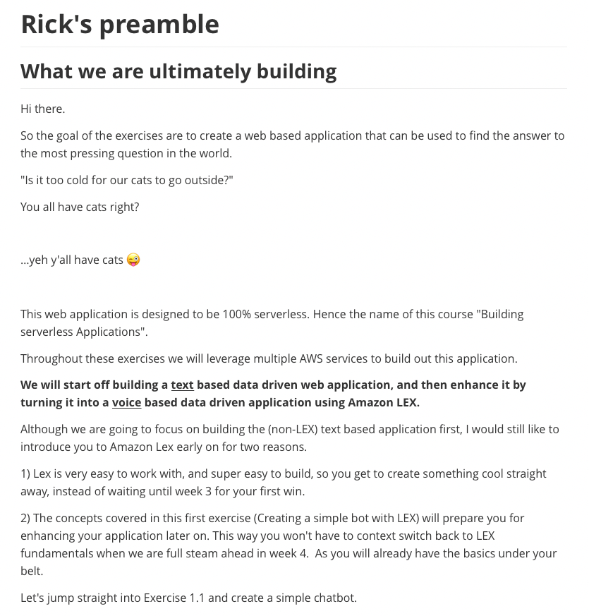

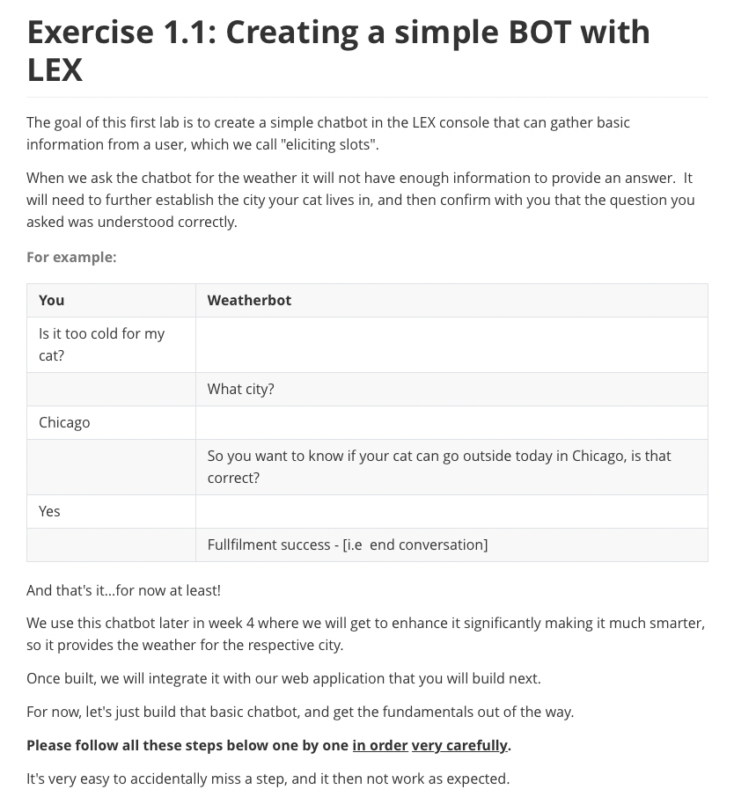

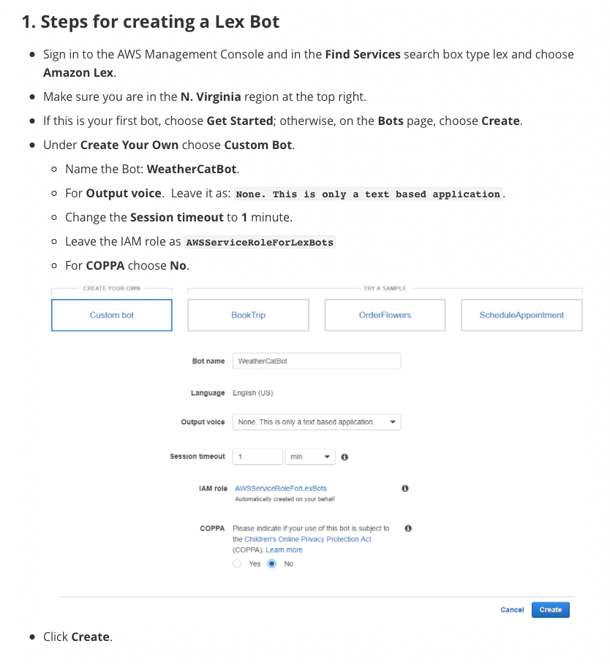

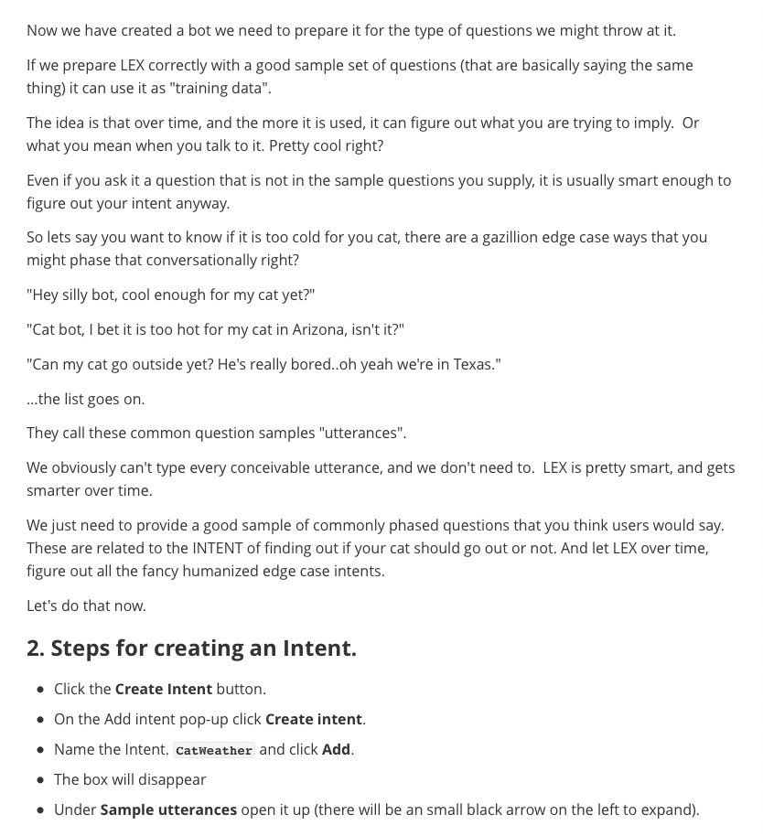

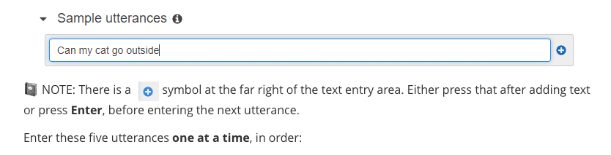

Can my cat go outside

Is it warm enough for my cat

Can I let my cat out in {city_str}

Should my cat wear booties in {city_str}

Will my cat stay dry in {city_str}

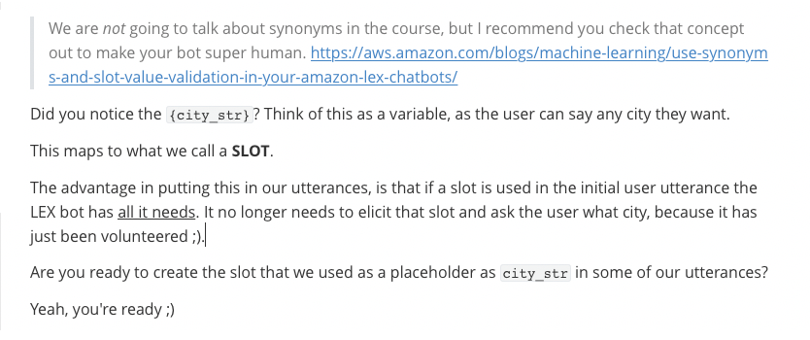

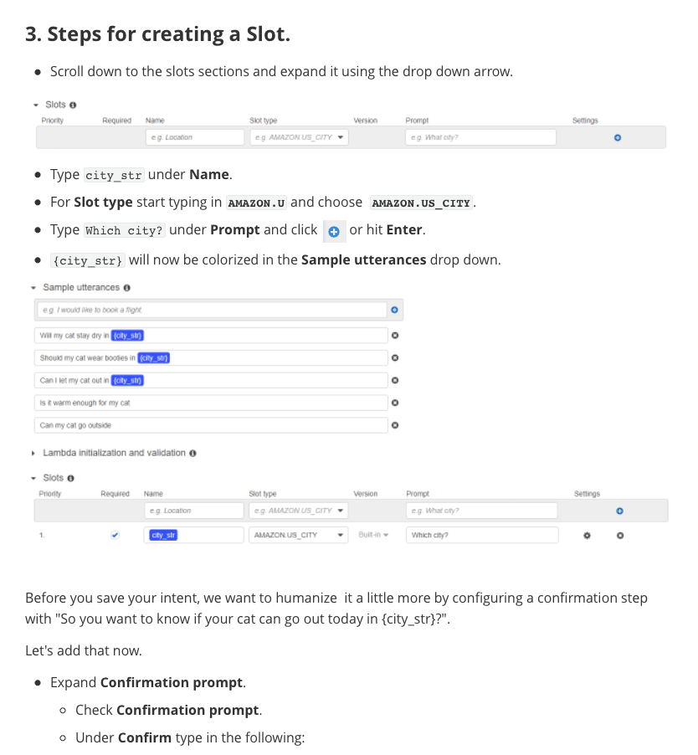

So you want to know if your cat can go out today in {city_str}?



Sorry, can you please repeat your initial question?

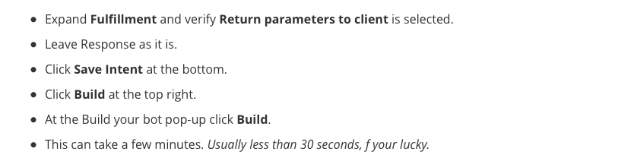

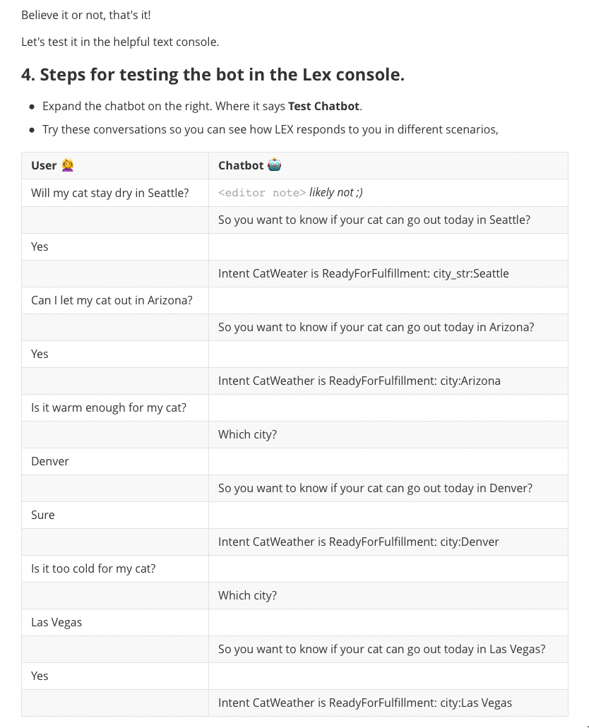

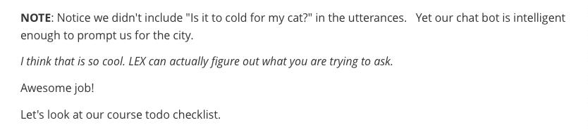

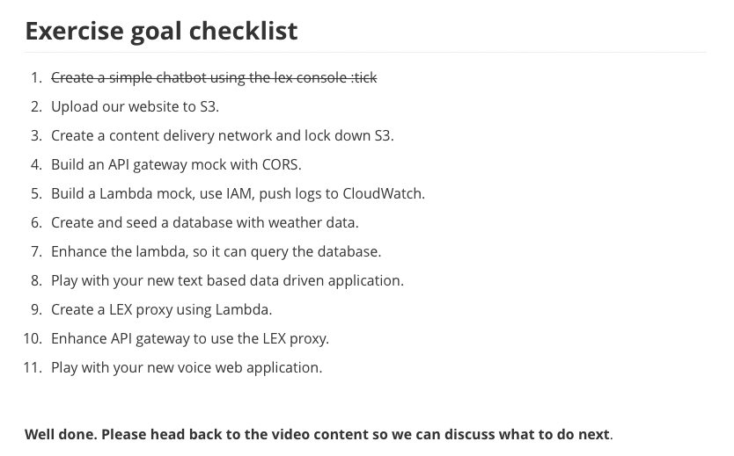

## 

## 

## 

## 

## **Create a serverless Website with S3**

### **Creating a Serverless Website with Amazon S3**

[Bobbie] Greetings.

I'm Bobbie,

and in this course we are going to learn

how to use Amazon Simple Storage Service,

or S3, to host a static website.

This is an example of "serverless,"

because you don't have to worry about managing the servers

or patching them.

Amazon Simple Storage Service is an object storage service

that offers industry-leading scalability,

data availability, security,

and performance.

Amazon S3 is designed for 11 nines of durability,

and stores data for millions of applications

for companies all around the world.

This means customers of all sizes and industries

can use it to store and protect any amount of data

for a range of use cases.

Like websites, mobile applications,

backup and restore, archive,

enterprise apps, IoT devices,

and big data analytics.

Amazon S3 provides easy-to-use management features

so you can organize your data and configure

finely tuned access controls to meet your specific business,

organizational, and compliance requirements.

When we think about the three number ones with AWS,

they are:

cost-effectiveness, security,

and resilience.

S3 helps you to meet all of these.

(spaceship whizzing)

I wasn't exactly thinking about alien,

more like an Earth-bound threat,

like a DDoS attack.

One of the biggest advantages for using S3

is that you can host your website

from an S3 bucket and reduce stress on origin

or on your actual data center or AWS Cloud.

This also minimizes your "attack surface" for your site

adding in an additional layer of security.

It's cost-effective because it's a frugal method

for storage and website hosting,

and you're also reducing traffic to your origin site

so you don't have to pay for more web servers

by scaling vertically or horizontally.

It works to help with your security

by reducing your attack surface by not sending traffic

to your infrastructure or origin.

It's resilient!

S3, using the Standard S3 storage class,

your data is being replicated in the background.

We will discuss more about the different storage classes,

and other options available,

when you create your S3 bucket

for your static website during the demo.

### **Exercise 1.2: Creating a S3 Bucket and Configuring as a Static Website**

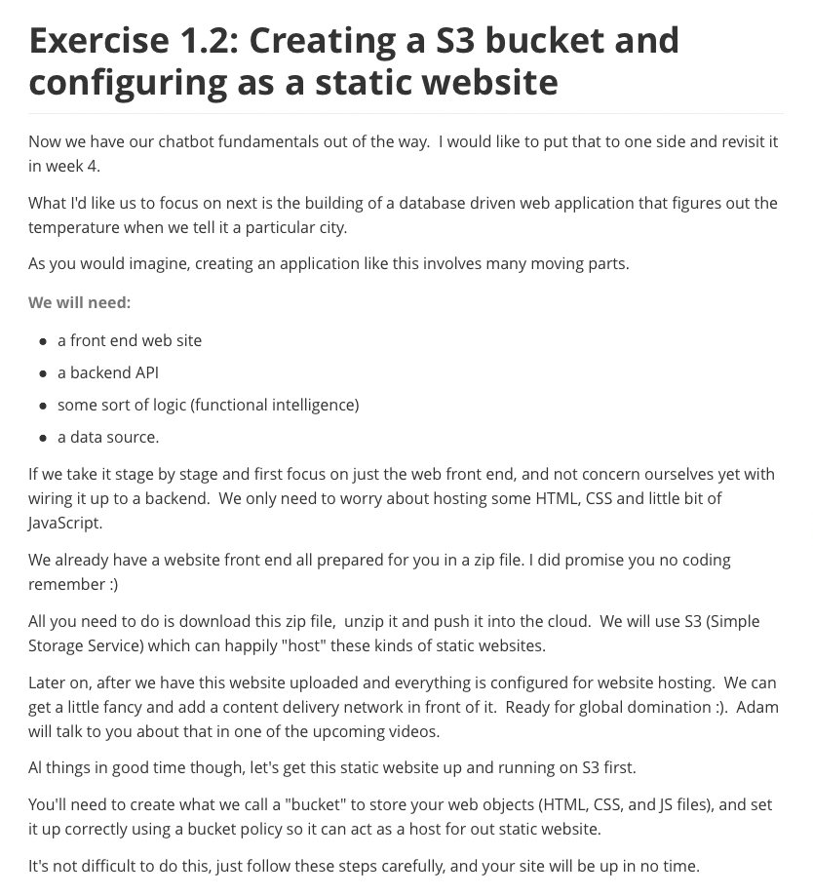

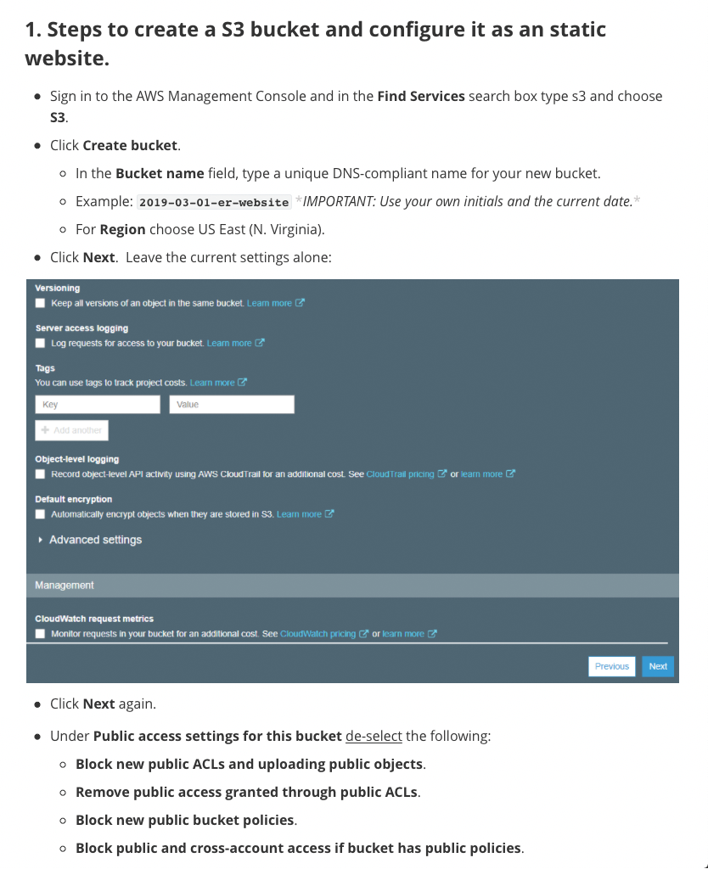

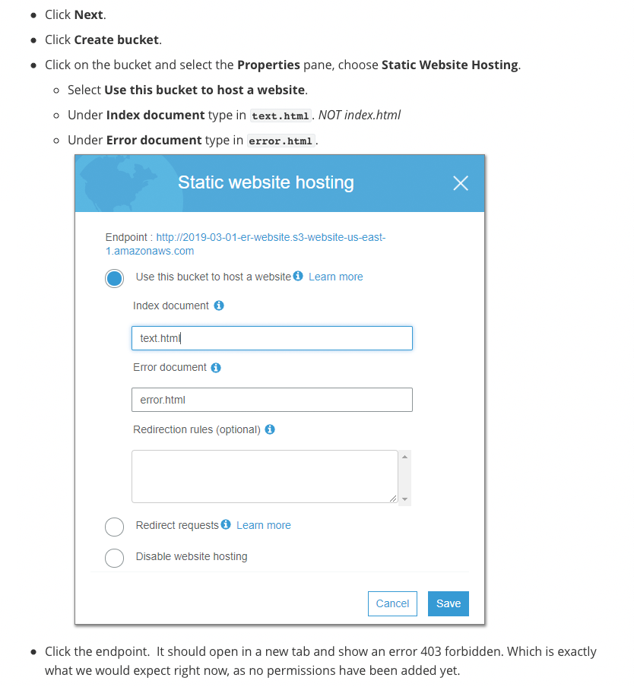

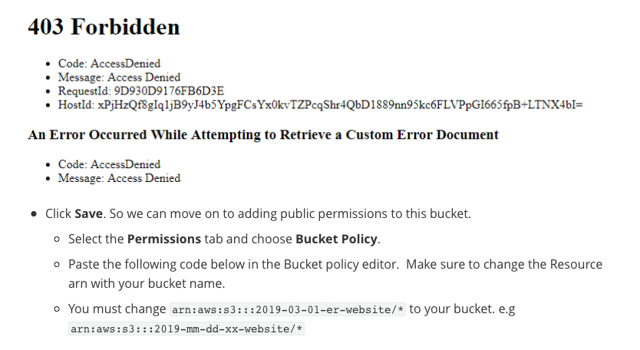

{

"Version": "2012-10-17",

"Statement": [

{

"Sid": "AddPerm",

"Effect": "Allow",

"Principal": "*",

"Action": [

"s3:GetObject"

],

"Resource": [

"arn:aws:s3:::2019-03-01-er-website/*"

]

}

]

}



<https://s3.amazonaws.com/awsu-hosting/CSA-TF-100-SCSRVL-10-EN/s3website.zip>



+ images

- mobile.jpg

+ scripts

- config.js

- helper.js

- jquery.js

- text.js

- voice.js

+ styles

- reset.css

- text.css

- voice.css

+ cities.md

+ error.html

+ favicon.ico

+ index.html

+ README.md

+ text.html

+ voice.html

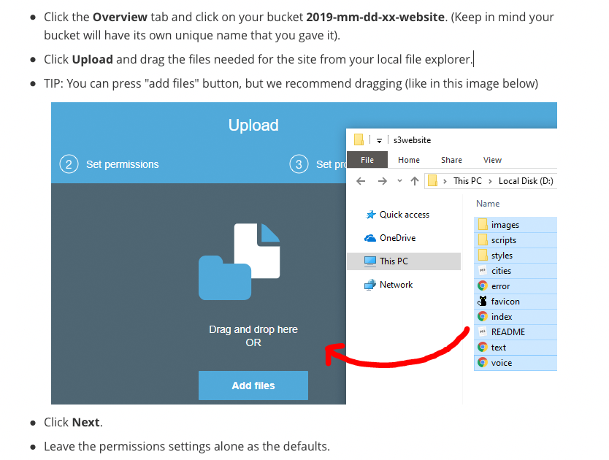

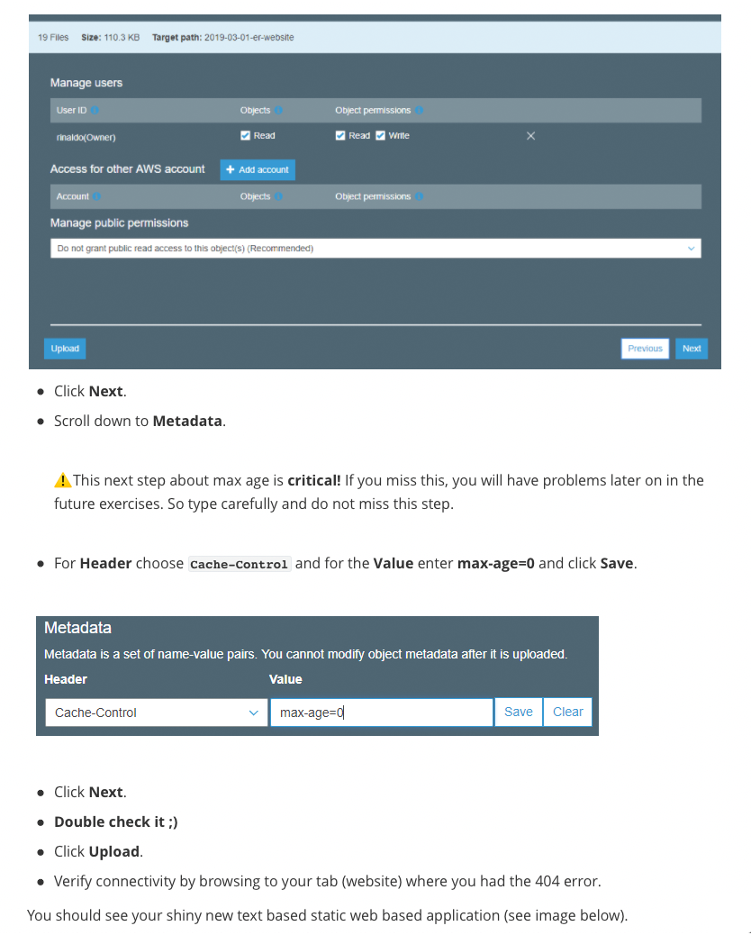

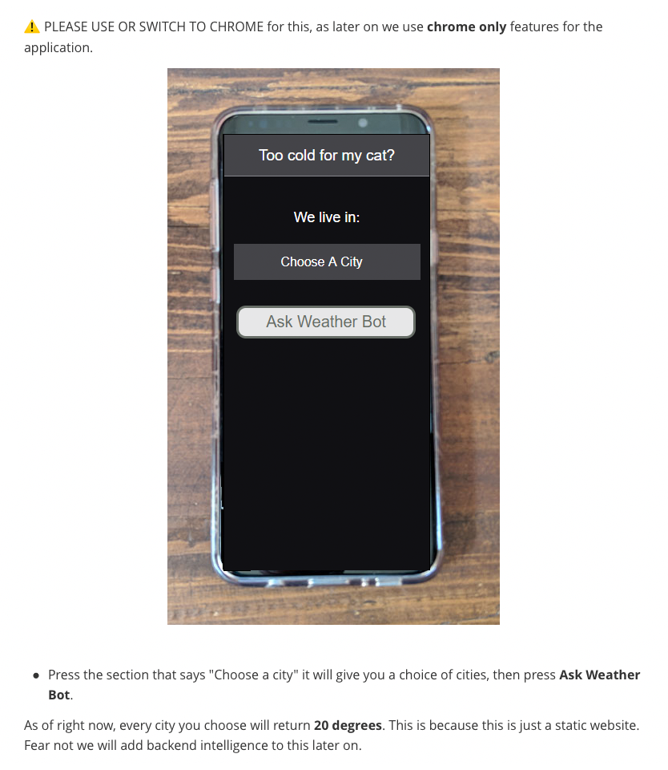

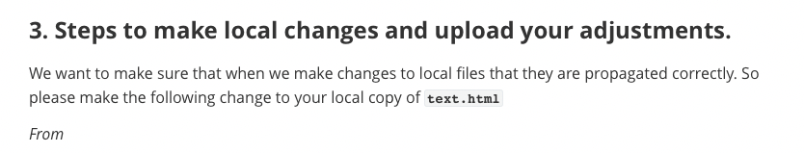

<h1>Too cold for my cat?</h1>



<h1>Too hot for my cat?</h1>

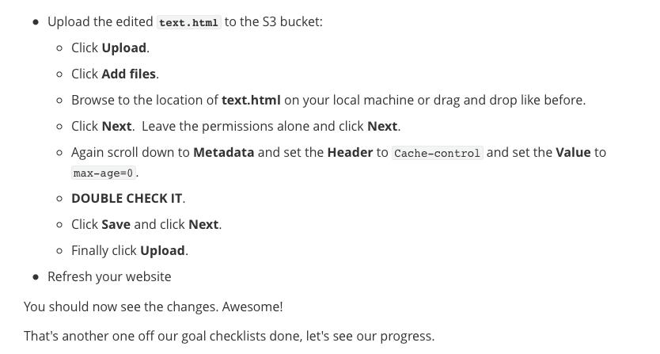

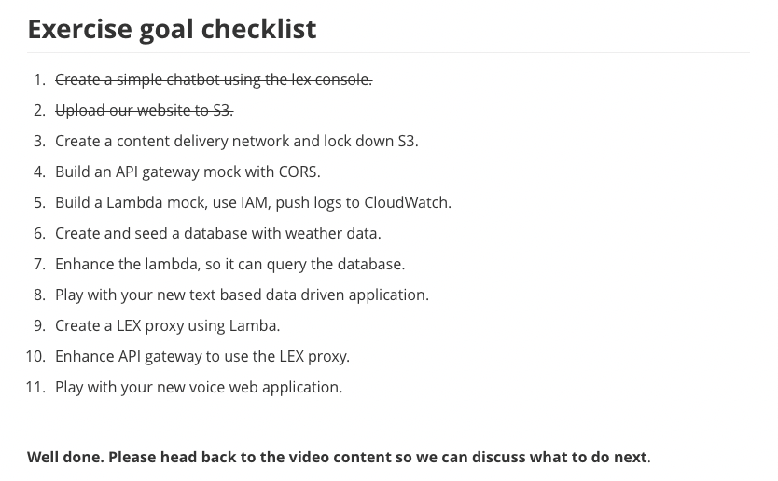

## **Week 1 Readings/Resources**

### **Amazon Lex**

[Amazon Lex](https://docs.aws.amazon.com/lex/latest/dg/what-is.html) is a service for building conversational interfaces into any application using voice and text. Amazon Lex provides the advanced deep learning functionalities of automatic speech recognition (ASR) for converting speech to text, and natural language understanding (NLU) to recognize the intent of the text, to enable you to build applications with highly engaging user experiences and lifelike conversational interactions. With Amazon Lex, the same deep learning technologies that power Amazon Alexa are now available to any developer, enabling you to quickly and easily build sophisticated, natural language, conversational bots [(“chatbots”)](https://aws.amazon.com/what-is-a-chatbot/).

### **Amazon Lex pricing**

With Amazon Lex, you pay only for what you use. You are charged based on the number of text or voice requests processed by your bot. Please see the [pricing page](https://aws.amazon.com/lex/pricing/) for current information.

### **What is Serverless?**

[Serverless](https://aws.amazon.com/serverless/) is the native architecture of the cloud that enables you to shift more of your operational responsibilities to AWS, increasing your agility and innovation. Serverless allows you to build and run applications and services without thinking about servers. It eliminates infrastructure management tasks such as server or cluster provisioning, patching, operating system maintenance, and capacity provisioning. You can build them for [nearly any type of application](https://aws.amazon.com/serverless/#Serverless_Application_Use_Cases) or backend service, and everything required to run and scale your application with high availability is handled for you.

In this class, we will build a serverless application that uses [Amazon S3](https://aws.amazon.com/S3/), host a static serverless website. [Amazon Cloudfront](https://aws.amazon.com/cloudfront/) to securily cost-effectively distrubute our content. [Amazon Lex](https://aws.amazon.com/lex), to create serverless [chatbot](https://aws.amazon.com/what-is-a-chatbot/). Amazon [API Gateway](https://aws.amazon.com/api-gateway), to create a test endpoint before we integrate the front and backend of your application. Amazon [DynamoDB](https://aws.amazon.com/dynamodb/), will provide a serverless database service behind [AWS Lambda](https://aws.amazon.com/lambda/), our serverless compute service.

## **Amazon CloudFront**

### **Introduction to Amazon CloudFront**

[Adam] Hi there.

To start this video,

I thought we would do a quick history lesson.

Content delivery networks, or CDNs, have been around

for quite some time now,

since the late 90s, when the first generation CDNs

were introduced to help reduce latency

associated with media transfer.

Traditionally, static material was retrieved directly

from origin each time a user requested it.

That took way too long.

The CDN reduced that roundtrip request time

by caching frequently used items

at an internet exchange location.

Now, to the current state of CDN.

Amazon CloudFront speeds up content delivery

by leveraging its global network of data centers,

known as "edge locations."

CloudFront has edge servers

and locations all around the world.

Let's take a look.

CloudFront fetches your content from an origin,

such as an Amazon S3 bucket, an Amazon EC2 instance,

an Amazon elastic load balancer, or your own web server

and stores it in the edge location.

CloudFront can be used to help optimize your application's

performance and security, while effectively managing costs.

We recommend that you also set up Amazon CloudFront

to work with your Amazon S3 bucket

to serve and protect the content.

By design, delivering data out of CloudFront

can be more cost effective than delivering it

from S3 directly to your users.

When a user requests content that you serve with CloudFront,

their request is routed to a nearby edge location.

If CloudFront has a cached copy of the requested file,

CloudFront delivers it to the user,

providing a fast, low-latency response.

If the file they've requested isn't yet cached,

CloudFront retrieves it from origin, and

as an added benefit, data transfer from S3 to CloudFront

is often more cost effective

than serving files directly from S3.

So, it's a win-win.

CloudFront also leverages AWS global private network,

a separate backbone across the internet

that helps bypass worldwide networking issues to provide

better performance for both static and dynamic content.

To help clarify how this works, let's take a look

at the scenario shown in this illustration.

We've stored our content in an S3 bucket

located in a European Region, and we have users located

around the world who have access to that content.

As the arrows show, whenever a user requests content,

the request must go over public internet to the source

location, in this case, the S3 bucket in Europe.

Depending on the user's location, this can take a long time.

Now, imagine we set up CloudFront

in front of that S3 bucket.

Much better.

You can see now that there are no longer requests

traversing the globe to get our content.

Instead, requests are routed to the least latent edge

location that is the closest in terms of delivery speed.

CloudFront then serves cached content quickly

and directly to the user nearby,

as shown by the green arrows.

If content is not yet cached, with an edge server,

CloudFront retrieves it from the S3 bucket origin.

And because the content traverses the AWS private network

instead of public internet, and CloudFront optimizes

the TCP handshake, the request and content return

is still so much faster than crossing the public internet.

Let's talk about securing your content.

Often, companies who distribute content over the internet

want to restrict access to documents, business data,

media streams, or other content so that only selected users,

like paying customers for example, can request that content.

By using CloudFront, we can set up additional access

restrictions, like GO restrictions, signed URLs,

and signed cookies, to further constrain access

to the content following different criteria.

Another security feature of CloudFront

is origin access identity, or OAI.

Let's take a look.

OAI restricts access to an S3 bucket

and its content to only CloudFront in operations

that CloudFront performs.

CloudFront includes additional protection

against malicious exploits.

To provide these safeguards, CloudFront integrates

with both AWS WAF, a web application firewall that

helps protect web applications from common web exploits,

and AWS Shield, a managed DDoS protection service

for web applications running on AWS.

The goal here is to place layers of protection

between your user requests and the data origin, but to do it

in such a way that it does not impact performance.

AWS WAF lets you control access to your content

based on conditions that you specify.

For example, IP addresses or the query string

on a content request.

CloudFront then responds with either the requested content,

if the conditions are met,

or with an HTTP 403 forbidden error.

All CloudFront customers benefit from the automatic

protection of AWS Shield standard at no additional charge.

I hope that now you're as excited about CloudFront as I am.

And as you can see, CDNs are incredibly important

to our internet infrastructure and service.

In fact, you're probably viewing this course

through a CDN distribution now.

Now that we've got a good footing on CloudFront, I'd like

to show you how to enable this very powerful service

in our next video.

See you then.

### **Amazon CloudFront Demo**

- [Adam] Let's get started with the CloudFront demo.

First step is I'm going to prepare my content.

In this step, I'm going to upload

my static content to an S3 bucket.

In later steps, we will use this bucket

as a CloudFront origin.

Amazon S3 is a good choice

for Amazon CloudFront origin

that includes static content,

such as images, videos,

HTML pages, .css files, and .js files.

The sample image we will use in this tutorial

is an image called Jingles.jpg.

The AWS Management Console is where we will begin

in a new browser window.

Type "S3" in the search box,

and double-click to open the dashboard.

Now that I am in the S3 dashboard,

I'll click the Create bucket button.

I'll enter a name for my bucket.

It must be unique and all lowercase.

I'll have the option to choose a Region

to minimize latency, minimize cost,

or address regulatory requirements based on my data.

I'll select Next.

On the Properties panel,

there are a number of useful options for my S3 bucket,

including versioning, server access logging,

tags, object-level logging, and default encryption.

I won't enable these features in this tutorial,

so I'll click Next.

On the Set permissions panel,

I can set access control permissions for our bucket,

but I won't enable these features for this tutorial,

so I'll click Next.

On the Review panel, I'll select Create bucket.

I'll double-click on my bucket and select Upload.

Then, add files

and select the picture of my cat, Jingles.

And, click Next.

On the Set permissions tab,

I will need to make my image publicly readable.

By default, S3 objects are set to private.

I'll change my Manage public permissions

to grant access to this object.

Select Next.

On the Properties tab,

I can set a storage class option.

On the Set properties tab,

I can set storage class, encryption, and metadata.

I won't enable these features for this tutorial,

so I'll click Next.

And, select Upload.

Step two will be entering the CloudFront console.

Once my content is uploaded to Amazon S3,

I can use the Amazon CloudFront console

to deliver that content to end users all around the world.

Let's get to it.

Go back to the AWS Management Console.

And then, I will type in CloudFront. Select.

And, I'll select Create Distribution.

Step three is going to be

configuring a web distribution.

A "web distribution" specifies configuration settings

so that CloudFront knows which origin

to get my content from when a user requests it.

I've got a couple options here.

I can use an Amazon S3 bucket,

I can use HTTP servers, web servers, as an origin, as well.

I will first choose my delivery option,

my delivery method.

A web distribution is used for static and dynamic content.

Because Jingles.jpg is a static image,

I'll select Get Started under the Web option.

I will now configure my settings.

In Origin Domain Name,

I'll select the name of the S3 bucket

I store Jingles.jpg in.

I can leave the rest of the configuration settings

with the default values for this tutorial.

You can learn more about each configuration setting

by clicking and hovering over the "i" next to each field,

just as I have done here.

Step four will be creating a distribution.

Once I have configured my distribution,

CloudFront will now create the distribution

and propagate it throughout the CloudFront network for me.

I'm going to scroll down and select Create Distribution.

After this process is complete,

the status column will change from In Progress to Deployed.

By the way, if you do this at home,

it might be a good idea to go ahead

and grab a cup of coffee.

Luckily, I have my friends in the studio

who are quite adept at time travel.

So on this video, step four goes very quickly for me.

But for you, it can take up to 15 minutes.

The domain name that CloudFront assigns to my distribution

appears in my list of distribution.

I will need to make note of this for the next step.

Clicking on the Distribution ID field

takes me to a page where I can see

the full CloudFront domain under Domain Name.

The next step is to test my link.

After I create my web distribution,

I can test it out by confirming

that CloudFront gets my object from origin

and returns it into my web browser.

For this test, I will need

the CloudFront domain name from step four

and the image name I uploaded to the S3 bucket

previously in step one.

I'll open a text editor on my computer, and

copy and paste the following HTML code.

I'll replace the domain name with the domain name

that CloudFront assigned my distribution.

I'll replace object name with the name

of my image file in the Amazon S3 bucket.

In my case, it's Jingles.jpg.

I'll save the text file

as mycloudfronttest.html.

I'll open my webpage in a browser

to ensure that we can see my content.

And there you have it, a cute cat.

Step six is to disable my distribution.

I can easily disable the distribution

from the CloudFront console.

In fact, it's a best practice to disable distributions

that you are no longer using,

so you don't keep getting charged for them.

However, note that when a distribution is disabled,

any website supported by that distribution will be down,

and the content will no longer

be accessible to the end users.

I'll select the checkbox next to

the distribution I created and click Disable.

I'll be asked to confirm,

and then I'll click Yes, Disable.

That's it. How easy was that?

Now, you can go and create your own

low latency static site

to serve up as many cute cat pictures

as you can possibly handle.

That's all for now.

I'll see you in other topics.

## 

## 

### **Exercise 2.1: Creating a CloudFront Distribution**

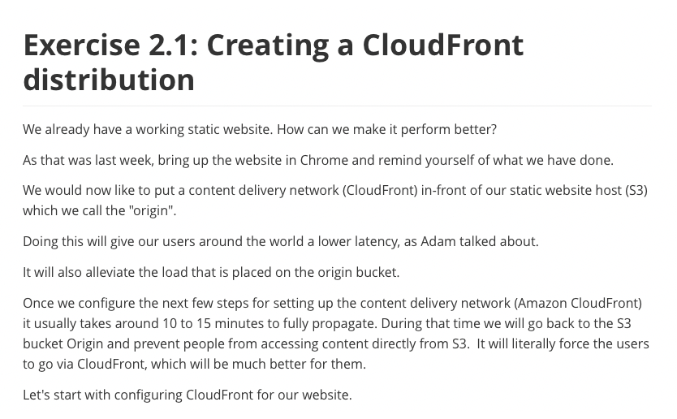

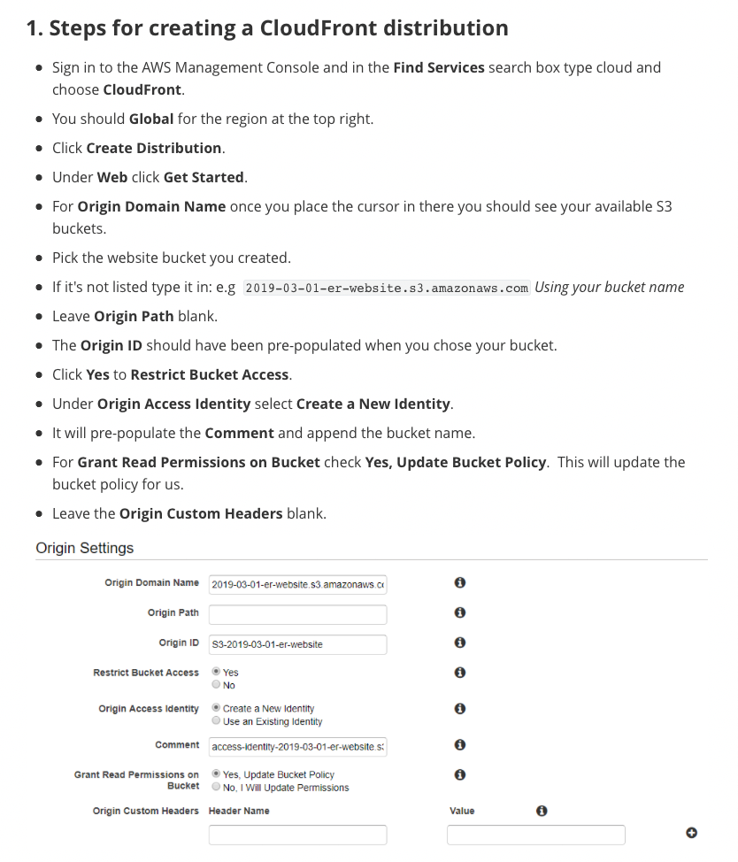

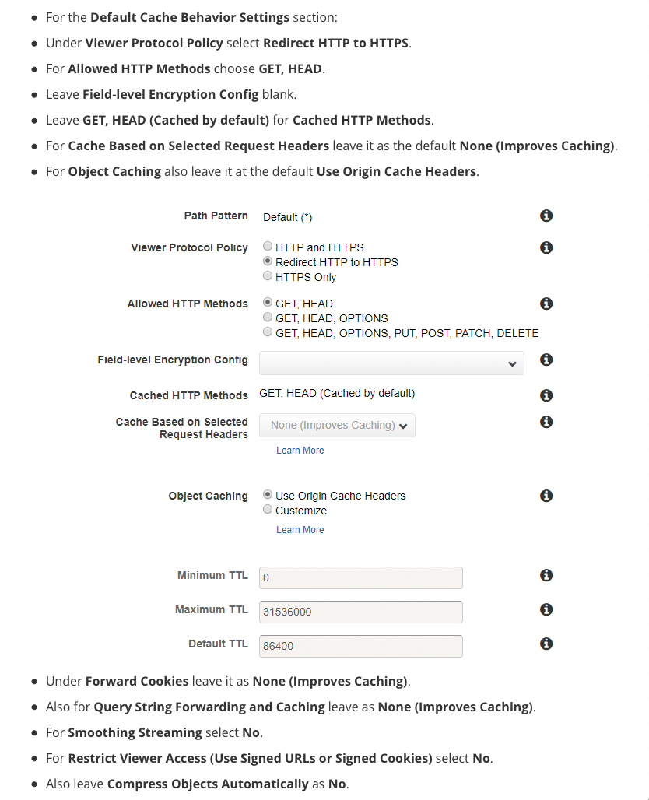

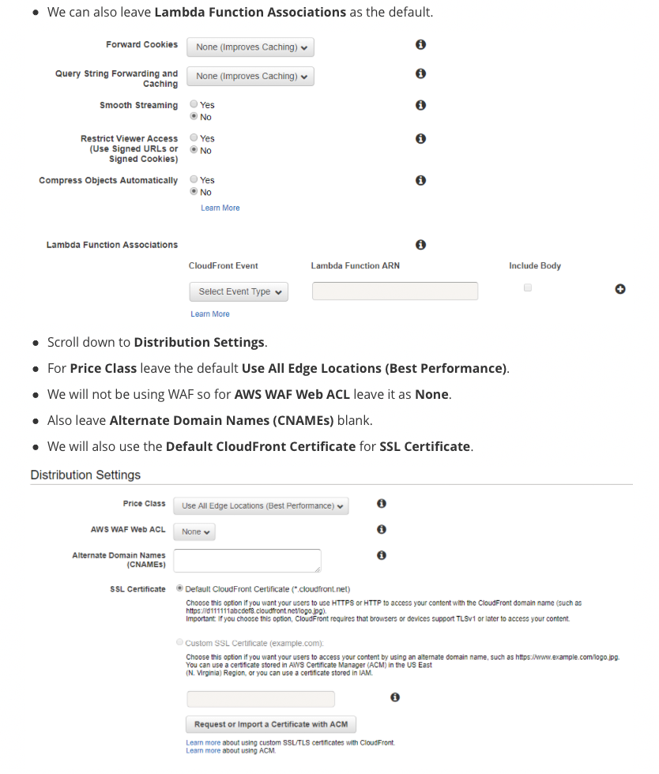

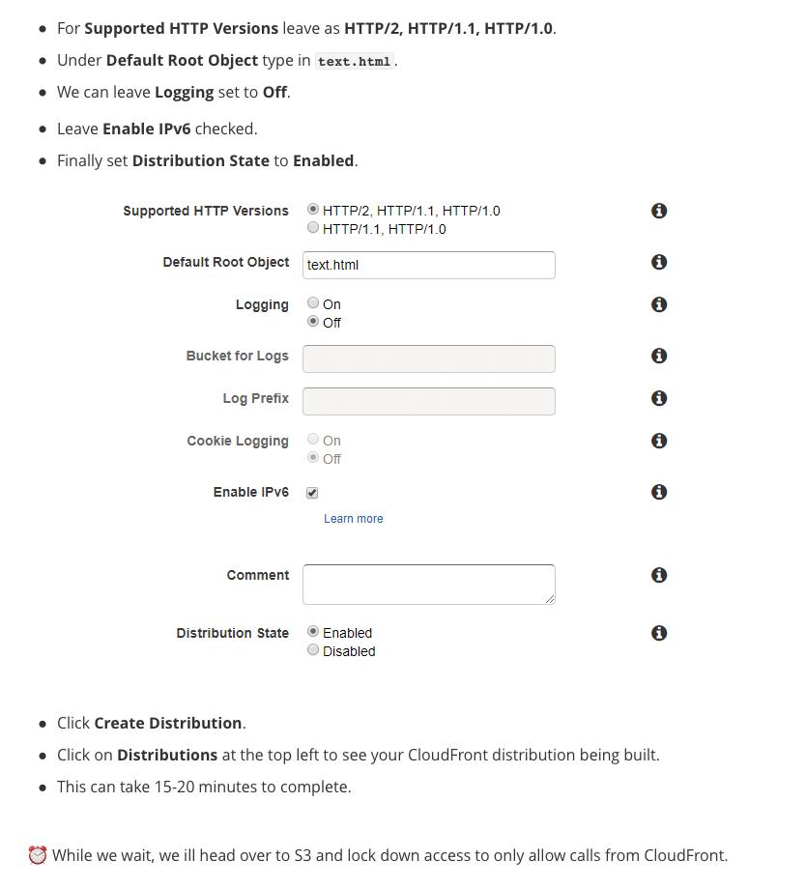

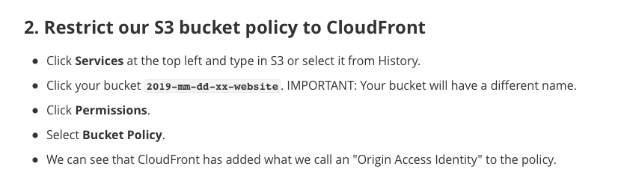

{

"Version": "2012-10-17",

"Statement": [

{

"Sid": "AddPerm",

"Effect": "Allow",

"Principal": "*",

"Action": "s3:GetObject",

"Resource": "arn:aws:s3:::2019-03-01-er-website/*"

},

{

"Sid": "2",

"Effect": "Allow",

"Principal": {

"AWS": "arn:aws:iam::cloudfront:user/CloudFront Origin Access Identity E1KO2GAPIWFF7X"

},

"Action": "s3:GetObject",

"Resource": "arn:aws:s3:::2019-03-01-er-website/*"

}

]

}



{

"Version": "2012-10-17",

"Statement": [

{

"Sid": "2",

"Effect": "Allow",

"Principal": {

"AWS": "arn:aws:iam::cloudfront:user/CloudFront Origin Access Identity E1KO2GAPIWFF7X"

},

"Action": "s3:GetObject",

"Resource": "arn:aws:s3:::2019-03-01-er-website/*"

}

]

}

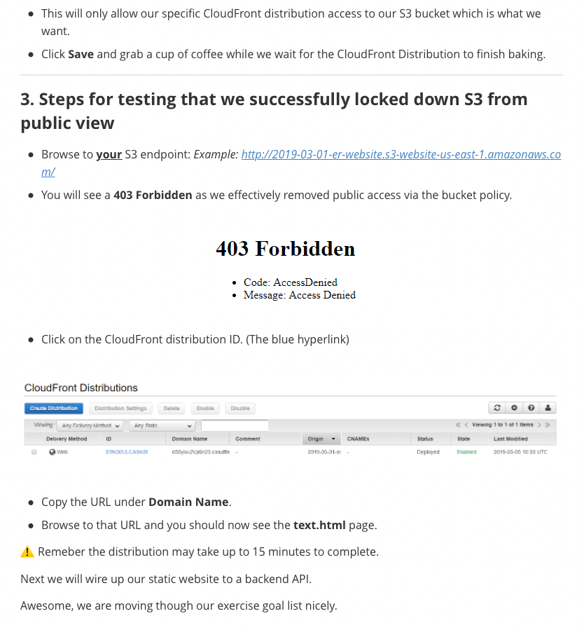

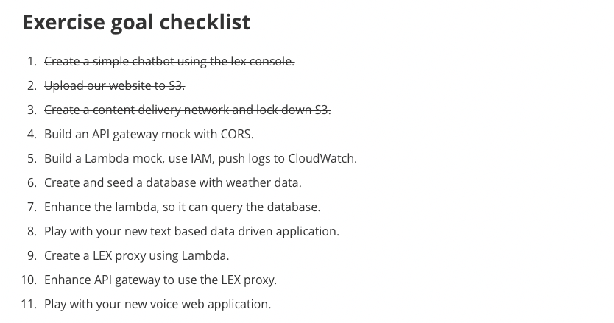

## **Taking to the Backend/ Amazon API Gateway**

### **Introduction to Amazon API Gateway and Demo**

Wes] Welcome back. I'm Wes,

and in this section we will introduce

Amazon API Gateway.

We're going to do a quick overview

of what the service is all about.

We'll talk about why you would want to use it,

and then we'll run through a quick demo

to show you how to create and configure

your very own API gateway in the AWS console.

Let's get started.

So API Gateway is a fully managed service

that's designed to make it easy for developers

to create, publish, maintain, and monitor

secure application programming interfaces,

or APIs, at any scale.

With a few clicks in the AWS Management Console,

you can create REST and WebSocket APIs

that act as a front door for your applications

to access data, business logic,

or other functionality from your backend services.

Like workloads, running on EC2, and web applications.

API Gateway also provides an easy interface

for code running on AWS Lambda and other AWS services,

which we'll discuss in detail later in this course.

First off, why would you want to use API Gateway?

Well, turns out that software development organizations

are moving more towards microservice architectures.

Microservices are an approach to software development

where software is composed of small independent services

that communicate over well-defined APIs.

These services are - in turn - owned by small,

self-contained teams.

Microservices architectures make applications

easier to scale and faster to develop.

And that really enables innovation and accelerates

the time-to-market for new features.

API Gateway fits right into this scheme.

So, why would you want to use it?

Well, developers can add headers,

map input variables from POST events,

to something your target application needs.

You're going to see this in the demo in a minute,

as well as later in this course.

Here are several more reasons

you might want to use API Gateway.

Efficient API development:

You can run multiple versions of the same API

simultaneously with API Gateway.

This allows you to quickly iterate, test,

and release new versions.

We're talking about the difference between days and weeks.

Easy monitoring:

You can monitor performance of metrics and information

- on API calls, data latency, error rates -

from the API Gateway dashboard,

which allows you to see millions of requests

in a single pane of glass.

Performance:

You can provide end users with the lowest possible latency

for API requests and responses,

by taking advantage of our global network

of edge locations using Amazon CloudFront.

You can also throttle traffic

and cache the output of API calls,

to ensure that the backend operations

withstand traffic spikes, and backend systems

are not unnecessarily called.

Cost savings:

API Gateway provides a tiered pricing model

for API requests.

You can decrease your costs based on the number

of API requests you make, per Region,

across your AWS accounts.

Flexible security controls:

You can authorize access to your APIs

with AWS Identity and Access Management, or IAM,

as well as Amazon Cognito.

If you use OAuth tokens or other authorization mechanisms,

API Gateway can help you verify incoming requests as well.

By providing an extra layer

in front of your backend service,

you can add extra layers to protection

and security as well.

So enough marketing speak.

Let's crack open the AWS console,

and show you how this thing works.

So in this demo,

we're going to log in to the AWS console,

go to the API Gateway service, and get started.

So, a little note there about an example API

that's already set up for you.

However, we're going to create a new API

by selecting New API.

We're going to give it a name.

In this case, we're just going to use "demo."

The description itself is optional.

Then we hit the Create API button.

In our Actions,

we're going to create, first, a new method.

And for this particular demo,

we're going to make it real simple,

and we're just going to use a GET request.

As part of this GET request,

since this is just a demo,

we're not actually going to do anything.

We're going to use for the integration method

we're going to use mocking.

And what mocking really is,

it's just a fake way to send some information

and bounce it back

without actually making anything happen.

So, we haven't written any code,

we don't really have a service,

but we want to test that the API Gateway works.

So, in this particular case,

we have created our Method Request.

We've decided that our Integration Request type

is going to be MOCK,

and again that's just for fake.

So the next thing we have to do

is the Integration Response.

And the way we do that,

is selecting Integration Response,

we're going to scroll down to expand this,

and we're going to simply use

a mapping template that's already been created for us,

application/json.

And the little dropdown here,

we've got our method passthrough.

This code's not super important,

but all it really does,

is bounces back any request that's sent to it

with all new information that's coming through

in the header within the request.

Check it out.

We save our particular request,

and now we are going to deploy it.

Go back to Actions, and hit Deploy API.

We're going to give this stage a name,

in this case we're just going to call it "test."

Call a new stage, we're going to call it "test,"

And we don't have to give it a description.

As you'll see,

since I've created this, we now have a URL.

I can click on this URL

to test my API.

All we've done is gone out,

we've taken all the information

that came from that particular request,

the header itself.

And you can see all kinds of information

in the query string that was just returned.

All the variables,

my IP address and all the browser information

that was returned.

It's really just

that simple.

#### **Exercise 2.2 Introduction to Amazon API Gateway**

Rick] Hi.

So, Wes has talked to you about API Gateway,

and specifically how to set up a mock API.

Want to guess what you're going to do in this lab?

That's right, you're going to mock an endpoint using -

surprise, surprise - API Gateway.

This concept is often used by developers

as they are building out their web apps,

because they might have to develop on the frontend first,

but might not be ready to wire up,

say a database, at the backend.

A mock is great for this kind of thing,

as we can wire up all the plumbing

for the website to communicate to a real backend,

but actually just receive dummy data back.

Once your mock's in place,

you can have a working frontend,

and kick that backend intelligence down the line,

worry about that later on.

So, you ready to mock out an API?

Well, thanks to Wes and his demo,

this exercise should be a breeze for you,

because you're following exactly the same steps.

You log into the API console,

except this time you'll create a POST method,

as our frontend will send a payload of city,

and hardcode the mock to send a fixed temperature back,

rather than echo the whole request back,

like you saw in Wes's example.

That's it.

We can worry about replacing the mock

with real functionality a little bit later on.

Oh, there's one other thing,

cross-origin resource sharing, aka, CORS.

This one's a pain.

You see, when a website makes a request via JavaScript

to a backend API

- such as one we're having you create -

the browser will complain,

and not allow the data back into the browser,

if it thinks it's not coming from your server,

a cross domain.

But why would it think it's cross domain?

Well, it turns out that because your website is hosted,

or at least served from, CloudFront,

and thus using a CloudFront domain name,

the browser thinks, "Hmm,

we're at one domain for this site,

yet JavaScript - from this site -

is trying to call a different API Gateway domain name.

Hmm, that doesn't smell right, you know what,

let's just block it and play it safe."

Ta da - broken website.

So, how do you get around this?

How can we inform the browser

that we actually manage that API endpoint, as well?

In other words, we need to say to the browser,

it's still us, please let this request through.

Luckily, there's an easy fix.

We leverage a feature of API Gateway console

that hides a complexity of manually setting up,

and configuring CORS.

It's literally a button that says Enable CORS.

Just press it.

Let API Gateway add all the technical stuff

behind the scenes in your API,

and that way, from your perspective, it just works.

Problem solved.

So, in this exercise, you're going to do two things.

One, you're going to create an API gateway

using POST with hardcoded mock data.

And two, you're going to press that Enable CORS button.

You'll know when you've got CORS enabled correctly,

because your website will work.

Remember, forums are your friend.

Go there if you get stuck.

### **Exercise 2.2 Amazon API Gateway**

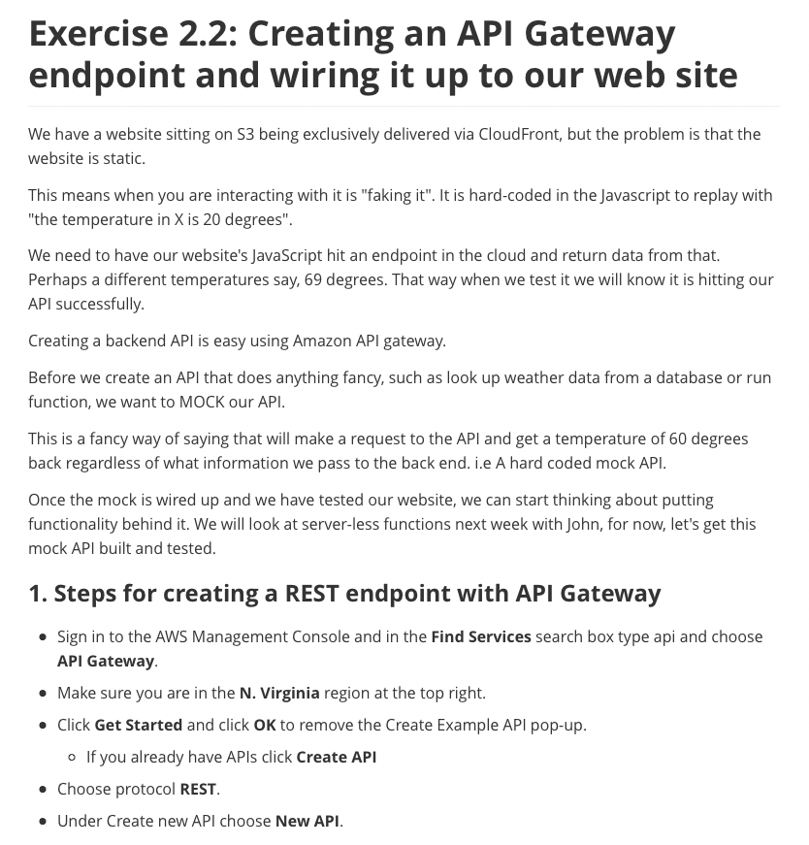

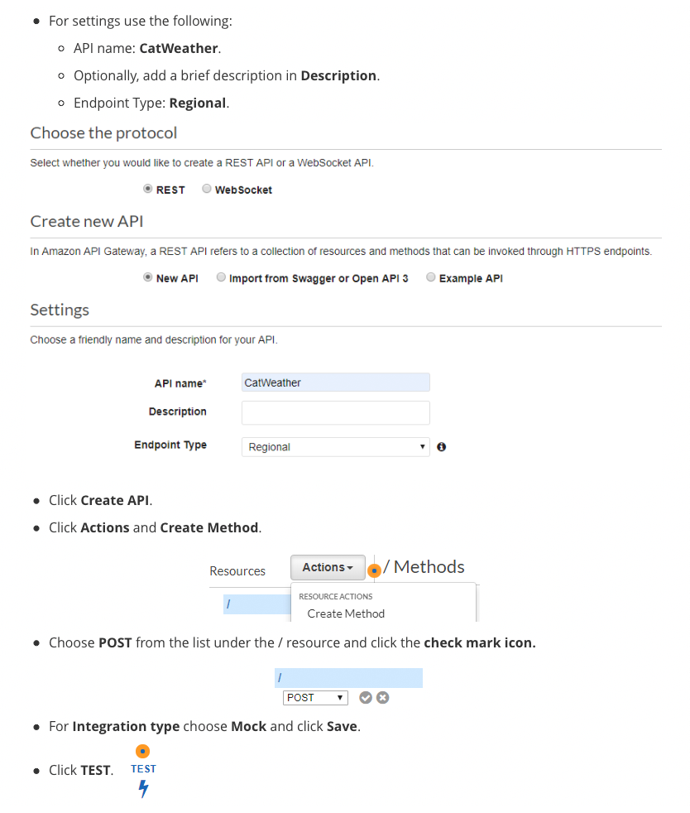



{

"city_str": "VEGAS"

}



no data



{"Content-Type":"application/json"}



HTTP Method: POST, Resource Path: /

Method request path: {}

Method request query string: {}

Method request headers: {}

Method request body before transformations: {

"city_str": "VEGAS"

}

Method response body after transformations:

Method response headers: {Content-Type=application/json}

Successfully completed execution

Method completed with status: 200

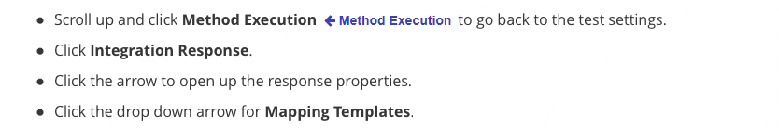

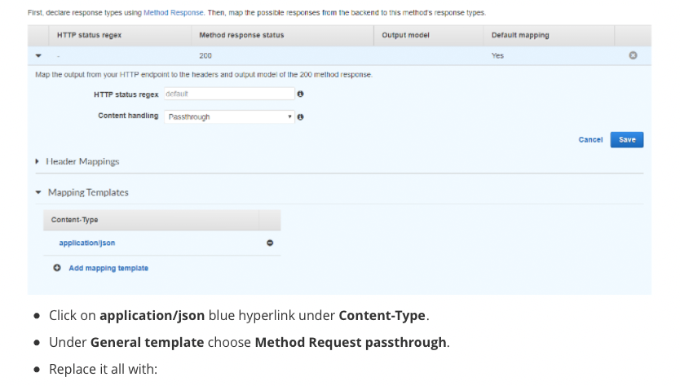

{

"temp_int": 69

}

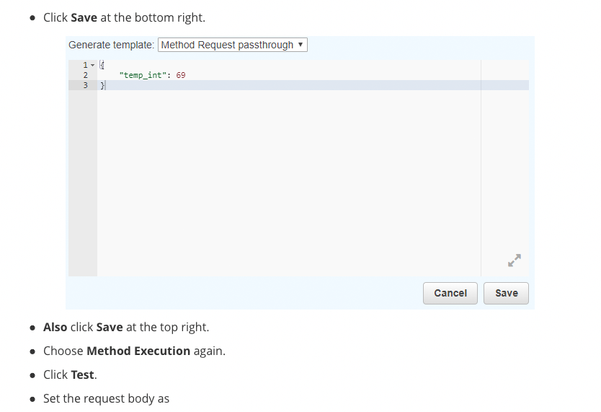

{

"city_str": "CHICAGO"

}



{

"temp_int": 69

}



{"Content-Type":"application/json"}



Execution log for request bc5f8d95-3f6b-11e9-9e4c-a7f1e746c2c6

Starting execution for request: bc5f8d95-3f6b-11e9-9e4c-a7f1e746c2c6

HTTP Method: POST, Resource Path: /

Method request path: {}

Method request query string: {}

Method request headers: {}

Method request body before transformations: {

"city_str": "CHICAGO"

}

Method response body after transformations: {

"temp_int": 69

}

Method response headers: {Content-Type=application/json}

Successfully completed execution

Method completed with status: 200

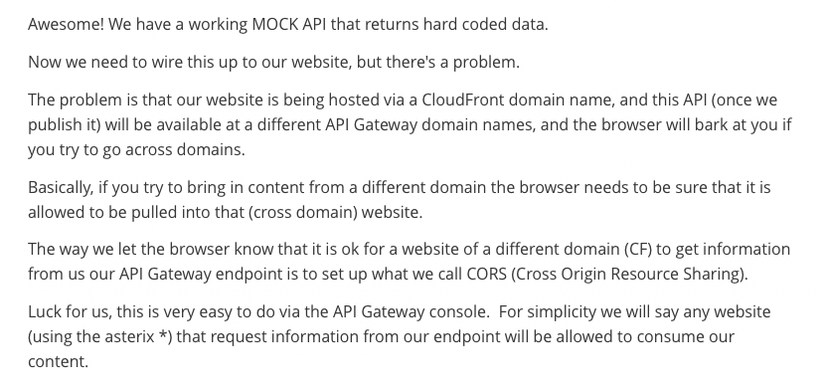

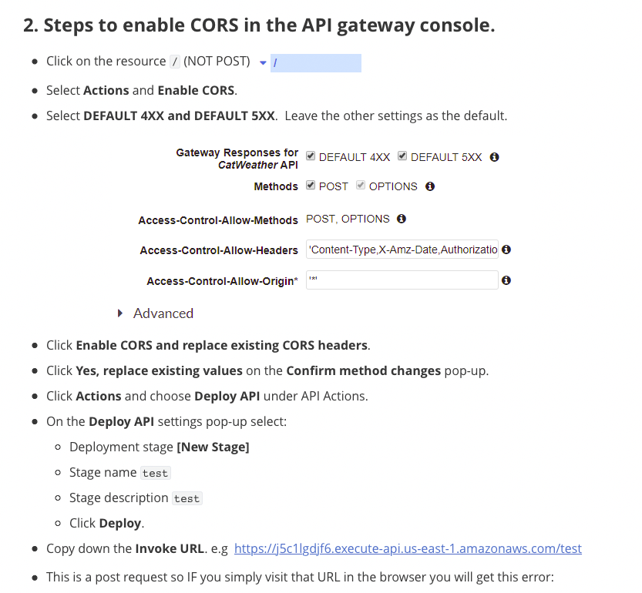

{

"message": "Missing Authentication Token"

}

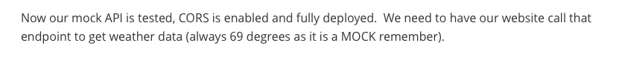

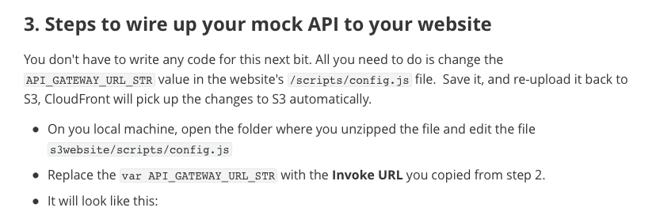

var API_GATEWAY_URL_STR = null;



var API_GATEWAY_URL_STR = "[https://Your-Invoke-URL.execute-api.us-east-1.amazonaws.com/test](https://your-invoke-url.execute-api.us-east-1.amazonaws.com/test)";

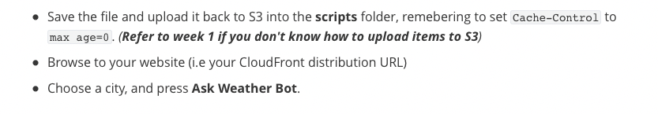

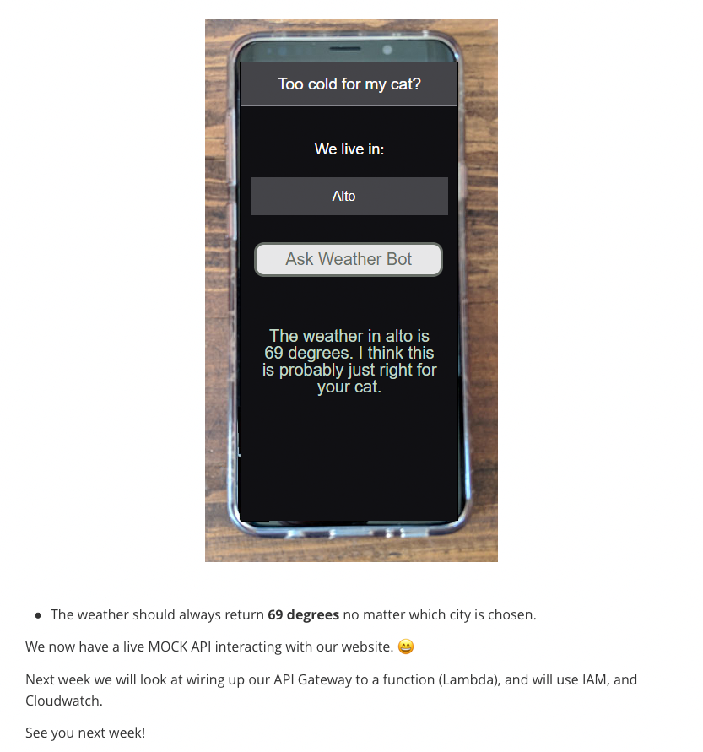

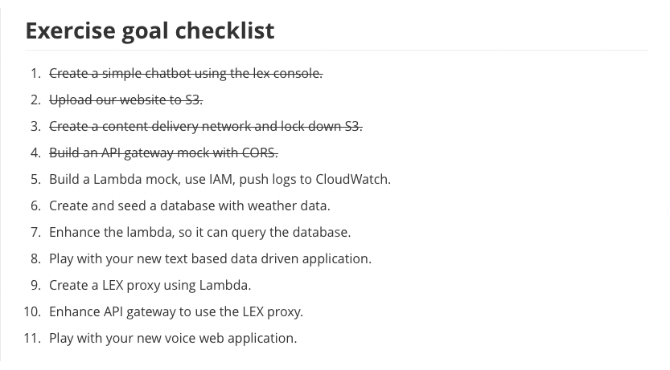

## **Week 2 Readings/Resources**

### **Amazon API Gateway**

[Amazon API Gateway](https://aws.amazon.com/api-gateway/) is a fully managed service that makes it easy for developers to create, publish, maintain, monitor, and secure APIs at any scale. With a few clicks in the AWS Management Console, you can create an API that acts as a “front door” for applications to access data, business logic, or functionality from your back-end services, such as workloads running on Amazon Elastic Compute Cloud (Amazon EC2), code running on AWS Lambda, or any web application.

### **Mock Integrations in API Gateway**

Amazon API Gateway supports mock integrations for API methods. This feature enables API developers to generate API responses from API Gateway directly, without the need for an integration backend. As an API developer, you can use this feature to unblock dependent teams that need to work with an API before the project development is complete. You can also use this feature to provision a landing page for your API, which can provide an overview of and navigation to your API. For an example of such a landing page, see the integration request and response of the GET method on the root resource of the example API discussed in [Build an API Gateway API from an Example](https://docs.aws.amazon.com/apigateway/latest/developerguide/api-gateway-create-api-from-example.html).

### **Pricing**

With Amazon API Gateway, you only pay when your APIs are in use. There are no minimum fees or upfront commitments. For HTTP/REST APIs, you pay only for the API calls you receive and the amount of data transferred out. Amazon API Gateway is [Free Tier](https://aws.amazon.com/free/) eligable and The Amazon API Gateway free tier includes one million API calls received for HTTP/REST APIs, and one million messages and 750,000 connection minutes for WebSocket APIs per month for up to 12 months. See the [Amazon API Gateway](https://aws.amazon.com/api-gateway/pricing/) pricing page for details. **Amazon CloudFront**

[Amazon CloudFront](https://aws.amazon.com/cloudfront/) is is a global content delivery network (CDN) service that securely delivers data, videos, applications, and APIs to your viewers with low latency and high transfer speeds. CloudFront is integrated with AWS – including physical locations that are directly connected to the AWS global infrastructure, as well as software that works seamlessly with services including [AWS Shield](https://aws.amazon.com/shield/) for DDoS mitigation, [Amazon S3](https://aws.amazon.com/s3/), [Elastic Load Balancing](https://aws.amazon.com/elasticloadbalancing/) or Amazon [EC2](https://aws.amazon.com/ec2) as origins for your applications, and [Lambda@Edge](https://aws.amazon.com/lambda/edge/) to run custom code close to your viewers. [The cost to use CloudFront](https://aws.amazon.com/cloudfront/pricing/) is based upon data transfer costs as well as requests and includes a free usage tier.

**Cloudfront Edge Locations as of March 2019**:To deliver content to end users with lower latency, Amazon CloudFront, uses a global network of 166 Points of Presence (155 Edge Locations and 11 Regional Edge Caches) in 65 cities across 29 countries. For current information about Edge Locations, [see this page](https://aws.amazon.com/cloudfront/features/).

### **Origin Access Identity (OAI)**

[Origin Access Identity](https://docs.aws.amazon.com/AmazonCloudFront/latest/DeveloperGuide/private-content-restricting-access-to-s3.html) provides a method to restrict access to S3 content to only a CloudFront Distribution.

## **AWS IAM and AWS Lambda**

### **AWS Identity Access Management (IAM)**

[Bobbie] Hi again.

I want to talk to you now

about Identity and Access Management, or IAM.

Later this week, you will see how roles

are used to allow services like Lambda to work.

So, let's talk about roles.

In AWS best practices,

roles are generally the right solution.

They allow us to give access to third parties

without creating a new IAM user.

This is great for service accounts or application IDs.

Let me give you an example.

In the Unix world, if someone told me

their user ID didn't have permissions to perform

a specific task, I would use the su command -

or switch user - to log in from my root account

to their user ID to see if their user

really didn't have access to perform a command.

Or perhaps it was just a syntax error on their part.

Although I had root - or super admin - rights on a system,

when I used the su - or switch user - function,

I assumed the privileges of that ID.

Let me give you another example.

When I assume my role as a fireman

and I have all my turnout gear in the fire truck,

speeding to a house fire, and pass a police officer,

he isn't going to stop me and give me a ticket.

In my role as a fireman,

I'm allowed to speed to the house fire.

However, when I get back to the station,

off duty, take off my turnout gear,

and get into my personal car -

if I speed past that same police officer,

he's going to give me a ticket.

In my role as Bobbie, private citizen,

I'm not allowed to speed.

I'm the same person with or without my turnout gear,

but in my role as a fireman, I'm allowed privileges

that I'm not afforded as a private citizen.

An IAM role is an IAM entity

that defines a set of permissions

for making AWS service requests.

IAM roles are not associated with a specific user or group.

Instead, trusted entities assume roles

such as an IAM user, an application,

or an AWS service like EC2.

IAM roles allow you to delegate access

with defined permissions to trusted entities

without having to share long-term access keys.

You can use an IAM role to delegate access

to IAM users - managed within your account -

to IAM users under a different AWS account,

or to an AWS service like EC2.

To get started with any IAM role,

you just need to create the role, similarly

to the way that you create a user.

Name the role and attach a policy, or permissions, to it.

You assume an IAM role by calling

the AWS Security Token Service, or STS.

You can also use the AssumeRole APIs:

AssumeRole, AssumeRoleWithWebIdentity,

or AssumeRoleWithSAML.

These APIs return a set of temporary security credentials

that applications can then use to sign in requests

for different AWS services or APIs.

There is no limit to the number of IAM roles you can assume,

but you can only act as one IAM role at a time.

When should I use a user versus group or role?

An IAM user has permanent, long-term credentials,

and is used to directly interact with AWS services.

A group is primarily a management convenience

to manage the same set of permissions

for a set of IAM users.

So for instance, I would want all of my DBAs -

or database administrators - in the same DBA group.

So that if I have a new DBA come onboard,

I can simply add him or her to that group

and know that they have all the privileges

they need to perform their job as a DBA.

An IAM role is an entity with permissions to make

AWS service requests.

IAM roles cannot make direct requests to AWS services.

They're meant to be assumed by authorized entities

such as an IAM user, an application,

or AWS services like EC2,

using IAM roles to delegate access

within or between AWS accounts.

There's a soft limit of 1,000 roles per account,

but because this is a soft limit,

you can request an increase

in the number of roles for your account.

For troubleshooting purposes, keep in mind

that there's an implicit denial for all actions.

IAM policies are evaluated along with the service's

resource-based policies.

When a policy of any type grants access

without explicitly denying it, the action is allowed.

Meaning if I have anywhere in the policy,

an explicit deny statement,

that will override any allow statement.

For more information on IAM,

go to the documentation located at www.aws.amazon.com/iam.

### **Introduction to Serverless Computing with AWS Lambda Part 1**

[Adam] Jon and I have this awesome web application

we're looking forward to deploying soon,

but we've been debating back and forth

about which deployment approach is best

because we're not really sure

if it's going to go viral or not.

But we'd like to be prepared for it.

- [Jon] You may have heard about the

Hello World application.

In fact, mostly everyone in IT has heard about it.

The issue with that application

is that it's boring and it's static.

Instead, we want to create the Hello World

version 2 application.

This application shall take a name as an input - "Jon" -

and then shall reply back with "Hello"

whatever that name was - in this case, "Hello Jon."

Since everyone in IT knows about Hello World,

I'm pretty sure it's going to go viral.

- [Adam] Let's certainly hope so. Okay.

I think the traditional deployment method

is probably our best bet.

One, I know it.

Two, it's tried and true.

Three, I could show it to you in just a few minutes.

- [Jon] Well, I'm pretty sure serverless is the right

approach, but if you want to show me architecture,

go for it.

- [Adam] Okay, well let's get to work.

Okay Jon, let's check out my architecture.

Alright, so I've got a VPC.

And that provides me logical isolation

at the network level.

I have an internet gateway, which allows

inbound and outbound traffic.

I have an ELB, which distributes the traffic

across two Availability Zones.

I've chosen two for high availability and fault tolerance.

And then I have two EC2 instances.

The ELB will distribute the load to those.

And I'll show you the flow of traffic now.

So, traffic comes inbound through

the internet gateway to the ELB,

and then is distributed to the EC2 instances.

So, what do you think?

- [Jon] Wow, that was a lot for a simple

Hello World application.

Let me show you a different way of doing this

that is a bit simpler.

API Gateway is going to receive traffic from the user.

It will send that traffic into Lambda,

and Lambda will be replying back with that traffic

all the way down to the user. And that's it.

Wasn't that much simpler? Adam?

Adam, you there?

(crickets chirp)

Clearly, Adam is in agreement that this is the way to go,

so let me discuss Lambda,

since you already know API Gateway.

At this point, you have learned about different

serverless services.

However, the category of serverless

I want to discuss with you today is compute.

AWS Lambda is a serverless compute service.

It lets you run your code

without provisioning or managing servers.

You pay only for the compute time you consume.

That means no charge when your code is not running.

In our example here, if there are no users

that send requests, there are no charges for Lambda

and there's no charge for API Gateway, either.

It also means that you don't need to wake up

in the middle of the night to respond to a server

that crashed or do patching outside of business hours.

With Lambda, you can run code for virtually

any type of application or backend service,

all with zero administration.

Just upload your code, and Lambda takes care of everything

required to run and scale your code with high availability.

With AWS Lambda, you pay only for the requests served

and the compute time required to run your code

for each of those requests.

Billing is metered in increments of 100 milliseconds,

making it cost-effective and easy to scale automatically

from a few requests to thousands per second.

Building serverless application using Lambda

means that developers can focus on their core products

instead of worrying about managing

and operating servers or runtime.

This reduced overhead lets developers reclaim time

and energy, and can be spent on developing great products.

Customers do care about the availability of an application.

But what they really want to see are new features.

So with Lambda, you can focus on those new features.

In the next lecture, I'll go in more detail

about how Lambda works.

Thank you for watching.

### **Introduction to Serverless Computing with AWS Lambda Part 2**

[Jon] In the previous lecture,

you learned about the benefits of Lambda.

Let's dive into the details.

Before you can start creating

the code of your Lambda function,

you will need to pick a programming language.

As of today, Lambda natively supports

six programming languages:

Node.js, Python, Java, C#, Ruby, and Go.

Sometimes those native runtimes aren't enough

because you may have a tool

that you don't want to rewrite that's in C++,

or maybe because your expertise isn't PHP.

That's why it's possible to use your own runtime,

but you will need to develop that piece as well.

Now that we figured out the runtime,

the next step required to create a Lambda function

is to upload our code.

That can be done in three different ways.

You can use the inline code editor,

upload your own ZIP file containing your code,

or decide to store that ZIP file in S3

and point Lambda to that file.

Depending on what your code does,

you may require Lambda to access other AWS services.

For that, you will need to specify

an Identity and Access Management role

that Bobbie will explain to you in the next lecture.

That role is required to do logging as an example.

That's right.

You aren't getting away with no logging here,

as you may need to troubleshoot

the execution of your Lambda function.

To do so,

you can just output to the console

in Node.js and Python.

Anything that is sent there

will automatically be sent

to the CloudWatch Logs service,

which is just a service to collect logs.

That's why the permissions of your Lambda function

are so important.

At that point, the Lambda function will be created.

However, a Lambda function on its own doesn't do much.

It needs to be executed.

We call that triggers.

There are many AWS services

that can trigger a Lambda function,

some that we have already seen this week

that can trigger a Lambda function -

like Simple Storage Service, CloudFront, API Gateway -

but there are many more.

For example,

a Lambda function can be triggered by S3

when a new object gets uploaded.

So if you wanted to transform a picture

that is uploaded to an S3 bucket

and flip it upside down towards another S3 bucket.

Let's take this example on a diagram.

On the left side of this diagram,

you can see an S3 input bucket with a triangle.

And then on the right-hand side, I have my S3 output bucket,

with that same triangle flipped.

In the server world, you will have to poll the S3 bucket

to know if a new image has been uploaded

every once in a while.

So adding my server here,

I'll need to poll that S3 bucket constantly

until the image is there.

And then once I'm ready,

I can then send that towards the other S3 bucket.

While with Lambda,

you can configure S3

to trigger the Lambda function

as soon as that image is uploaded.

S3 needs to be allowed to trigger your Lambda function.

As by default, nothing can trigger it.

To do so, you use a function policy

referencing the S3 bucket -

in this case, our input bucket.

Luckily for us, if we use the AWS Management Console,

that policy can be automatically created,

as you will see in the next demonstration.

When your Lambda function gets executed,

Lambda - the service - needs to know

what piece of your code it needs to execute.

That is the entry point for your code.

In the Lambda world, that's called a "handler."

This tells Lambda in which file or class

the function to execute is, as well as its name.

Lambda will use that handler to execute your Lambda

from the trigger it received,

but your code probably needs

to receive some more information

about what just triggered it.

That information is passed to the handler

via what we call an "event payload."

If we go back to our example

of a picture uploaded to S3 to be transformed,

that event payload will contain the bucket name

and the object key of the blue triangle,

which Lambda can now use to know which one of the objects

from that input S3 bucket to transform.

When a service like S3 invokes the Lambda function,

there is no need for S3 to get return data

from the function.

It really doesn't care about what Lambda does.

That is what we call an "asynchronous invocation."

If we take another example

where we will have API Gateway

that sends a request to Lambda

for a REST API call,

API Gateway is really interested

in the response from Lambda

to be able to send it back towards the user.

That is what we call a "synchronous invocation."

Those are the two types of invocation of Lambda.

While the function is running

and transforming that image from S3,

RAM and CPU are used.

How are those allocated in Lambda?

Well, you don't allocate CPU power,

you only allocate RAM.

However, the more RAM you provide,

the more CPU power your Lambda function will also have.

As of today, that RAM allocation

can go from 128 MB to 3 GB.

Why would you not always allocate the highest amount of RAM?

Well, the reason is that you pay

more money per 100 milliseconds

when you allocate more RAM.

So that's obviously more expensive.

Let's not do that.

But wait,

if the Lambda function finishes in less time

because it has more RAM and CPU power,

then it means that it uses less 100 milliseconds,

thus reducing the price

of the length of our Lambda function.

Let's take a look at a graphic here.

What you can see here is Lambda compute cost

by function execution time for 100,000 invocations.

On the y-axis, you can see the cost of compute

from $0 to $12 USD.

It is not that expensive,

but again, this is Lambda.

On the x-axis, I can see the function

execution time in milliseconds.

So in orange, for example, at the 3-second mark,

what I can see is that for a function

that will have 2 GB of RAM,

it will cost close to $10

for running that for 3 seconds

for 100,000 invocations.

For a 512 MB of RAM,

it will cost a lot less,

so about $2.50 or $3 here.

Well, then you will always be using

the lower amount of RAM.

No, but let's think about this for a second.

If it takes 3 seconds

to execute our Lambda function

with 512 MB of RAM,

how much time will it take

to execute that with way more horsepower here?

Well, I don't know. It's not always the function of this,

it's not division in here.

So maybe it will arrive towards 400 milliseconds?

So, if you look at the price difference -

now we're at about, I don't know - about $1 here,

versus executing that at the $2 to $3 mark that is here.

So since this all depends on the complexity

of your Lambda function code,

you will need to execute some tests to figure out

which amount of RAM is better here,

which is the lower cost.

Now a limitation of Lambda

is that a single execution

can only run for maximum of 15 minutes.

After 15 minutes, we will yank the carpet under your code

and you will now have no choice but to stop abruptly.

If you do need to run for more than that,

you are probably looking for another type of compute.

Staying in the serverless world,

you can take a look at AWS Fargate,

or you could go to an architecture

like the one Adam talked about with those servers.

Since you paid per 100 milliseconds of your code running

and Lambda has a maximum timeout of 15 minutes,

what happens if your code was to go in an infinite loop?

Will you be charged for all the way to those 15 minutes?

The answer here is: Yes, you will.

However, there's a timeout that is configurable

for your Lambda function

to prevent this kind of behavior.

In the next lecture,

I will do a demonstration

of all of the topics we just covered

using the Hello Name application

we discussed with Adam earlier.

Thanks for watching.

### **AWS Lambda Demo Part 1**

[Jon] So, now that you have learned

a lot about Lambda, but all in theory,

let's put it to practice.

In an earlier lecture, I told you about

that brilliant application of HelloName.

So, I want to use this, this time,

and then do a demonstration

about that HelloName application.

If you don't remember it, don't worry.

Let me re-explain it to you.

The idea from it is I want to go to

www.example.com/?name=jon and then

that is supposed to reply with "Hello jon."

So, the architecture that you've seen

from our previous lecture was that API Gateway

was receiving, was the endpoint of this

www.example.com, sending that into Lambda,

and then Lambda, when it needed to, was sending

its logs into CloudWatch Logs.

That was the whole architecture.

So, for this to work, right now,

the first piece that we need to do

is to create an Identity and Access Management role.

Why do we need that?

Well, this role is going to be

applied to our Lambda function, because

Lambda needs to be able to send its logs

into CloudWatch Logs.

So, that's the first step that I need to go and do.

So, join me into the console.

First, I am into the Identity and Access

Management console, under the Roles,

and I'm going to create a brand new role.

This role is going to be for Lambda,

and then the permissions that I need,

I'm going to use an already built policy

that comes with your account.

That is called the "AWSLambdaBasicExecutionRole,"

which gives us Write access

into CloudWatch Logs.

Don't forget to click that little check mark

button that is right there.

And, I'll click Next: Tags, which are

optional, so I'm not gonna go through them.

And then, in Review, I need to specify a name,

I'm going to call that the LambdaBasicExecutionRole,

and create this role.

Now that my role is created, I can go and create

my Lambda function.

So, let's go into the Lambda console,

click the Create a Function button.

I'll author it from scratch. I won't be using

any blueprints or Serverless Application Repository here.

So, I will give it a name, called the

HelloName Lambda function, and now, I need

to select a runtime, the language I will want to use.

Obviously, I will be using Node.js because

that's my favorite language.

And then, I need to specify a certain role,

well, the LambdaBasicExecutionRole

that we have just created into the

IAM console a few seconds ago.

I'll hit Create this function.

Let me explain to you this console that is right here.

The first part is the designer that you

see at the very top.

This designer makes everything work

inside of the Lambda console.

If I click on different buttons that

is inside of this designer,

the bottom of the page changes, as we move along.

So if I click on this View permissions,

at the bottom of the page, I now see

the function policy and then my execution role

that I have just created.

If I go back and I click on this HelloName

piece that is there, which is my Lambda function,

now, I can see my code of my Lambda function.

Yes. This is how the designer is actually working.

On the left-hand side, I can define triggers

for my Lambda function, what will call

the Lambda function itself.

And then from the Lambda function,

what it has access to, or what you see

on the right-hand side, CloudWatch Logs,

is the only thing that my Lambda

function has access to right now.

Now, let me scroll down into that function code.

I have the code entry, three methods.

Upload a .zip file, upload a

file via S3, or edit the code inline.

Today, I'm going to use the edit the code inline.

Then, my runtime, Node.js, and then I have the handler.

This handler is what tells Lambda, the service,

what to call inside of your code.

It says call the index file,

index.js file. So, if I look

on the lower left, I have the index.js file,

and then, call the handler function.

I have an export of a handler function.

That's how Lambda will call my Lambda function.

Now, inside of this code, I have

a status code of 200, which means an okay

status, that everything has worked.

And, I have the body, which says

Hello from Lambda, and that response

is being returned by this handler.

So, that's what we return back,

depending on the event data that's

being sent into my Lambda function.

So, what I really want here is to change

this Hello to be Hello jon.

That's what I want to send.

So, I'll save this function, and I'll test it.

When I click the Test button, I need to configure

an event data, an event data that will be sent into Lambda.

So, I'll give it a certain name, HelloNameTest.

I'll pass in a certain parameter, name,

and then the value is going to be jonathan.

And, I'll create this test, then execute it.

Now, my execution. If I scroll back to the top of the page,

I can see the execution succeeded.

It's in green.

If it was in red, then I will have had a problem

with my test itself.

Let's take a look at the details.

It says statusCode 200, and the body says "Hello jon."

Isn't that supposed to say "jonathan?"

Let's go and take a look at the code.

Oh yeah. I've hard-coded the value

of the name inside of my code.

I'm not supposed to have done that.

I need to take the data coming from the event payload.

So, let me remove that piece in there,

and I'll add event.name. From the event variable,

I'm going to have a name parameter sent into it.

I'll save it and test it again.

And this time, I can see "Hello jonathan."

Another piece that I can see from within this console

is I can see the duration of this Lambda function.

It only took 28 milliseconds for it to execute,

and I got billed 100 milliseconds.

I used 71 MBs of memory, out of 128 MBs

of memory that has been assigned

to this Lambda function.

Scrolling down in the page, in the

basic settings, I can see that this is where

I can specify my amount of memory

for this specific Lambda function,

which also controls the CPU, the amount

of CPU power that I get, as well as the timeout,

the maximum amount of time, that I want

my Lambda function to run.

So, the next step into here that I

want to show you is logs.

So, Lambda is supposed to be able to execute,

and call, and output logs.

So, let's go into our code, and add certain logs into here.

I'll go into this and remove that TODO implement,

and I'll output a certain log statement.

One of the good things to output

in your logs is the event payload,

to be able to troubleshoot that a little bit later.

So, I'll pass an event, event,

and then I'll use the JSON.stringify function

to take the event payload that is passed

as a JSON input, and then stringify it, create a string

from it, and then that will be what will be logged in there.

I'll hit Save on this and test it one more time.

Now, I want to go and look at those logs.

Let's go and take a look.

I have the Configuration tab right here.

This is what we've been playing with all along.

But if I go into the Monitoring tab,

there is a whole new dashboard that gets executed here.

In here, you're going to find that I have

invocation count, how many times

I have invoked this. You'll find the

duration of my Lambda function,

and you'll also find the errors.

It seems like there are zero errors for this

Lambda function I have executed.

So, my Lambda function is working.

At the top, I also find the View logs

in CloudWatch button. So, if I click that,

the CloudWatch Logs console opens.

I can see now that I have a certain log stream

that got created for me.

So, there are three log streams.

Why is that?

Well, every time that I change my Lambda

function, a brand new container gets

deployed, a brand new Lambda function gets invoked in there,

which means there will be a brand new

log stream that gets created.

I changed my code three times;

hence, why I see three log streams in there.

The last log stream is the 10:30 log stream,

right here. So, if I click on it,

what I am going to find in there

is the start of my Lambda function.

And then, I have the event, colon, my payload,

so the name "jonathan" that was sent as part of my test.

So, this is how you can do troubleshooting with Lambda.

Lambda is using console.log, or any print output

in Python, for example, will be sent into CloudWatch Logs,

and you can go in and review them

inside of CloudWatch Logs.

Let's go back into our diagram.

So at this point, we've created everything

on the right-hand side from Lambda to CloudWatch Logs.

In the next video, I'm going to integrate

API Gateway into this architecture,

where this www.example.com/?name=jon

is going to be sent into.

If you have the time, you can follow me over there.

### **AWS Lambda Demo Part 2**

[Jon] In a previous lecture, I introduced to

you Lambda, or did a demonstration with you

of Lambda, with CloudWatch logs

of this example.com application.

The next piece that we need

to integrate in here is API Gateway.

So, API Gateway is going to receive a request.

This request is going to be on the slash resource,

and it will be a GET request

with a query string parameter

of "name" being passed in.

So, let's go into console, and go and take a look.

In the API Gateway, I'll click the Get Started button,

which will say hey, do you want to create an example API?

Not really. I want to create a brand new API.

I'll give it a name, called the "HelloName" API,

of type endpoint Regional. I'll create that API.

Now, in my resources, on the slash,

I'll create a new method that will be of type GET,

and I want this GET request to send

the data into a Lambda function

that is called the HelloName Lambda function.

I am also going to make use

of the Lambda Proxy Integration.

The Lambda Proxy Integration

automatically takes the input request, packages

that into a JSON payload,

and sends that into Lambda.

We may have to do a few tweaks in the Lambda function

to adapt for this type of payload being sent in there.

But first, let me save this this setup right here.

When I hit the Save button,

it says Add Permission to Lambda Function.

Yes. API Gateway needs to have access

to call that Lambda function,

but only your API Gateway needs to have access to it.

So before I click the OK button,

I want to go back into my Lambda console,

and then show you the current permission

of this Lambda function.

So, I click on that view permission button right here,

and then I can see under the function policy

that this Lambda function's policy is empty,

which means no one is allowed to invoke

this Lambda function unless they have IAM permissions.

Well, let me go back into the API Gateway console,

and click the OK button.

I'll go back again into the Lambda console, hit

the Refresh button, click on that view permissions,

and I can now see that API Gateway has access

to call my Lambda function. My resource is right here

on the right, HelloName.

he SourceArn

ends with qae and GET request.

Let's go to be API Gateway.

I can see qae and then the GET request.

So, only my API Gateway that I have just created

is allowed to invoke this Lambda function.

That's why this ARN is very important

to have inside of your function policy.

So, you can always let API Gateway do

that for you automatically,

or you can do that manually yourself.

So, the next step here is the Method Request.

In the Method Request, I need to specify

that there is a name parameter being inputted.

So, in the URL Query String Parameters,

I'm going to add a query string called "name,"

and I'll say this one is required.

Now, I am ready to test this API Gateway.

However, I don't know if you remember

what I said about that Lambda proxy integration.

But, because API Gateway sends

its data into Lambda via

automatically packaging everything

up into a JSON payload,

the name parameter may not be passed

the same way as how I've done

my test in the first place.

In fact, we're going to need to go and modify our code.

We should create a brand new test for this though.

It needs to be sent from API Gateway.

So, I'll configure a brand new test event here,

and I am going to create this new test event,

and use an event template

of API Gateway AWS Proxy.

I will need to specify a name here.

HelloNameAPITest,

and you can see that there's a lot more data being passed.

One of the important pieces here

is the queryStringParameters.

The queryStringParameters is an element

that API Gateway is creating for us,

and this is where it will add

the name queryStringParameters that gets added

with the value that I want it to have.

So, in our code, we cannot just say event.name

anymore. I'm going to need to say,

event.queryStringParameters.name,

because this is where now

that query string is located.

So, I'll save this test, will create this test,

and I'll go into my Lambda function, HelloName.

Go into my Lambda function, and I'll modify it

with my event.queryStringParameters.name.

I'll save it, and hit the Test button.

Go back to the top, and it now says "Hello jon."

So, we're good.

It should work with API Gateway.

We've created our test.

Well, the best way to know that is to go test

it from the API Gateway console.

Let's go there.

In API Gateway, there is a Test button right here.

I'll use the input my name parameter, name=jonathon.

I'll click the Test button

at the bottom of the page.

I get the data back. Latency was 21 milliseconds,

and in the response body, it says "Hello jonathan."

So, API Gateway is able to invoke Lambda,

and Lambda was able to get the data that

the queryStringParameters name

from the event payload.

The last step here is to deploy this API Gateway,

because I'm not going to give access

to the console for my users

and them coming in into here

and doing this test themselves.

I want them to be able to use a URL in there.

So, I'll click Action > Deploy API.

I need to create a new deployment stage,

you've learned these with Wes in a previous lecture.

So, today, I feel a little bit cowboy, so

we're going to deploy right away in prod,

don't do that at home though,

and hit the Deploy button.

I now have my invoke URL that I can copy

and input my name parameter

with "hopethisworks." And what I get back is

"Hello hopethisworks." So, API Gateway was able to,

I was able to, deploy my API Gateway in prod,

and now any user who has this URL that

want to pass this query string can now use

my brilliant HelloName application

that will now be used from the entire world.

No need to scale Lambda. No need

to worry about API Gateway scaling. All of

that is managed for me.

That's the beauty of serverless here.

So in our next lecture, Rick is going

to introduce you to the exercise,

which will take a lot of everything

that you have learned in the last few modules

and integrate them, and do an exercise around Lambda.

### 

### 

### 

### 

### 

### **Exercise 3.1 Creating an AWS Lambda Function**

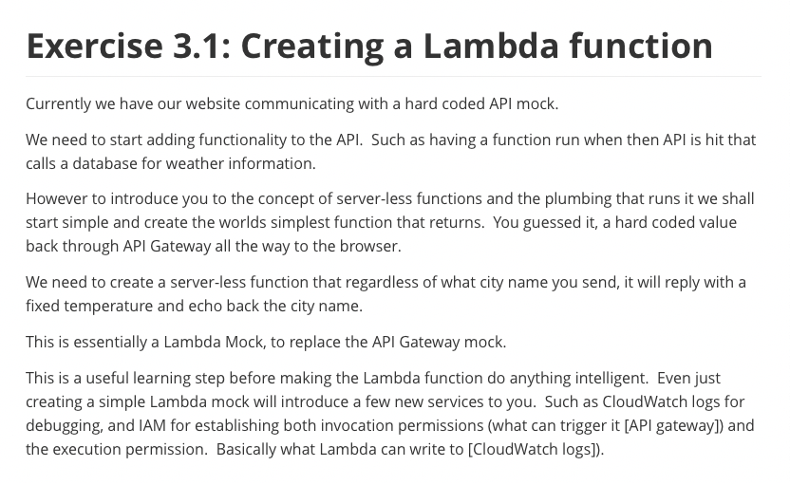

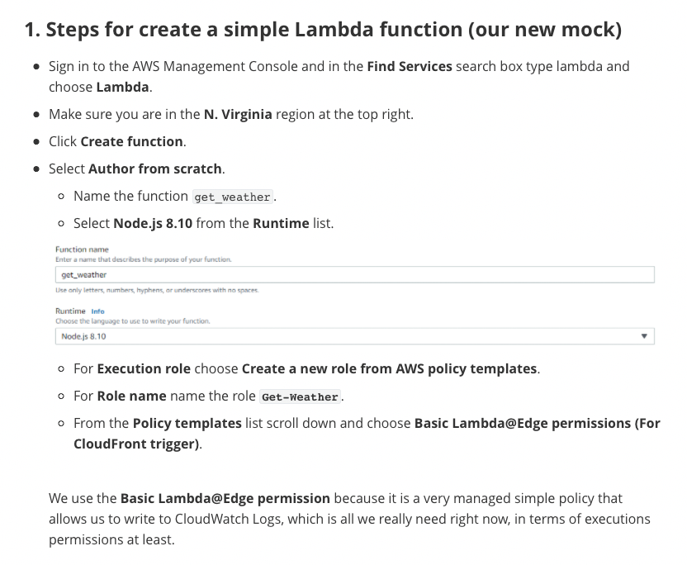

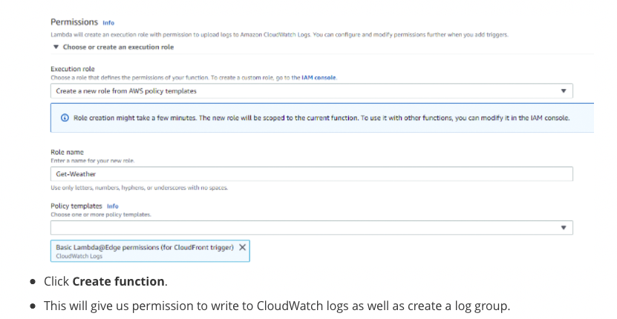

{

"Version": "2012-10-17",

"Statement": [

{

"Effect": "Allow",

"Action": [

"logs:CreateLogGroup",

"logs:CreateLogStream",

"logs:PutLogEvents"

],

"Resource": [

"arn:aws:logs:*:*:*"

]

}

]

}

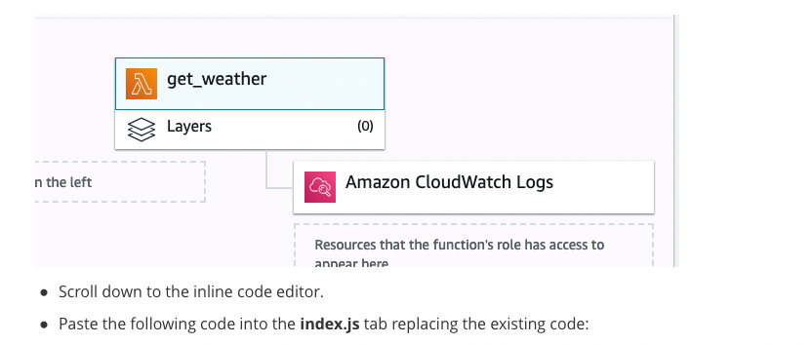

function handler(event, context, callback){

var

city_str = event.city_str,

response = {

city_str: city_str,

temp_int: 74

};

console.log(response);

callback(null, response);

}

exports.handler = handler;

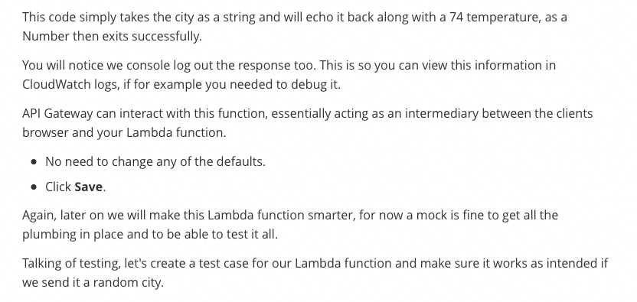

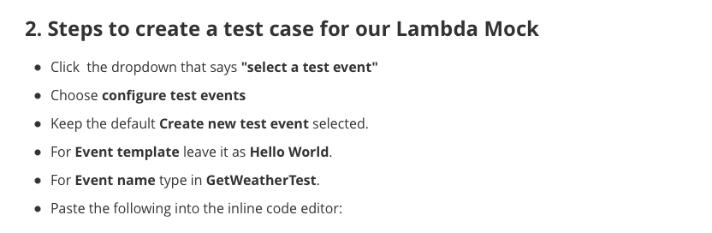

{

"city_str": "LA"

}

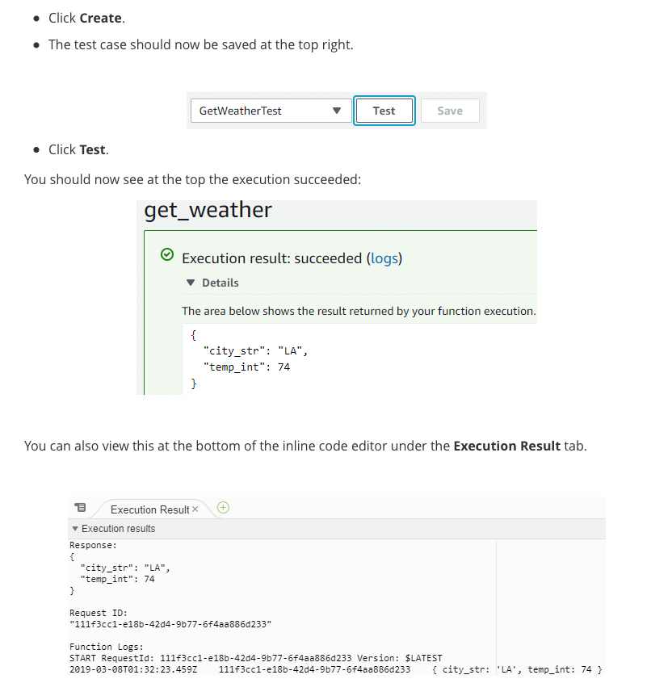

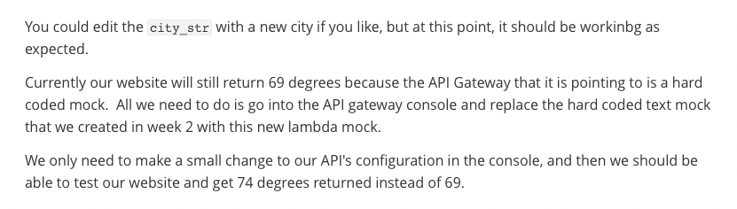

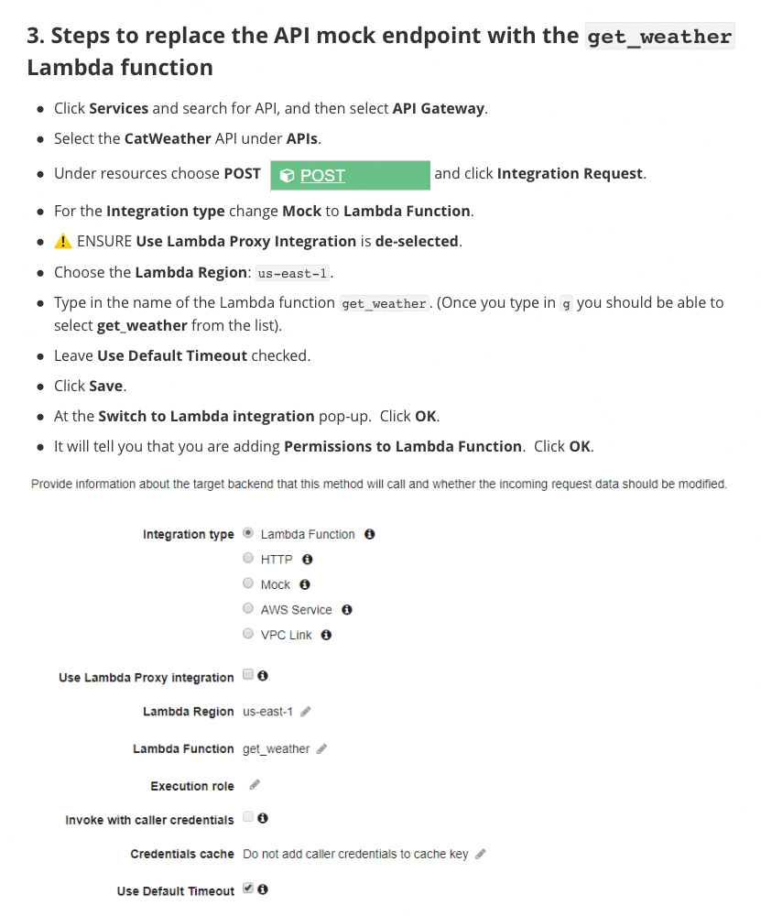

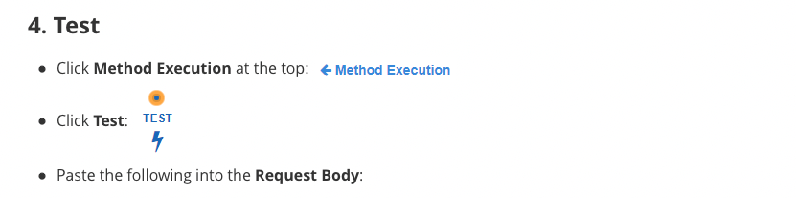

{

"city_str": "SEATTLE"

}



{

"city_str": "SEATTLE",

"temp_int": 74

}



Sending request to https://lambda.us-east-1.amazonaws.com/2015-03-31/functions/arn:aws:lambda:us-east-1:179741345863:function:get_weather/invocations

Method response body after transformations: {"city_str":"SEATTLE","temp_int":74}

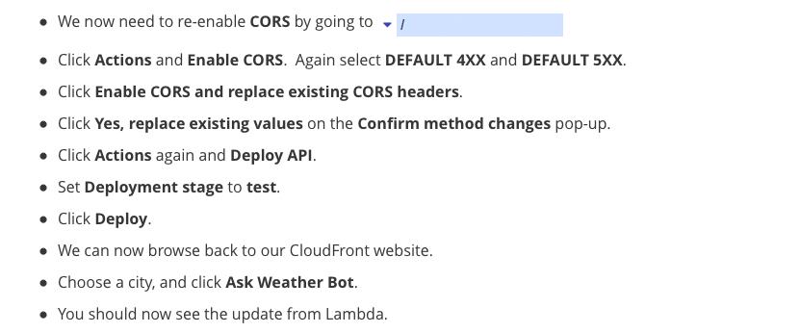

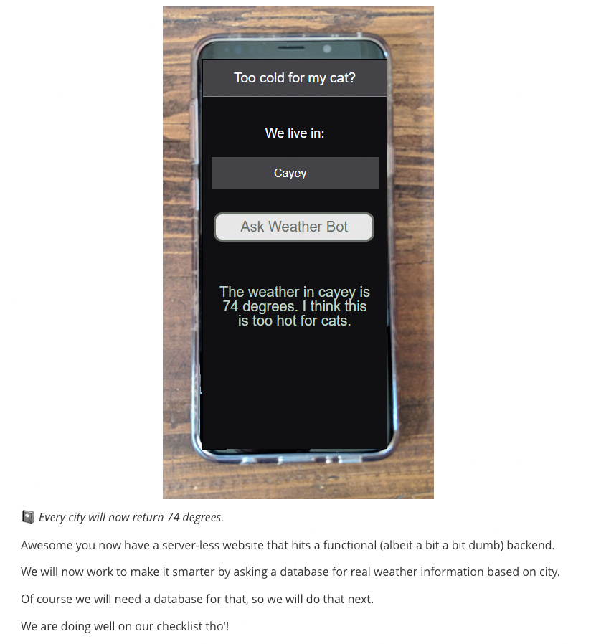

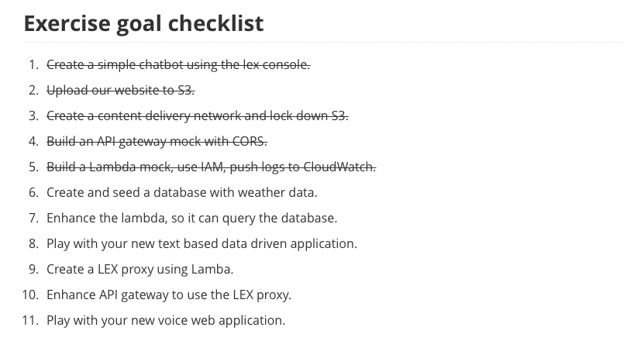

## **Amazon DynamoDB**

### **Introduction to Amazon DynamoDB Part 1**

[Adam] Hi, welcome back.

In this portion of the class, we're discussing

the serverless NoSQL solution

on AWS called Amazon DynamoDB.

Together, we will discover how DynamoDB service

stores data, sorts, and completes scans and queries.

Amazon DynamoDB makes your life easier

by offering a simple and cost-effective way

to store and retrieve any amount of data

and serve any level request of traffic.

Listen, we are talking

about millions and millions of requests here.

It's important to understand

the foundational concepts of DynamoDB,

such as partition keys and sort keys,

as well as local and global secondary indexes.

That was a mouthful.

Okay. Let's start with the basic concept of a table.

Remember, we're not building a database here

in the traditional sense. Instead,

in DynamoDB, we call that set of information "tables."

A table is a collection of items,

and each item is a collection of attributes.

I'll tell you what.

Let's draw this out, so that it's easier to understand

as I explain the remaining things that make up a table.

First is the partition key, which is a simple primary key,

composed of one attribute.

In the case of our table, we are storing music data.

Our primary key should be "Artist."

You see that next to the partition key is a sort key.

That should be a song title.

When a partition and a sort key exist in a table,

it is referred to as a "composite primary key"

and is composed of two attributes.

The first attribute, again, is Artist.

The next attribute is Song Title.

Okay. So, while this table isn't super useful yet,

it will become useful when we add attributes.

Let's think of some attributes to add

that are music related.

Hmm, well chart number.

Let's see, that's pretty important.

Genre, year, beats per minute.

For creating playlists to match your speed,

that's kind of important, too.

All this data seems like it would be very helpful to know.

So now, let's add those attributes to the table

that we've drawn previously.

Wow. This table's actually starting to become useful.

But now, we need to figure out how this data will be queried

to derive meaningful insights.

Let's talk indexes.

A "secondary index" is a data structure

that contains a subset of attributes from a table,

along with an alternate key to support query operations.

A table can have multiple secondary indexes,

which give you application access

to many different query patterns.

First up is a local secondary index.

That's an index that has the same partition key

as the base table, but a different sort key.

So, an example of a query that we could use

on a local secondary index would be to say,

let's find all of the songs, the number one songs,

from a particular artist, one artist.

A "local secondary index" is an index

that has the same partition key as the base table,

but a different sort key.

A good example of a local secondary index query

would be all the songs from a particular decade per artist.

So if I have a favorite artist,

all the songs from the 80s, all the songs from the 90s.

That would be an example of a query

for a local secondary index.

A "global secondary index"

is an index that has a partition key and a sort key

that can be different from those based on the base table.

So, an example of a global secondary index query

could be all the number one songs from a particular artist.

Or, all of the songs of a particular genre -

doesn't matter what artist produced them.

I want you to pause and consider for a moment

how you will use DynamoDB.

The secret to a successful deployment

is to develop your application first

and determine what your queries will look like.

Then, design your tables to best serve that data.

Next, let's review a bit about performance.

Provision throughput is represented

in units of read and write capacity.

There are several options to manage this.

First is the ability for you to provision throughput,

again, based on read and write capacity units.

There are a number of ways

for you to configure this setting.

Be sure to use our good friend

Amazon CloudWatch to help guide you

with your decision to increase or decrease.

Next, you can use the on-demand mode for DynamoDB.

This will help you get up and running quickly

without much concern to performance configurations.

And then, auto scaling.

Auto scaling is a way for you to run a more forgiving

type of DynamoDB environment.

Auto scaling allows DynamoDB to scale based on demand,

much like you could with EC2 for compute.

As far as performance goes,

these tools are largely automated,

since it's a managed service,

which is really nice for you.

In our next video, I will show you

how to create a DynamoDB table

and enter items into it to make it more useful.

Thanks for watching.

### **Introduction to Amazon DynamoDB Part 2**

[Adam] In this demonstration,

we're going to build out an Amazon DynamoDB table,

and then we're going to run a query against it.

So, let's get started.

At the AWS Management Console,

we'll go ahead and look for DynamoDB in the search bar.

It pops right up.

Click,

and then I'm presented with the service front page.

Now, there is some learning opportunities here,

but, again, we're focusing on creating a table.

So, I'm going to click Create table.

For our Table name, we'll put "Music,"

the Partition key will be "Artist,"

and in this case, I'd like to add a sort key,

because artists could have more than one song.

Typically, they do.

So, let's go ahead and make the sort key "Song Title."

Great.

Now, let's scroll down.

We could select the default settings,

and as you can see on the screen,

it sets it up with really no fuss about performance

or any of the other parameters

that you would typically have to set.

It just gets you up and running.

In this case, I'm going to deselect the default settings,

and that's so I can show you the different areas

that you could configure for DynamoDB.

Scrolling down, you'll see

that you can add secondary indexes.

By the way, if it's a local secondary index,

which this would be,

this is your one and only opportunity to add it.

Read and Write capacity mode.

We can choose whether we want this Provisioned,

or if we want it placed into that On-demand,

which remember is a very forgiving environment

for us to run our DynamoDB in.

In this case, we're going to stick on the free tier,

and use Provisioned at 5 Read

and 5 Write capacity units.

Auto Scaling is next.

You'll notice that you can auto scale

your Read and your Write,

one or the other, or both,

and you set this by the total utilization

of the Read or the Write units.

Scrolling down further,

I have the ability to use an IAM role that already exists,

or I can have the DynamDB service create that for me.

Scroll down further, and then enable Encryption At Rest.

You can select encryption settings for your DynamoDB,

DEFAULT or KMS.

I'm going to just review my settings here,

and I'm going to click Create.

The table is being created,

and it takes anywhere from 1 to 3 minutes, on average.

Now that the table has been created,

I'm going to want to add some items.

So, let's take a look at the Items tab.

I'll click on the Create item button,

and a window appears.

This allows me to enter the values

for Artist and Song Title.

So for Artist, I have a favorite artist of mine,

and that is Jon.

My favorite song of Jon's

is the Maple Syrup Blues.

Okay. I've added my artist and my song,

and now, you'll see that the item appears.

I'm going to add a few other items to the table,

and then we'll come back.

All right, now that we have all of our items

populated in the table,

I'm going to run a query.

So, I'm going to click the pull-down.

It says Scan currently, but don't worry,

there's a Query under that.

We click Query,

and we're going to set our values to run this on.

You notice that the Partition key is Artist.

The Sort key is Song Title.

So in this case, I'd like to say

that I want see all the songs

written or sung by Evan.

I place him in the key for the Artist,

and I click Search,

because I don't need to enter a specific song title value,

because he has many songs that he's written or sung.

In this case, "All My AMI's Live in Texas" and "S3 Rhapsody"

are Evan's two hits that I have populated in the table.

All right, so that was how you build out a DynamoDB table,

enter items, and run your first query.

Well, that's it for the DynamoDB demonstration.

You're going to be able to apply what you've just learned

in the exercise that Rick has put together for you.

I'll see you in future topics.

### 

### 

### 

### 

### 

### 

### 

### 

### 

### 

### 

### **Exercise 3.2 Amazon DynamoDB**

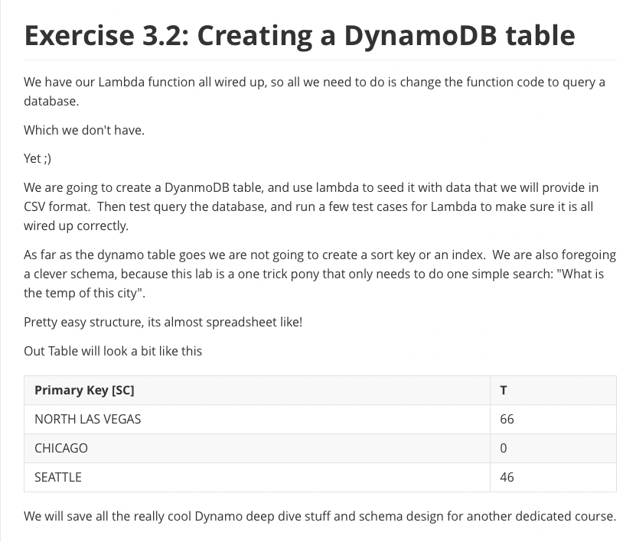

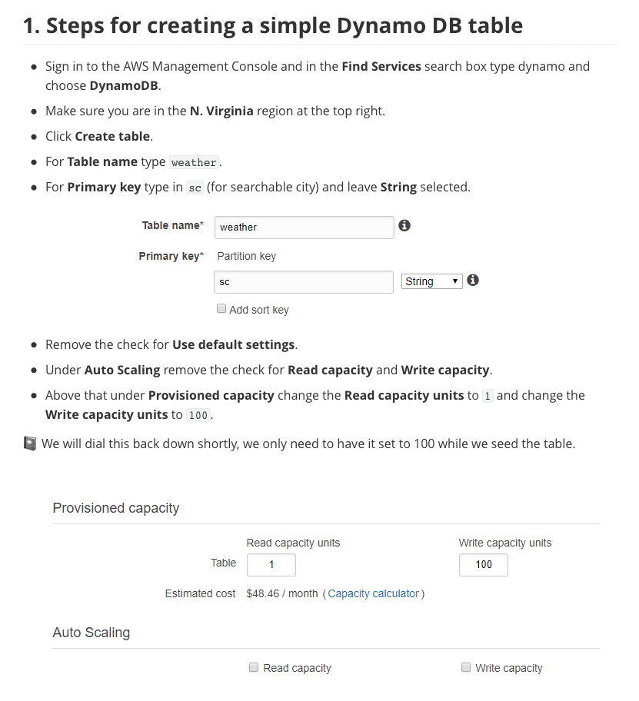

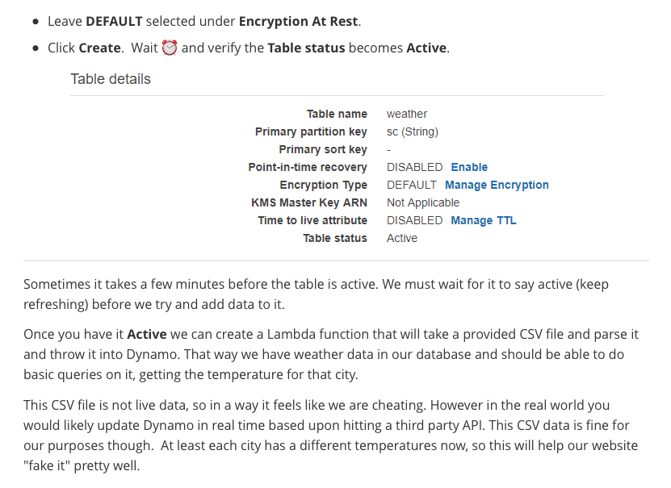

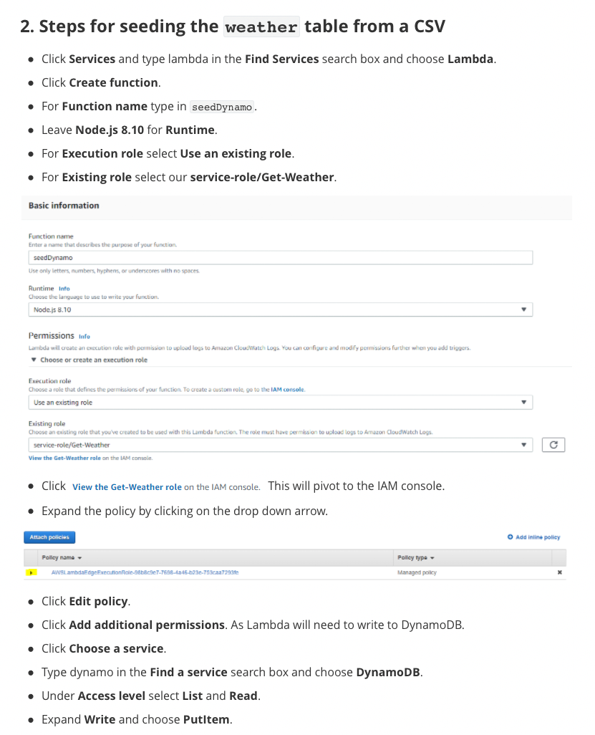

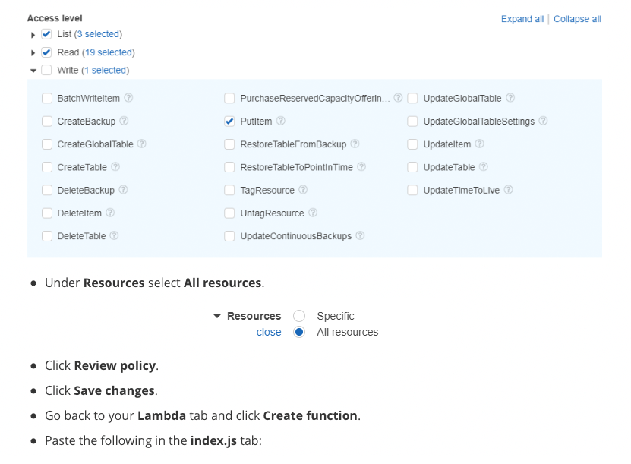

exports.handler = function(event, context, callback) {

var

AWS = require("aws-sdk"),

fs = require("fs"),

item = {},

some_temp_int = 0,

params = {},

DDB = new AWS.DynamoDB;

AWS.config.update({

region: "us-east-1"

});

fs.readFileSync("cities.csv", "utf8").split('\n').map(function(item_str){

params.ReturnConsumedCapacity = "TOTAL";

params.TableName = "weather";

params.Item = {

"sc": {

"S": item_str.split(",")[0]

},

"t": {

"N": String(item_str.split(",")[1])

}

};

DDB.putItem(params, function(err, data){

if(err){

console.error(err);

}else{

//ignore output

}

});

});

setTimeout(function(){

callback(null, "ok");

}, 1000 * 10);

}

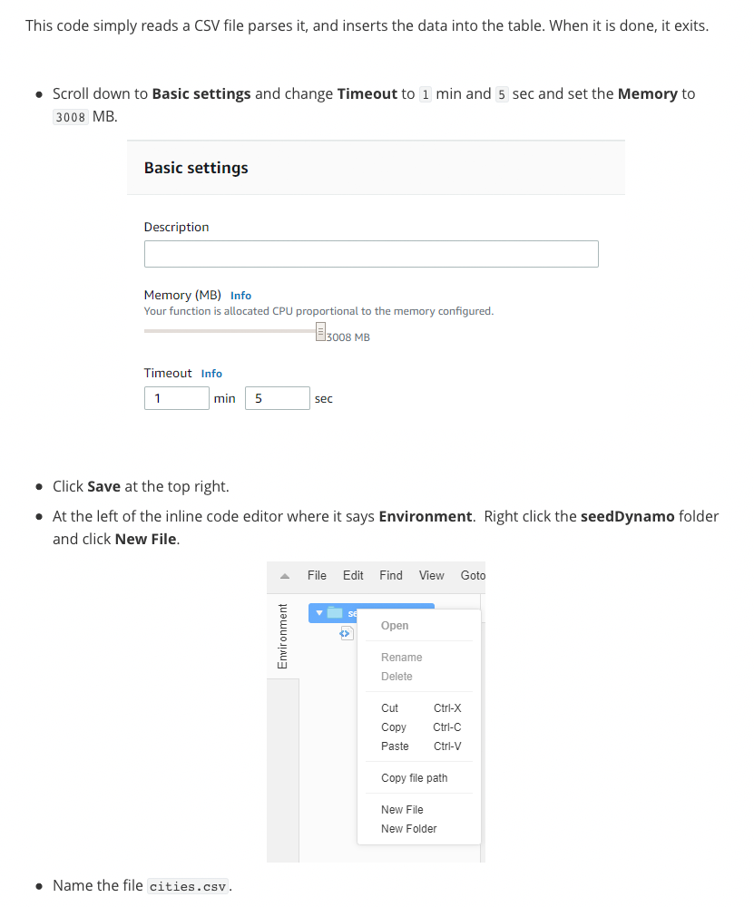

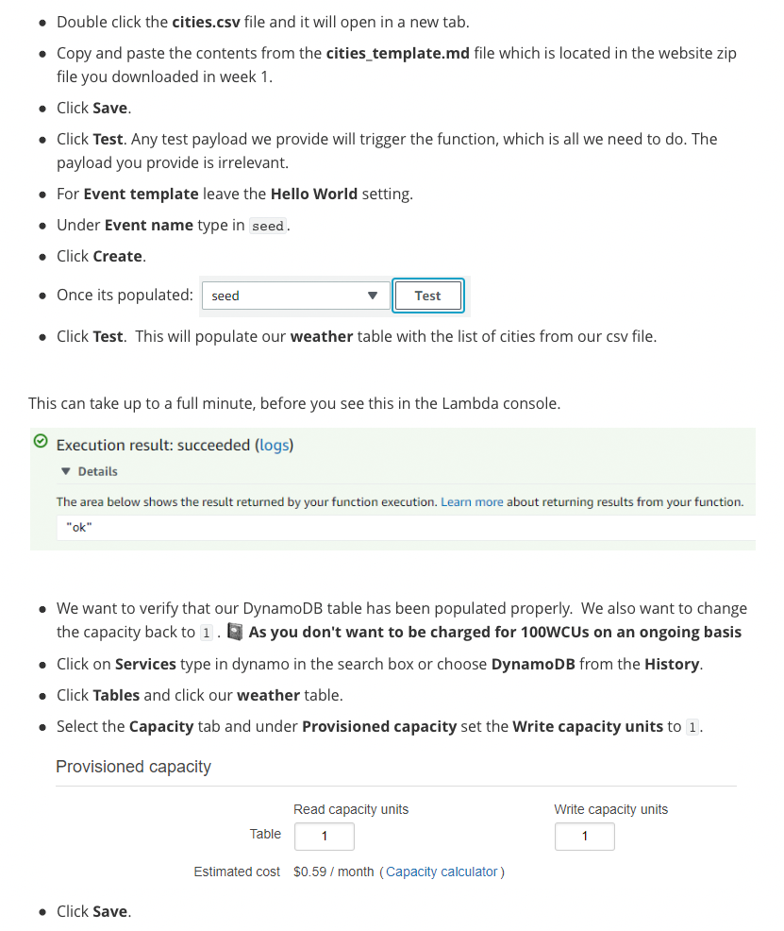

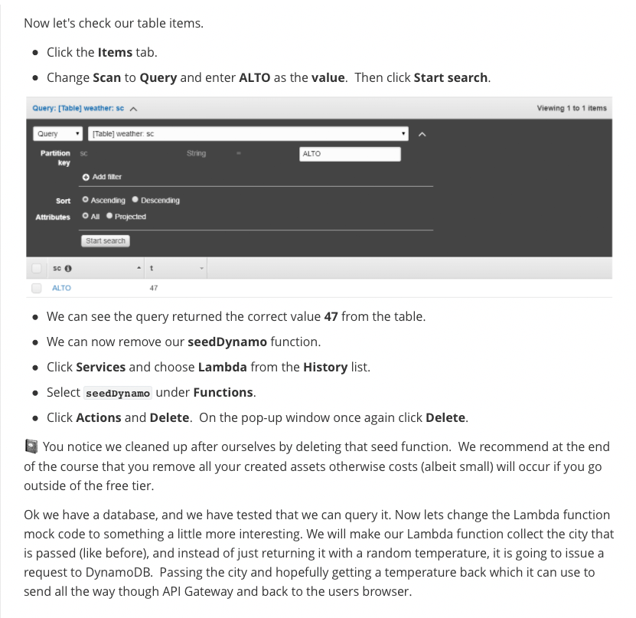

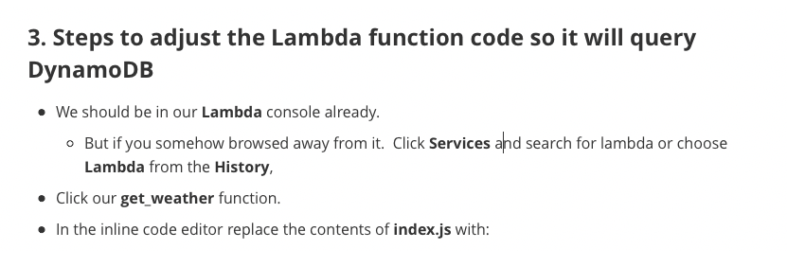

function handler(event, context, callback){

var

AWS = require("aws-sdk"),

DDB = new AWS.DynamoDB({

apiVersion: "2012-08-10",

region: "us-east-1"

}),

city_str = event.city_str.toUpperCase(),

data = {

city_str: city_str,

temp_int_str: 72

},

response = {},

params = {

TableName: "weather",

KeyConditionExpression: "sc = :v1",

ExpressionAttributeValues: {

":v1":{

S: city_str

}

}

};

DDB.query(params, function(err, data){

var

item = {},

response = {

statusCode: 200,

headers: {},

body: null

};

if(err){

response.statusCode = 500;

console.log(err);

response.body = err;

}else{

// console.log(data.Items[0]);

var data = data.Items[0];

if(data && data.t){

console.log(data.sc.S + " and " + data.t.N);

item = {

temp_int:Number(data.t.N),

city_str: data.sc.S

};

}else{

item = {

city_str: event.city_str

//when we don't return a temp, the client can say city not found

};

}

}

response = item;

// console.log(response);

callback(null, response);

});

}

exports.handler = handler;

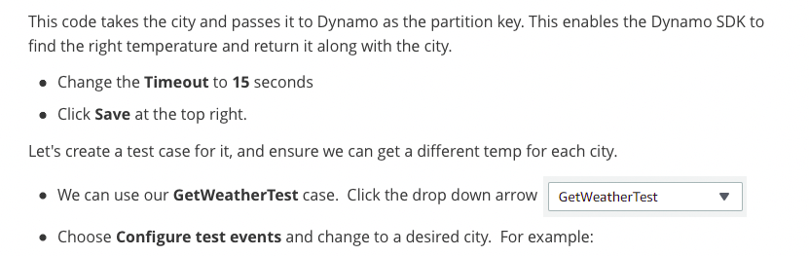

{

"city_str": "DENVER"

}

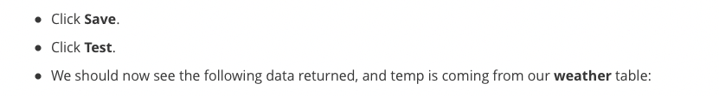

{

"temp_int": 38,

"city_str": "DENVER"

}



{

"city_str": "PITTSBURGH"

}



{

"temp_int": 78,

"city_str": "PITTSBURGH"

}

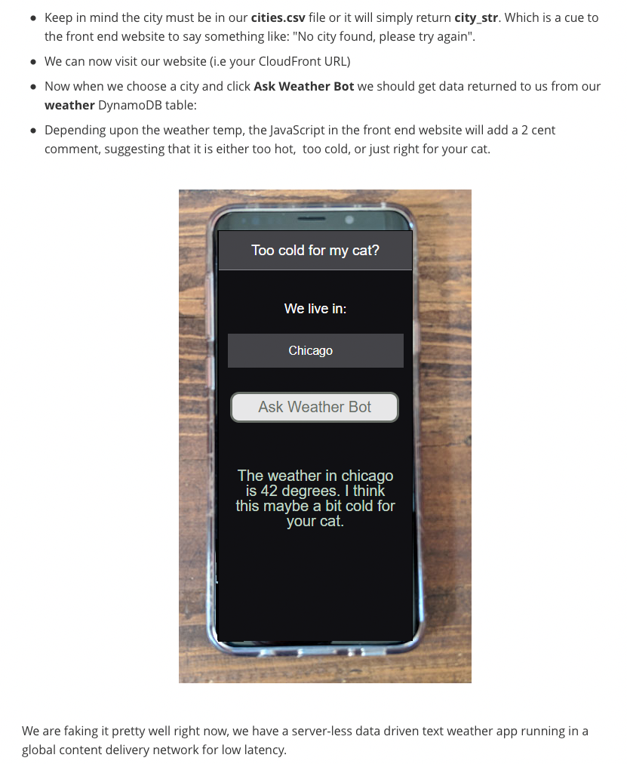

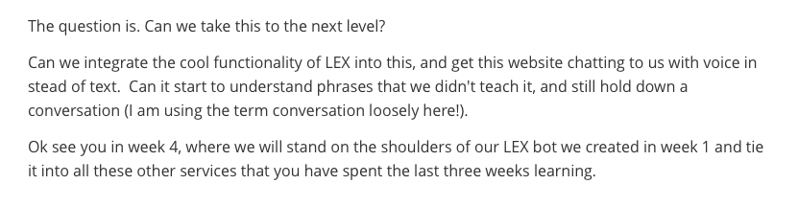

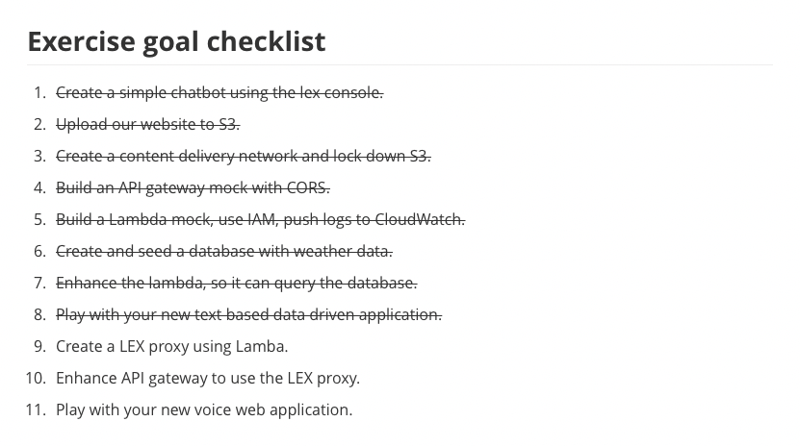

## **Week 3 Readings/Resources**

### **Amazon DynamoDB**

[Amazon DynamoDB](https://aws.amazon.com/dynamodb/) is a fast and flexible NoSQL database service for all applications that need consistent, single-digit millisecond latency at any scale. It is a fully managed cloud database and supports both document and key-value store models. Its flexible data model, reliable performance, and automatic scaling of throughput capacity make it a great fit for mobile, web, gaming, ad tech, IoT, and many other applications. [Pricing for DynamoDB](https://aws.amazon.com/dynamodb/pricing/) includes a non-expiring free tier allotment. **AWS Identity and Access Management**

[AWS Identity and Access Management (IAM)](https://docs.aws.amazon.com/IAM/latest/UserGuide/introduction.html) is a web service that helps you securely control access to AWS resources. We typically use credentials from *IAM Users* or *IAM Roles* to authenticate with AWS when making API calls. We control the permissions for which API actions those Users or Roles can perform with *IAM Policies*.

In this course we focus on [IAM *roles*](https://docs.aws.amazon.com/IAM/latest/UserGuide/id_roles.html). An IAM role is an IAM identity that you can create in your account that has specific permissions. Unlike an IAM user, A role is intended to be assumable by anyone who needs it. Also, a role does not have standard long-term credentials such as a password or access keys associated with it. Instead, when you assume a role, it provides you with temporary security credentials for your role session.

IAM is a feature of your AWS account offered at no additional charge. You will be charged only for use of other AWS services by your users. Detailed information about AWS IAM can be found in the [documentation](https://docs.aws.amazon.com/IAM/latest/UserGuide/introduction.html).

### **AWS Lambda**

[AWS Lambda](https://docs.aws.amazon.com/lambda/latest/dg/welcome.html) lets you run code without provisioning or managing servers. AWS Lambda executes your code only when needed and scales automatically, from a few requests per day to thousands per second. You pay only for the compute time you consume - there is no charge when your code is not running.

Because your code is only running on-demand, in order to troubleshoot, you'll need to take advantage of [monitoring](https://docs.aws.amazon.com/lambda/latest/dg/troubleshooting.html). You can [troubleshoot Lambda with Amazon Cloudwatch](https://docs.aws.amazon.com/lambda/latest/dg/monitoring-functions.html) and also [troubleshoot Lambda with AWS X-Ray](https://docs.aws.amazon.com/lambda/latest/dg/lambda-x-ray.html).

With Lambda, there are [2 types of permissions](https://docs.aws.amazon.com/lambda/latest/dg/intro-permission-model.html) to be aware of. First, your code running in a [Lambda function is granted permissions by using an IAM Role](https://docs.aws.amazon.com/lambda/latest/dg/intro-permission-model.html#lambda-intro-execution-role). Second, the service triggering your Lambda function can be granted the permissions to do so with a [Lambda Function Policy](https://docs.aws.amazon.com/lambda/latest/dg/intro-permission-model.html#intro-permission-model-access-policy). When configuring triggers using the AWS Management Console, the console will create the necessary Lambda Function Policy for you when you enable the trigger.

If you want more details about what's available to your code as it runs inside AWS Lambda, you can find out more about the [Lambda execution environment](https://docs.aws.amazon.com/lambda/latest/dg/current-supported-versions.html) in the documentation.

## **Extending Our App**

### **Extending Our App Part 1**

[Jon] In week one, I told you about Lex.

We had some fun in the console with a simple BookTrip bot.

There are a few components that I did not discuss

during that lecture, and most of it

had to do with the Lambda integration.

Now that you know about Lambda,

it's time to discuss the interaction between Lex and Lambda.

Let's take a look at our BookTrip bot again.

It has two intents: BookCar and BookHotel.

We're going to go in BookHotel.

When the user enters a utterance,

Lex chooses the right intent and then uses prompts

to ask questions to the user to fill every slot

of the intent so it can be fulfilled.

So we can see, many slots are at the bottom in here.

As I mentioned, in the Lambda integration wasn't discussed,

this includes the Lambda initialization

and validation, as well as the fulfillment.

The reason to use Lambda for fulfillment

is the same reason as to why you

would use Lambda to replace servers.

You only pay while your Lambda function is running,

and it's serverless, which means you don't need to

manage the components behind Lambda,

and you can concentrate on your backend code.

In this bot example, I will want the Lambda function

to include the pricing for the hotel booking

and car booking, add the fulfillment on.

Let's first look at validation, though.

When the intent in configured to invoke a Lambda function

as initialization and validation code hook,

Amazon Lex invokes the specified Lambda function

on each user input after Amazon Lex understands the intent.

If the intent is not clear,

Amazon Lex can't invoke the Lambda function.

Why would we want a Lambda function invoked

for every single utterance or prompt?

Validation, of course!

But don't we already do validations in the case

where we select Restrict to Slot values

and Synonyms in a slot type?

As an example right here - restrict to slot types.

Well, yes, but sometimes we don't control

the slot because it's a built-in slot.

As you can see, the slots down here, the Amazon ones.

Let's take the Location slot

of the BookHotel intent as an example.

What if we only had hotels

in a very specific list of cities?

We can't change the Amazon.US_CITY slot type,

to include only the values that we want.

It's a built-in slot type.

That's where Lambda comes to our rescue.

It allows us to extend the capabilities of the bot.

Let me show you what happens when I

book a hotel in Moscow right now.

As you can see, it prompts me back to supply a city.

Let's supply Moscow.

It continued on.

As you can see, this city's accepted.

However, what if it wasn't one of the city we had hotels in?

Well, there's no validation here.

Of course, it will let me go.

We will need to fix that.

Let's finish this iteration with the bot to refresh

your memory of what happens across this entire bot.

So in here: "What day do you want to check in?"

I'll answer: tomorrow.

"How many nights will you be staying?"

Five.

Then finally: "What type of room would you like,

queen, king, or deluxe?"

Queen is good for me.

I get a confirmation prompt: "Okay, I have you down

"for a 5 night stay in Moscow starting

on 2019-02-21.

Shall I book the reservation?"

Yes.

And I get back the normal fulfillment

that you have seen in the past.

To add validation, we first need

to create a Lambda function.

I will be using a blueprint, as the Lex team

was nice enough to give us a template

for the Lex sample bot that we all need to use.

From the Lambda console, I'll click Create function.

I'll select Blueprints and then search for Lex.

I can see that the lex-book-trip-python blueprint

isn't here, and that's the one I will use.

I'll click Configure at the bottom of the page,

and I'll need to supply a name for it.

I'll give it a name like lex-book-trip.

And then I will have to choose a role for my Lambda function

to be able to send logs to CloudWatch Logs.

Let's not look at the code yet, though.

I'll create the function.

Let's go back to the Lex console to modify our bot

to send this traffic towards this Lambda function.

In the Lex console, I will modify both intents

to use this Lambda function for initialization

and validation, as well as fulfillment.

So in the BookHotel, I am going to go to the section

of Lambda initialization and validation,

select that check box, select our lex-book-trip function,

and I'll get this popup.

That is asking me to allow Lex to call our Lambda function,

else Lex won't be able to send that request to it.

I'll click OK here.

Let's do the same with the BookCar intent,

as well as the fulfillment in there.

I'm starting to build now, for my chain should take effect.

With the power of recording,

I will skip ahead for the build to finish.

Okay, it's ready for testing.

Let's try the same example as earlier.

Book a hotel.

"What city will you be staying in?"

Moscow.

And I get this prompt, "We currently do not

support Moscow as a valid destination.

Can you try a different city?"

It doesn't seem to want to let me

go forward with the city.

That is normal, as Lambda is now doing

the validation and only allows a specific set

of cities where we have hotels.

You are welcome to look at the Lambda code

if you feel comfortable with Python.

It will explain a few things that are in here.

However, instead of looking at the code itself,

I will explain to you the flow of the data

passed back and forth between the client, Lex, and Lambda.

Let me explain it to you in a diagram now.

As you can see in this picture,

I have a user on the left-hand side,

Lex in the middle, and Lambda on the right.

The user inputs, "Book a hotel."

That is a sent as a utterance towards Amazon Lex.

Amazon Lex will parse the data and send it

as an input JSON to Lambda.

Lambda will do its validation and then return

some output JSON statement towards Lex.

And Lex will finally send some of that response

back towards the user, which will probably prompt for

"In which city," by that point.

The user can now enter Moscow at that time.

Now, remember that the first step

is the data sent from the client into Lex.

If I roll back a little, I have "Book a hotel,"

the data gets sent into Lex.

Let me restart this test that I have here

by clicking on Clear chat history.

I'll book a hotel.

Let's see what is sent into Lex in this case.

Because remember, I have the utterance

that is now sent into Lex.

Let's take a look at that JSON payload.

This is the data that is being sent.

You can see that there is the client

sending a POST towards our BookTrip

in the alias LATEST and for a very specific user.

I will come back to this user

a little bit later in this lecture.

I also can see the inputText data: book a hotel.

That is what will be sent towards Lex.

The next step is for Lex to send

the data to Lambda and input JSON.

Let me switch back towards the input

that was sent, and then this is it.

A lot of information is here, but let's take a look.

The invocation source is set to -

so, invocationSource - to DialogCodeHook.

This is how the Lambda function knows

that it's supposed to do validation of the entries

and not do fulfillment, as that will be

the other option that we will see later.

We can see the bot name, BookTrip, in there,

in case that the same Lambda function

was used for more than one bot.

The currentIntent name is pretty important though,

because I'm reusing that same Lambda function

for BookHotel and BookCar.

It's currently set to BookHotel,

which means Lex was able to figure out that we wanted

to book a hotel from the text that was sent.

That didn't seem that difficult.

All of the slot types are currently set

to null, as you can see.

So Lambda doesn't need to do much validation at that point.

So to itself, it doesn't really do anything there.

However, it will need to send some data back towards Lex.

Now that Lambda has done that processing,

which means that it's essentially nothing this time around,

as it's only the initialization,

it will send data back to Lex.

Let's take a look at it.

This is how our response looks like.

It needs to be a dialogAction type.

I will have a dialogAction of type: Delegate.

This means - or that directs Amazon Lex to choose

the next course of action based on the bot configuration.

That next course of action is to prompt

for the first launch, which is the city, right?

If we look at our configuration of our bot,

we can see that the first slot is the Location.

So it needs to say, "What city will you be staying in?"

The data will be sent as a Lex response

back towards the user.

Let's take a look at what that looks like.

What I get is "What city will you be staying in?"

sent back towards the user as you saw inside of the console.

I will now go back into my Lex console and write Moscow.

Let's go back to our diagram now.

What did I just do?

Well, I just sent a prompt into Lex.

I just fulfilled a slot.

It is the exact same four steps

that will need to happen again here.

Let's take a look at all of those four interactions' payload

and then we're not going to really come

back into this diagram now.

So the next section is the client sends Moscow.

As you remember, the inputText is set to Moscow.

Next, Lex needs to send that data into Lambda.

So, the data that is now going to be sent is towards

the currentIntent, name: BookHotel.

And then the location is now going to be set to Moscow.

Lambda can now process the city

and validate it against its list of cities

where there are available hotels.

In this case, Moscow isn't part of it.

Here is what Lambda sends back.

It will say dialogAction type, of type ElicitSlot,

which informs Lex that the user is expected

to provide a slot value in the response.

The intentName is specified - BookHotel -

and the Location is now set back to null,

as it wasn't valid, and the slotToElicit

is now set to Location, which is the important one.

We now tell Lex which slot to prompt back the user for.

However, instead of using a built-in message,

we also supply a message to the user.

"We currently do not support Moscow as a valid destination.

Can you try a different city?"

That is what will be sent towards the user.

That data is now sent back to the client.

Here's what Lex sent.

"We currently do not support Moscow as a valid destination.

Can you please try a different city?"

This time around, the client is ready

to choose a different city.

Let me pick another one, Chicago.

Oh, it seems it let me through.

Let's go and take a look at what happened there.

The client sent Chicago -

inputText: Chicago.

Lex sends the data into Lambda.

This time around, currentIntent, name: BookHotel.

And then the Location: Chicago.

Nothing really has changed in this case.

Now Lambda will need to validate this city.

Chicago is a city where we have a hotel,

so this passes the validation.

This is what Lambda replies.

DialogAction, type: Delegate.

A Delegate type, as we want Lex to continue

its processing to the next slot.

As you can see, Lex is now asking for the check-in date.

"What day do you want to check in?"

Yes, it's the next one in the order.

If you remember well, I have the Location,

and then the number two is CheckInDate.

So that's why I used that prompt.

We've now seen how validation works between Lex and Lambda.

In our next video, I'll go over how to do fulfillment

with Lambda and the usage of session attributes.

I'll see you there.

### **Extending Our App Part 2**

[Jon] In our previous lecture,

we used Lambda to validate slot values.

I will continue from that example to discuss

fulfillment and session attributes.

I'll start by interacting with the bot

and fill all of the slots this time.

Book a hotel.

"What city will you be staying in?"

I will select Chicago.

"What day do you want to check in?"

Tomorrow.

"How many nights will you be staying?"

Five nights.

"What type of room would you like, queen, king, or deluxe?"

Queen.

I'm now getting a prompt configuration,

but something has changed here

from the time where we didn't have Lambda integrated.

If you look, a price is provided for this hotel.

Don't worry, though, it's just a generated price randomly.

It's not that expensive to stay in Chicago.

Well, I hope not!

To understand how this happened,

you will need to understand another concept

called "session attributes."

They contain application-specific information

that is passed between a bot and the client application

during a session.

Amazon Lex passes session attributes

to all Lambda functions configured for a bot.

If a Lambda function adds or updates session attributes,

Amazon Lex passes the new information back

to the client application.

Session attributes can also be used

to add more information in the prompts

to the user, as you can see it here.

How long are those sessions being kept?

Well, if we go under the Settings of our bot,

under General, you will find the Session timeout here.

We can see that it's currently set to 10 minutes.

You may also be wondering what constitutes a user to Lex.

Well, when a request is sent to Lex,

a user ID is also passed,

and that's what Lex will use as its key

to associate all of the session's attributes

until the timeout is reached.

Your application is responsible for generating it.

When testing with the Management Console,

it is generated automatically for you.

That's why we never had to worry about it.

Back to our interaction with the bot,

we just sent the last piece of information to Lex.

That was the last slot to fill,

which looks like the following.

As you can see, it is a POST for queen as my bed,

but you can also see the user ID right here.

That's what I meant by the user IDs being sent into Lex.

Lex then sends that information to Lambda.

The Lambda function will need to realize

that all of the slots have been filled,

as you can see it right here.

And it will need to use a session attribute

called currentReservationPrice,

it's up to the Lambda function to decide that,

to store the price of the hotel.

Lambda will send back that data

to Lex as you can see it.

It uses the Delegate function

to let Lex continue with its processing,

provides all of the slots again.

But, there's something a little bit different here.

The sessionAttributes is currently set

to currentReservationPrice: 1195,

$1,195 dollars,

which is what we saw in our prompt.

Let's take a look at the prompt

that we'll be using this information here.

Back into our Editor, I will go

towards the Confirmation prompt.

Clicking on the little gear icon,

I can see the price of this night - amount of night

night stay in the Location, from checkInDate, is

[currentReservationPrice].

As you can see, there are two prompts.

One of them makes use of those square brackets,

referring to that currentReservationPrice.

This is the way to invoke session attributes

within a prompt.

The client can now confirm that the entry

is correct at that point.

So, I will type Yes here.

The input data for this is going to look like the following.

As you can see it, inputText: Yes.

This time, Lex will invoke the Lambda function

with a different invocation source,

as you can see it here -

invocationSource: FullfillmentCodeHook.

That is how Lambda knows that it's supposed

to fulfill this.

It can use all of the slot's data

to do the booking in the backend system.

Lambda will need to send one last dialog action back,

and that is of type: Close,

with the fulfillmentState set to Fulfilled.

A message can also be supplied,

or the Response section of the bot will be utilized.

In this case, we use the message.

Lex will send that message back to the user

and then now our interaction with our bot is now finished.

However, the session is still alive.

It's set to 10 minutes.

And if the user wanted to continue booking a car,

there are some slots that are already filled

from our previous interaction with the bot

during our book hotel.

Let's test that out.

Let me book a car.

As you can see, it asks me a question:

"Is this car rental for your 5 night stay

in Chicago" around that date?

Huh, it found that information.

If I look at the Summary, it even figured out

the PickUpCity Chicago,

and it figured out my PickUpDate and my ReturnDate,

and did the math for me.

This is done using the Lambda function

and the session attributes that can be passed

between all of the different intents.

I'm inviting you to explore the code

to see how this was done, if you're familiar with Python.

Soon, you'll put to use everything you have learned

about Lex into an exercise.

Thanks for watching.

### **Adding a Channel**

[Jon] If you want to extend your bot further,

let's see how I can integrate different

channels with my Lex bot.

This is done using the Lambda function

in the session attributes.

I'm inviting you to explore the code

to see how this was done, if you have the time

and if you want to read some Python code.

Now that I have a bot that is fully tested,

I can publish it and show you the Channels tab.

On top of easily integrating Lex into web UI,

like you will do in the next exercise,

or in your mobile application via

the AWS mobile SDK, you can integrate your bot

with Facebook Messenger, Kik, Slack,

and Twilio SMS.

Let's see how to do that with Facebook Messenger.

First, we need a name.

I'll input ServerlessChatBot.

Then, I need to fill which alias

I want to associate to my Facebook page.

Ill use prod, that we've created before.

Then, I need to select which Key Management Service key

I want to use to encrypt all of the data

that I will use below.

I'm going to leave it as aws/lex.

I need to input a verify token that I will use,

reuse it in fact, on the Facebook developer portal.

I'm going to use the verysecuretoken.

It's a very secure token.

For the other two parameters,

I need to go on Facebook to get those.

First, I will create a Facebook page.

I hit the Create button and select Page.

I will use Community or Public Figure

by clicking the Get Started button.

My page is going to be called Serverlesschatbot

and then the category is going to be Just For Fun.

Then, I will click Continue.

I'll skip the next two steps out here

because I don't really need that here.

Now that I have a page, I will need to jump over

to the developer portal of Facebook,

a little bit different website.

In here, where I'm already logged in,

I'll create a brand new application

by clicking on the My Apps menu at the top,

and clicking Add New App.

For the Display Name, I'm going to use Serverlesschatbot.

They don't need to match, but it's all right,

and I'm going to make them match.

I'll click Create App ID.

I'll confirm that I am not a robot,

and I'll click Submit.

Going under the Settings, under Basic,

I am going to find my App Secret.

I'll need to click that Show button right here

to display it.

I'll take this App Secret, go back to Amazon Lex,

and enter it as my App Secret input here.

Next, I'll go back to my developer portal in Facebook.

I will go under the Products page, and I will add Messenger,

and I'll set up Messenger here.

I will go under the Token Generation, and I'll select

the Facebook page I created called Serverlesschatbot.

I'll continue as myself.

Now, this gives me a page access token that I'll copy

and paste back onto my Lex console.

I now have all of the data that I need

to create my channel in Lex, so let's activate it.

I will get an Endpoint URL. I will copy this Endpoint URL,

that I'll then use a little bit later.

So, still under the developer portal,

under the setting of Messenger, I'll go under Webhooks.

I'll click the Setup Webhooks button,

where I will input this Endpoint URL

that I have just copied from the Lex endpoint.

Then, I need my Verify Token. If you remember,

that was the verysecuretoken.

Then I need to specify Subscription Fields -

those are messages,

messaging_postbacks, and messaging_optins.

I'll click Verify and Save. And it seems like it worked.

The next step is to subscribe, under my Webhooks,

subscribe my Serverlesschatbot page

to this application that I have right here.

So now that it's subscribed,

it's time to test the chatbot via Facebook Messenger.

In my Facebook page, I will add a button,

by clicking the Add button. I'll select Contact you,

send the message, click Next, select Messenger,

and hit Finish.

Now, this Send Message button allows us

to send a message to the chatbot.

I'll test it out, so putting my cursor

on top of Send Message and clicking the Test Button.

My chatbot is now available via my Facebook page.

So let's do a quick chat,

book a hotel.

What city will you be staying in?

Oh, that sounds familiar.

It looks like I'm interacting, from Facebook this time,

all the way back to our bot.

Exactly, that's how channels work.

It's an integration between a few different components -

Facebook, Twilio SMS, Kik, and Slack - towards your bot.

Soon, you'll put to use everything you have learned

about Lex, into an exercise.

Thanks for watching.

### 

### 

### 

### 

### 

### 

### **Exercise 4.1: Make Amazon Lex Smarter**

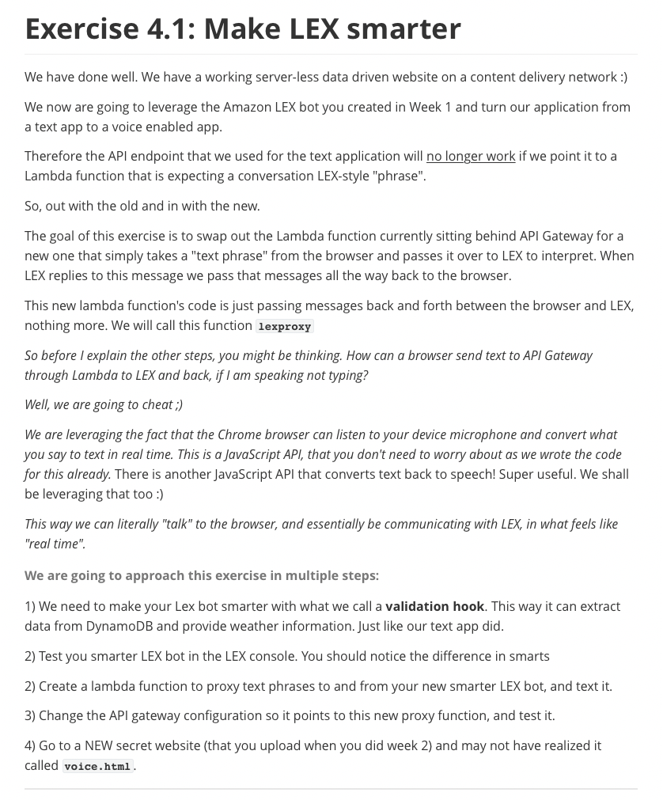

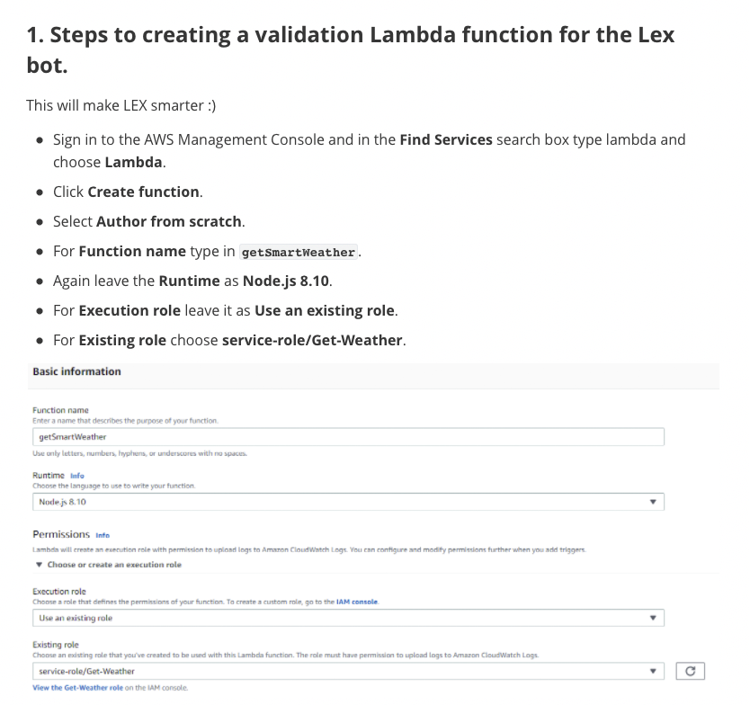



exports.handler = function(event, ctx, cb){

var

my_response = {};

if(event.currentIntent.slots.city_str){

// we have the city already awesome keep going

}else{

//we need to ask for (elicit) a city

my_response.statusCode = 200;

my_response.body = {

"dialogAction": {

"type": "ElicitSlot",

"message": {

"contentType": "PlainText",

"content": "Name the city your cat lives in, thanks"

},

"intentName": "CatWeather",

"slots": {

"city_str": null

},

"slotToElicit" : "city_str"

}

};

return cb(null, my_response.body);

}

var

city_str = event.currentIntent.slots.city_str,

AWS = require("aws-sdk"),

DDB = new AWS.DynamoDB({

apiVersion: "2012-08-10",

region: "us-east-1"

}),

lookup_name_str = city_str.toUpperCase(),

params = {

TableName: "weather",

KeyConditionExpression: "sc = :v1",

ExpressionAttributeValues: {

":v1":{

"S": lookup_name_str

}

},

ProjectionExpression: "t"

};

console.log(params);

DDB.query(params, function(err, data){

if(err){

throw err;

}

if(data.Items && data.Items[0] && data.Items[0].t){

console.log("city weather found");

console.log(data.Items[0]);

my_response.statusCode = 200;

my_response.body = {

"sessionAttributes": {

"temp_str": data.Items[0].t.N,

"city_str": event.currentIntent.slots.city_str

},

"dialogAction":{

"type": "Close",

"fulfillmentState": "Fulfilled",

"message": {

"contentType": "PlainText",

"content": data.Items[0].t.N

}

}

};

}else{

console.log("city weather not found for " + lookup_name_str);

my_response.statusCode = 200;

my_response.body = {

"dialogAction": {

"type": "ElicitSlot",

"message": {

"contentType": "PlainText",

"content": "Please try another city, we couldn't find the weather for that city"

},

"intentName": "CatWeather",

"slots": {

"city_str": null

},

"slotToElicit" : "city_str"

}

}

}

return cb(null, my_response.body);

});

};

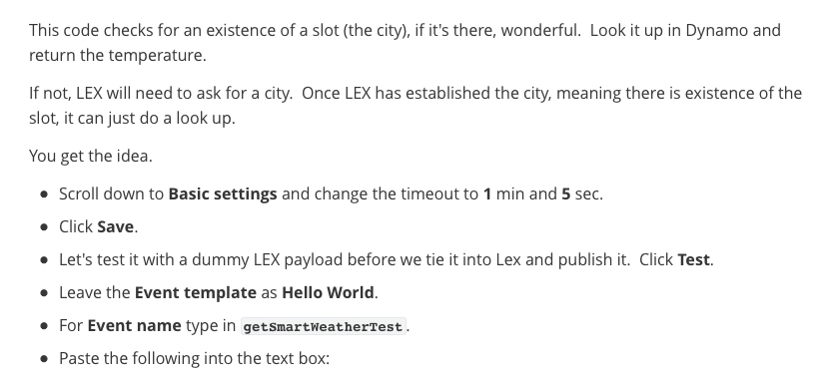

{

"messageVersion": "1.0",

"invocationSource": "DialogCodeHook",

"userId": "1012602",

"sessionAttributes": {

},

"bot": {

"name": "WeatherCatBot",

"alias": "$LATEST",

"version": "$LATEST"

},

"outputDialogMode": "Text",

"currentIntent": {

"name": "CatWeather",

"slots": {

"city_str": "CHICAGO"

},

"confirmationStatus": "None"

}

}



{

"sessionAttributes": {

"temp_str": "42",

"city_str": "CHICAGO"

},

"dialogAction": {

"type": "Close",

"fulfillmentState": "Fulfilled",

"message": {

"contentType": "PlainText",

"content": "42"

}

}

}

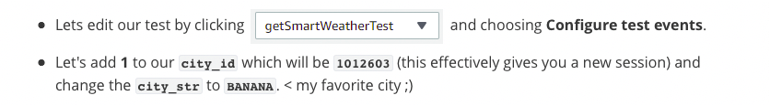

{

"messageVersion": "1.0",

"invocationSource": "DialogCodeHook",

"userId": "1012603",

"sessionAttributes": {

},

"bot": {

"name": "weather",

"alias": "$LATEST",

"version": "$LATEST"

},

"outputDialogMode": "Text",

"currentIntent": {

"name": "catWeather",

"slots": {

"city_str": "BANANA"

},

"confirmationStatus": "None"

}

}



{

"dialogAction": {

"type": "ElicitSlot",

"message": {

"contentType": "PlainText",

"content": "Please try another city, we couldn't find the weather for that city"

},

"intentName": "CatWeather",

"slots": {

"city_name_str": null

},

"slotToElicit": "city_str"

}

}

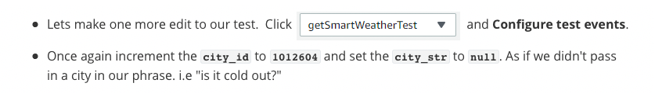

{

"messageVersion": "1.0",

"invocationSource": "DialogCodeHook",

"userId": "1012604",

"sessionAttributes": {

},

"bot": {

"name": "weather",

"alias": "$LATEST",

"version": "$LATEST"

},

"outputDialogMode": "Text",

"currentIntent": {

"name": "catWeather",

"slots": {

"city_str": null

},

"confirmationStatus": "None"

}

}



{

"dialogAction": {

"type": "ElicitSlot",

"message": {

"contentType": "PlainText",

"content": "Name the city your cat lives in, thanks"

},

"intentName": "CatWeather",

"slots": {

"city_str": null

},

"slotToElicit": "city_str"

}

}

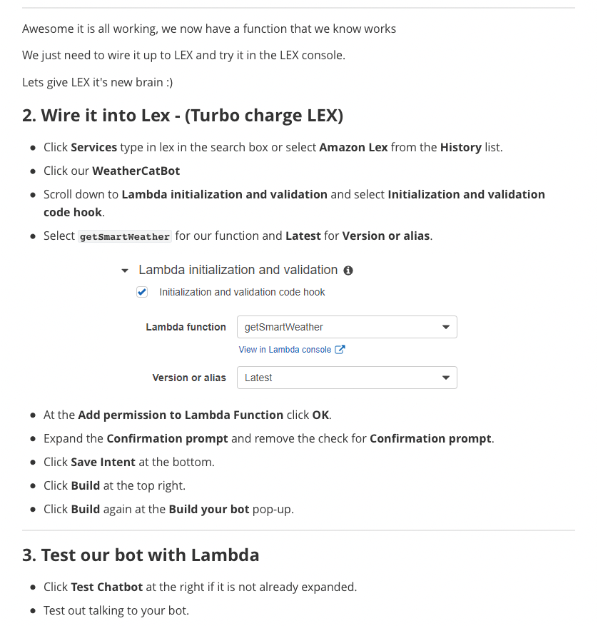

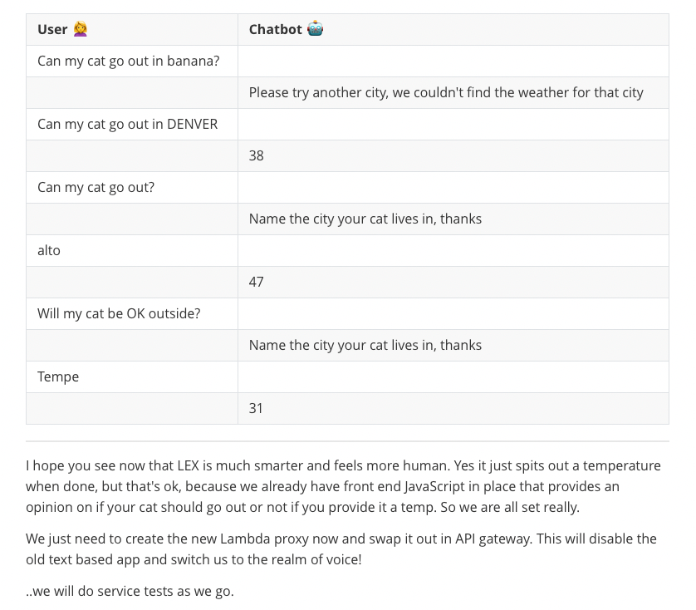

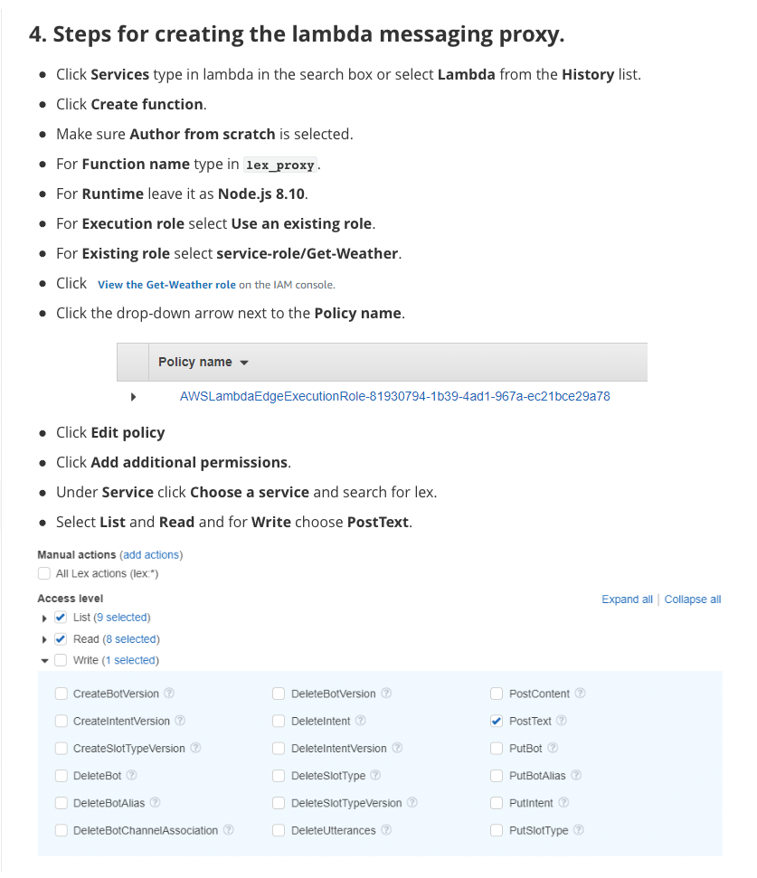

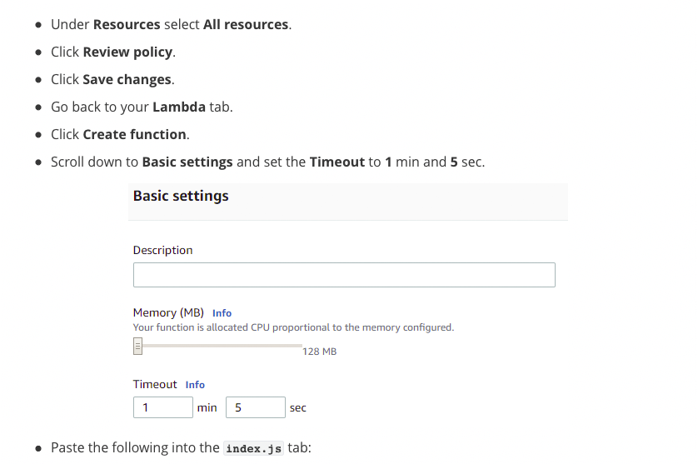

function handler(event, context, callback){

var

MESSAGE_STR = event.message_str,

USER_ID_STR = event.user_id_str,

AWS = require("aws-sdk"),

LEXRUNTIME = {},

BOT_NAME_STR = "WeatherCatBot",

BOT_ALIAS_STR = "$LATEST",

sessionAttributes = {

},

params = {};

AWS.config.update({

region: "us-east-1"

});

LEXRUNTIME = new AWS.LexRuntime();

params = {

botAlias: BOT_ALIAS_STR,

botName: BOT_NAME_STR,

inputText: MESSAGE_STR,

userId: USER_ID_STR,

sessionAttributes: sessionAttributes

};

LEXRUNTIME.postText(params, function(error, data){

var response = {};

if(error){

console.log(error, error.stack);

response = "problem with lex";

callback(null, response);

}else{

console.log(data);

response = data;

callback(null, response);

}

});

}

exports.handler = handler;

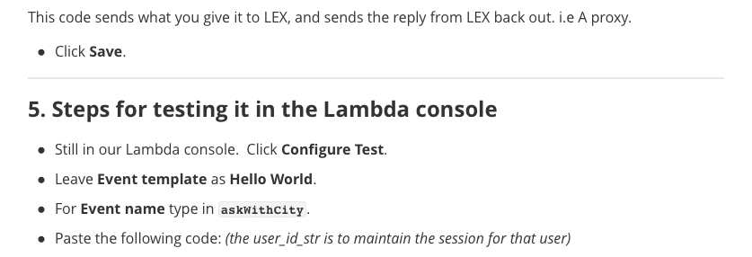

{

"message_str": "can my cat go out in alto?",

"user_id_str": "10126023"

}



Response:

{

"intentName": "CatWeather",

"slots": {

"city_str": "alto"

},

"sessionAttributes": {

"city_str": "alto",

"temp_str": "47"

},

"message": "47",

"messageFormat": "PlainText",

"dialogState": "Fulfilled",

"slotToElicit": null

}

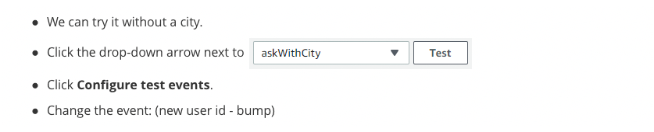

{

"message_str": "can my cat go out in alto?",

"user_id_str": "10126023"

}



{

"message_str": "can my cat go out?",

"user_id_str": "10126024"

}



{

"intentName": "CatWeather",

"slots": {

"city_str": null

},

"sessionAttributes": {},

"message": "Name the city your cat lives in, thanks",

"messageFormat": "PlainText",

"dialogState": "ElicitSlot",

"slotToElicit": "city_str"

}

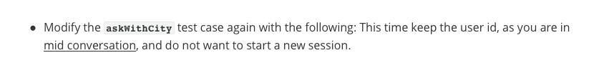

{

"message_str": "DENVER",

"user_id_str": "10126024"

}



{

"intentName": "CatWeather",

"slots": {

"city_str": "DENVER"

},

"sessionAttributes": {

"city_str": "DENVER",

"temp_str": "38"

},

"message": "38",

"messageFormat": "PlainText",

"dialogState": "Fulfilled",

"slotToElicit": null

}

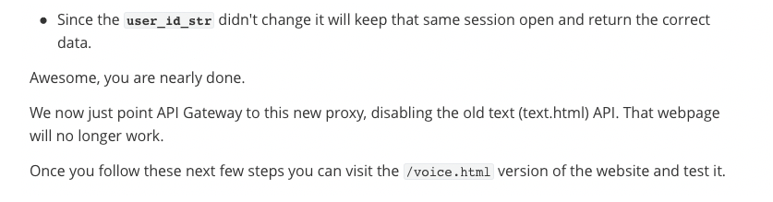

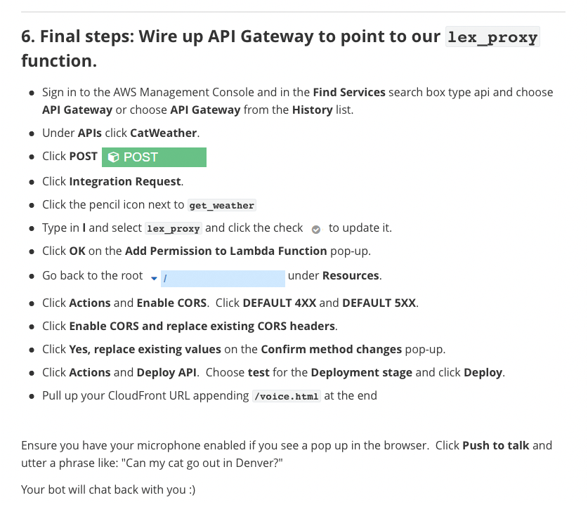

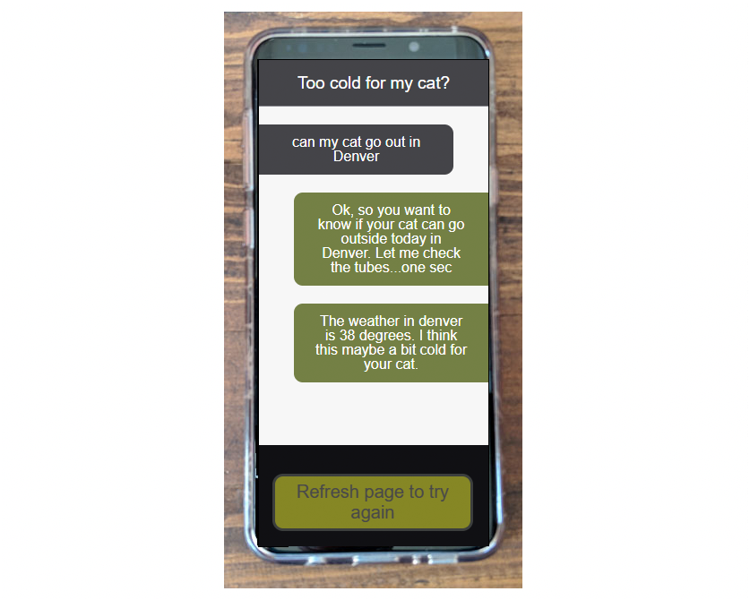

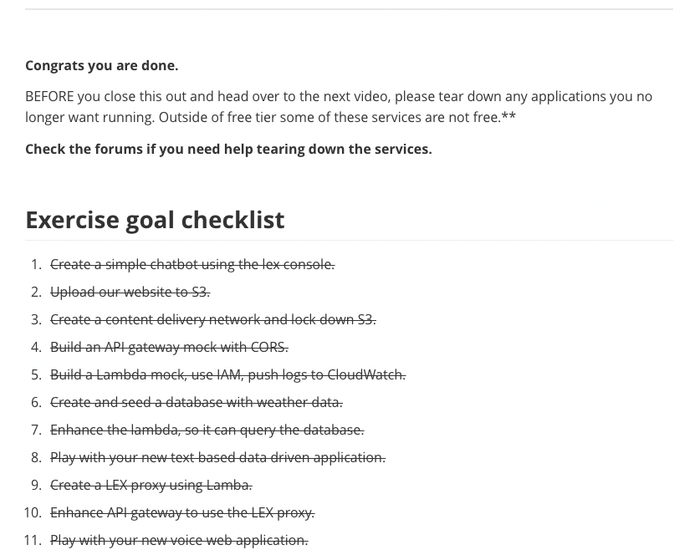

## **Week 4 Readings/Resources**

### **Deploying an Amazon Lex Bot on a Messaging Platform**

In the video, we explained how to integrate our Lex bot with Facebook messenger. As noted, in Addition to Facebook messenger, you can deploy your Lex bot on Slack and Twilio.

Examples and details about how to do this can be found in the [Lex Documentation](https://docs.aws.amazon.com/lex/latest/dg/example1.html).